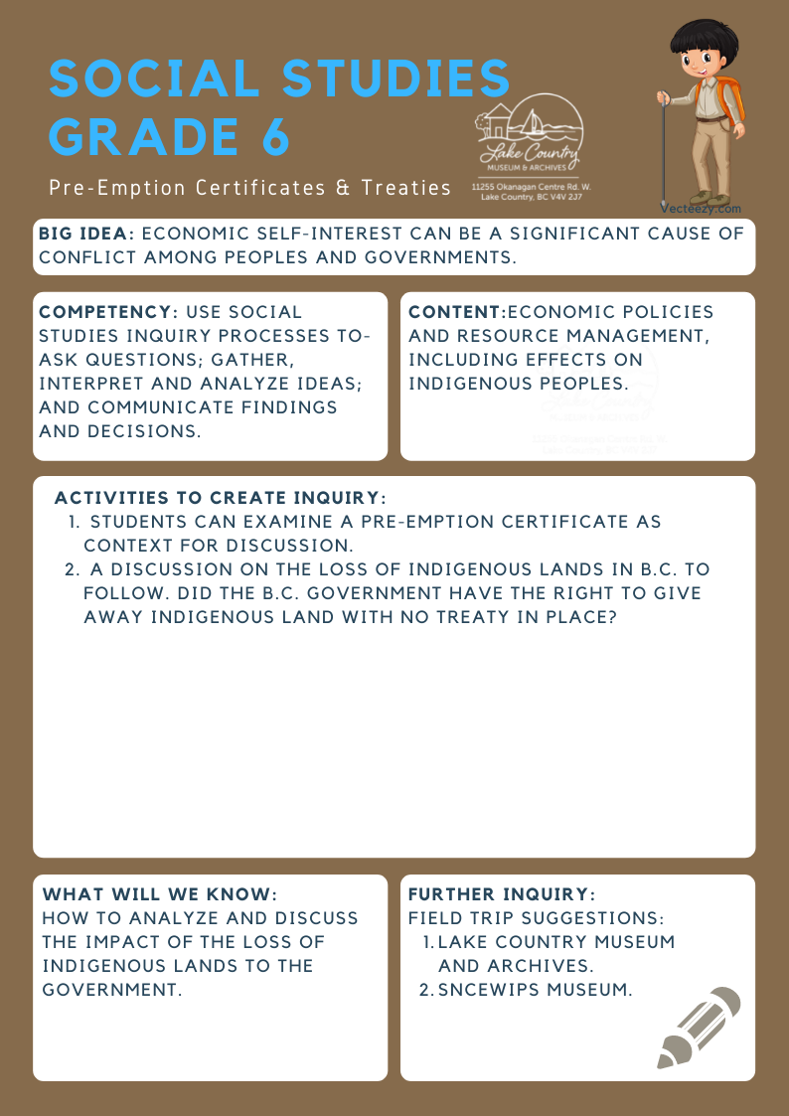
We respectfully acknowledge that the land on which the Lake Country Museum is situated, where this lesson was developed, is on the unceded territory of the Syilx (Okanagan) Peoples.

Copyright © 2021
Lake Country Heritage and Cultural Society
11255 Okanagan Center Road West
Lake Country, BC V4V 2J7

All rights reserved. No part of this publication may be produced, stored in a retrieval system, or transmitted, in any form or by any means, electronic, mechanical, photocopying, recording, or otherwise, without prior written permission of the publisher.
Social Studies Grade 6: Pre-emption Certificates & Treaties
Learning Experience
Students can examine a primary source document (pre-emption certificate) and hold a discussion on the impact of the loss of Indigenous lands in B.C.

Objective | Students will further their knowledge about the loss of Indigenous lands in B.C. to the government through the use of pre-emption certificates that were issued to settlers.
Historical Reading | The Commonage  The word ‘Commonage’ was derived from the contraction of ‘Common’ and ‘Pasturage’, meaning common pasturage. This means "... a large tract of land set aside for grazing purposes".  Many European settlers were arriving in the Okanagan Valley. It was important to provide both the settlers and the Syilx people a place to pasture their livestock. The Commonage area was, at that time, the vacant land available in the area. The area of the land planned for the Commonage was 25,114 acres. It extended from Okanagan Lake to Long Lake (Kalamalka and Wood lakes), north to today’s boundary of Vernon, and south to Okanagan Centre.  On May 8, 1876 an agreement was made that the Commonage was to be reserved from pre-emption for the use of the Syilx people and the settlers for pastureland. This agreement was signed by Indian Reserve Commissioner A. C. Anderson; Dominion Commissioner Archibald McKinley, Commissioner for British Columbia; and Joint Commissioner G. M. Sproat.  However, in 1889, a new agreement was reached between British Columbia’s Chief Commissioner of Land and Works and P. O'Reilly and the Indian Reserve Commissioner. The new agreement stated that the provincial government would take over the Commonage and in return it would establish an Indian Reserve on the west side of Okanagan Lake.  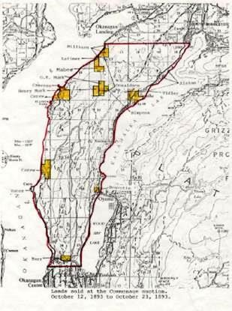  LCMA  Map of lands sold at the Commonage auction, 1893. Reproduced from LCMA manuscript North- ern Okanagan Commonage
Activity | Pre-emption Certificate Examination & Discussion  Pre-emption Certificates  Have students examine the following: Thomas Wood Crown land grant document, Jeremiah Clark pre-emption record, Thomas Simpson pre- emption record, and the British Columbia Crown Land Pre-emption Registers, 1860-1971: https://familysearch.org/search/collection/2053657  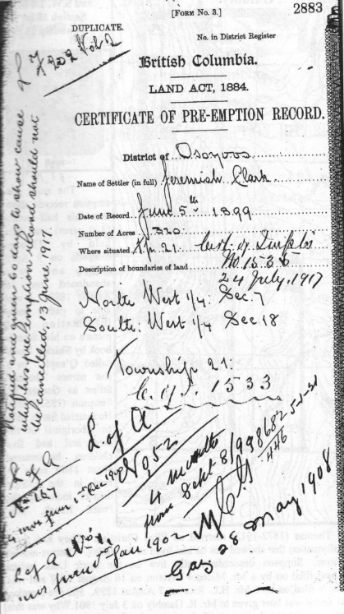  History of Fir Valley, by Ron Taylor  Discussion: Did the government have the right to give away this land? No treaties were signed regarding land in Lake Country or in most areas of British Columbia. What difficulties do you think this created?  British Columbia Crown Land Pre-emption Registers, 1860-1971: Pre-emptions are purchased land that has not been fully surveyed. The pre-emption registers summarize the information from the pre-emption certificates. The pre-emptions are listed in registration number order, with an alphabetical index in the back of each volume.  Extension: Discussion: What are treaties? Why were they signed? Why are treaties only now being negotiated in BC? Investigate the cost of treaty negotiations. Do you think these negotiations are effective?  BC Treaty Commission: http://bctreaty.net/index.php  When BC joined Confederation in 1871, only 14 treaties on Vancouver Island had been signed, and aboriginal title to the rest of the province was left unresolved. It wasn't until 1970 that Canada's aboriginal peoples were able to pursue aboriginal rights in the Supreme Court of Canada. With the exception of Treaty 8 and negotiations with the Nisga'a Nation, most First Nations had to wait until 1993 to pursue their aboriginal rights through the BC treaty process.
Further Inquiry | Field Trip Suggestions:  - Sncewips Museum  - Lake Country Museum and Archives  (The Lake Country Museum and Archives)  The Museum has a wide range of exhibits and activities for your class to take advantage of. There may be the opportunity for a guest lecturer to visit your classroom or be present at the museum with the knowledge of more local history stories. If interested, please contact the Museum ahead of time.  Suggested Resources:  - LCMA website resources: Northern Okanagan Commonage, History Index  - Okanagan Nation Alliance website: www.syilx.org (map of traditional Syilx territory)  - Where the Grass is Always Browner on the Other Side of the Fence: A History of the Okanagan Common- age by, Dr. D. John Price  - British Columbia Crown Land Pre-emption Registers, 1860-1971: https://familysearch.org/search/ collection/2053657  - Aboriginal Affairs & Northern Development Canada - Kids’ Stop: https://www.aadnc-aandc.gc.ca  - BC Treaty Commission: http://www.bctreaty.net/  - BC Archives Research Guide: Pre-emption and homestead claims

