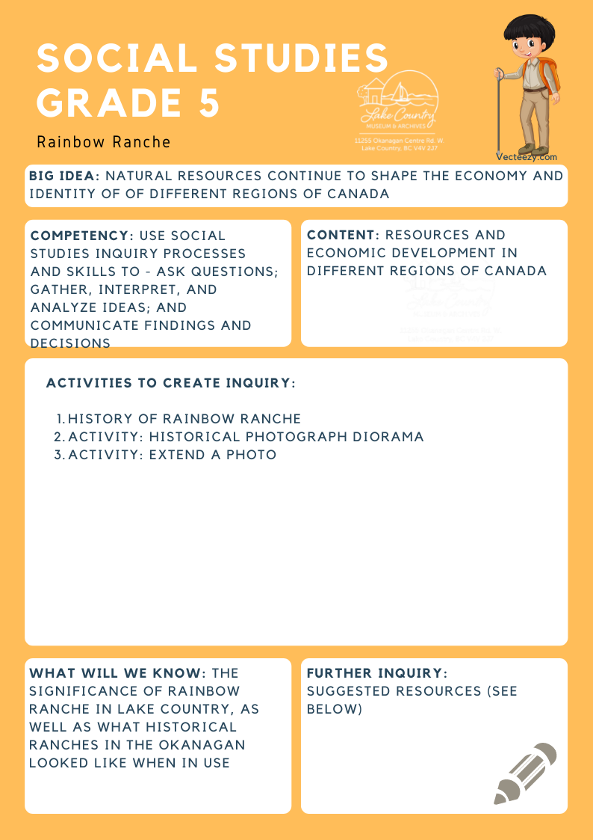
We respectfully acknowledge that the land on which the Lake Country Museum is situated, where this lesson was developed, is on the unceded territory of the Syilx (Okanagan) Peoples.

Copyright © 2021
Lake Country Heritage and Cultural Society
11255 Okanagan Center Road West
Lake Country, BC V4V 2J7

All rights reserved. No part of this publication may be produced, stored in a retrieval system, or transmitted, in any form or by any means, electronic, mechanical, photocopying, recording, or otherwise, without prior written permission of the publisher.
Social Studies Grade 5: Rainbow Ranche
Learning Experience
Students will learn about the historical significance of Rainbow Ranche, one of the first orchards in the Okanagan, as well as combine their imagination with what they have learned to create artistic representations of early ranches, orchards, and other types of homesteads in Lake Country.

Objectives | To learn about the history of Rainbow Ranche, as well as use imagination and knowledge about the ranch to create artistic representations of early ranches/orchards/areas of significance in Lake Country.
Historical Reading | The Rainbow Ranche  The Rainbow Ranche was one of the first independent fruit ranches in Lake Country. The history of the Rainbow Ranche began in 1893 when it was purchased by the Barr brothers at a land auction in Vernon. Originally part of the Commonage, the Barrs named it the ‘Rainbow’ because of the frequent rainbows spanning the property.  In 1896, the Barr brothers sold the property to Northcote Henry Caesar and his partner, T. F. Valentine for $2000.00. They planted hay and added to their income by logging, working at the Big Bend Mine, and transporting freight and passengers in their boat, Wanderer.  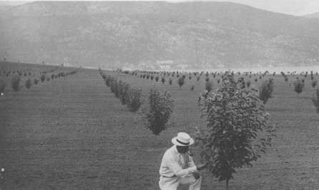  Rainbow Ranche Orchard, 1910 (LCMA)  Until 1909, there were at least six different owners. At that point, J. E. McAllister (1/2 share), R. S. Dormer (1/4 share), and James Goldie (1/4 share) formed The Rainbow Ranche Ltd. Goldie was appointed manager for the absentee owners. The partners planted the first orchard. The Rainbow orchard was the first large-scale fruit orchard in the Lake Country area.  With irrigation, fruit orchards soon covered the property, including 125 acres of apples. The Rainbow had its own packinghouse at the top of Rainbow Hill. When the packinghouse was in full operation it employed a large number of sorters and packers, most of whom were Japanese Canadians. The fruit was taken by wagon and team to the wharf at Okanagan Centre where it was picked up by one of the sternwheelers and taken to the railhead at Vernon.  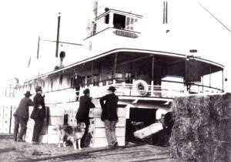  SS Aberdeen in 1915, loading Rainbow Ranche fruit at the wharf at the foot of Pixton Road in Okanagan Centre. The man on the right is Rainbow Ranche Manager Jim Goldie. (LCMA)  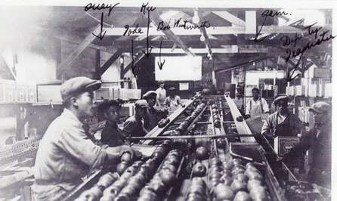  Sorting apples at the Rainbow Ranche packinghouse, 1920  (LCMA)
Activity | Activity #1: Historical Photograph Diorama  Choose a historical photograph of a person or persons with a featured background.  Using a 40 cm x 40 cm cardboard base, create the geography of the photograph. Paint the background, add and attach three-dimensional features, and add some details. Enlarge a copy of your photograph. Cut out the people and other key features in the photograph. Glue them on cardboard to stand them up in your model.  Compare the original photograph with your model. Develop a keen eye for detail.  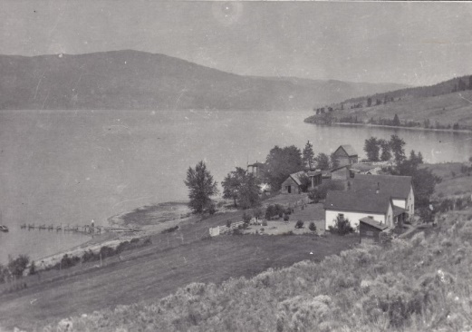  Rainbow Ranche House, 1910 (LCMA)  Activity #2: Extend a Picture!  Students can choose one of the four Rainbow Ranche photographs provided above.  - What is happening in the photograph?  - When was it taken?  - Why did you choose this photograph?  Students can place a copy of their photograph on a blank sheet of paper and continue drawing a section of the photograph or adding in something that they feel is missing. Afterwards, they can write a fictional story based on the photograph.
Further Inquiry | Field Trip Suggestions:  - Lake Country Museum and Archives  - There may be the opportunity for a guest lecturer to visit your classroom or be present at the museum with the knowledge of more local history stories. If interested, please contact the Museum ahead of time.  Suggested Resources:  - LCMA website resources: The History of Rainbow Ranche, by Susan Funk, Record of a Life, by Northcote Henry Caesar, The Goldie Saga 1793-1886, by Theresa Goldie Falkner  - Oral history interview of Anne Goldie Land, Anne Land Memories  - Map of the Rainbow Ranche orchards, by Nancy Goldie

