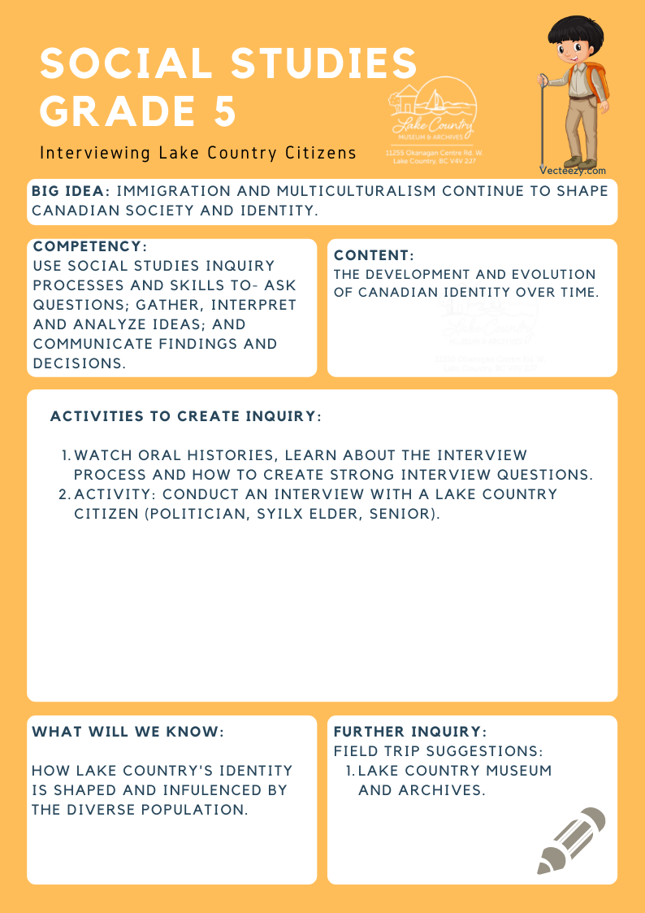
We respectfully acknowledge that the land on which the Lake Country Museum is situated, where this lesson was developed, is on the unceded territory of the Syilx (Okanagan) Peoples.

Copyright © 2021
Lake Country Heritage and Cultural Society
11255 Okanagan Center Road West
Lake Country, BC V4V 2J7

All rights reserved. No part of this publication may be produced, stored in a retrieval system, or transmitted, in any form or by any means, electronic, mechanical, photocopying, recording, or otherwise, without prior written permission of the publisher.
Social Studies Grade 5: Interviewing Lake Country Citizens
Learning Experience
Students will further their knowledge of Lake Country’s history by exploring the concept of oral history through an interview with a Lake Country resident.

Objective | Students will gain knowledge of the process of an interview, including best practices to form strong interview questions. These interviews conducted with Lake Country representatives will further the student’s knowledge of how residents shape the history and identity of Lake Country.
Historical Reading | Consult the Museum for further readings and archival material.
Activity | Oral History Videos & Interviews:  Students will view a selection of oral history videos by the LCMA on YouTube.  Link: https://www.youtube.com/channel/UCaLQH3PBcsHp5srS6I8e2pA  The writing of history has been traditionally based on diaries, documents, and other written sources. Recently, however, historians have come to recognize the value and historical significance of oral histories as first-hand accounts of past events and people.  As a class, watch and listen to selections of oral history interviews. Discuss the interview content, the inter-viewees responses, and whether or not the style and tone of the interviews are different from a written transcript of an interview.  Establish protocols for interviews and identify topics and questions to be discussed during the interviews. Students brainstorm and write down questions to ask. Determine interview roles such as interviewer, recorder, or scribe.  Invite Lake Country citizens (e.g. seniors, municipal representatives, Indigenous elders, etc.) to your school for tea and cookies. Pairs or triads of students are matched with a citizen to meet and to interview. Students should listen to the citizen carefully and in a respectful manner while taking notes. Ensure students know to check with the interviewee if they don't understand words used or would like to clarify something the citizen said. Interviews should encourage the person to share feelings and impressions about past events in Lake Country and include specifics about their daily lives.  After the interview students write their own reflection on the experience. Class discussion could follow.
Further Inquiry | Field Trip Suggestions:  The Lake Country Museum and Archives  The Museum has a wide range of exhibits and activities for your class to explore. There is also a playground and field behind the building and the lake nearby that students can make use of for various activities.  There may be the opportunity for a guest lecturer to visit your classroom or be present at the museum with the knowledge of more local history stories. If interested, please contact the Museum ahead of time.

