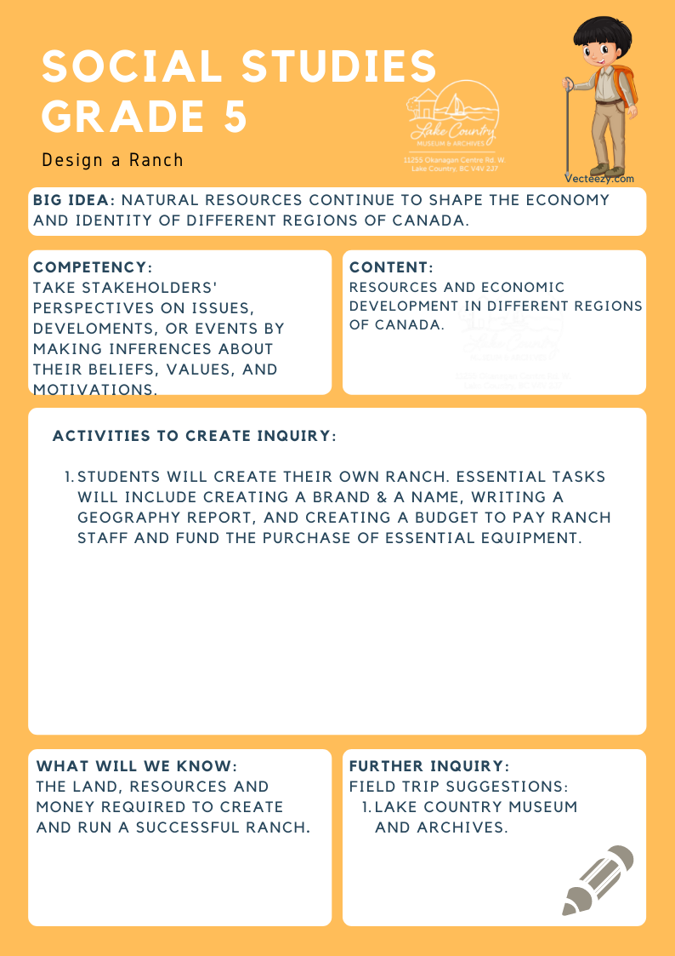
We respectfully acknowledge that the land on which the Lake Country Museum is situated, where this lesson was developed, is on the unceded territory of the Syilx (Okanagan) Peoples.

Copyright © 2021
Lake Country Heritage and Cultural Society
11255 Okanagan Center Road West
Lake Country, BC V4V 2J7

All rights reserved. No part of this publication may be produced, stored in a retrieval system, or transmitted, in any form or by any means, electronic, mechanical, photocopying, recording, or otherwise, without prior written permission of the publisher
Social Studies Grade 5: Design a Ranch
Learning Experience
Students will design, plan and create a fictional ranch that will take into account all aspects of ranching. These include the geography and climate of the land, a financial budget, and creating a name and a brand for their ranch.

Intention | Students will gain further knowledge of the financial and geographical requirements of building and maintaining a successful ranch.
Historical Reading | The Rainsford Ranch and the Goulding Family  George Cassilis Goulding (1886 – 1943) was the son of a wealthy Toronto family. Rather than going to work in his family’s millinery business, George moved west.  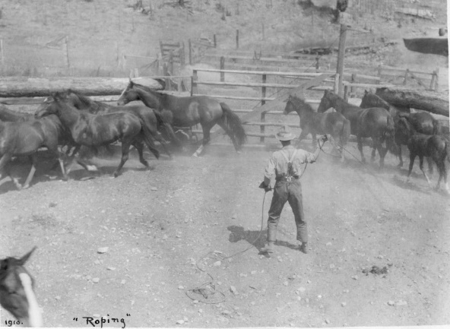  Roping horses at the Rainsford Ranch, 1910 (LCMA)  In 1906, he arrived in this area and boarded with the Lloyd family at Long Lake Farm. The following year, he purchased 377 acres on the Long Lake Farm property at $20.00 an acre and also bought additional range land above the property. He eventually owned 2,060 acres - 60 acres in orchard and the rest as rangeland. The land, known as the Rainsford Ranch, was located northwest of the Oyama isthmus, and extended from the lake up the hillside.  George Goulding, with his wife May and their three children, Florence (1911), Margaret (1913), and William (1916), had one of the largest orchards in the Oyama area. He had arrived and purchased his land just before irrigation was brought in.  The Goulding’s also established a large horse farm on the Rainsford Ranch. Here they bred and raised horses which they sold to other ranches and to new settlers. Goulding hired John Sadler as ranch foreman in 1908, and the whole Sadler family of John, his wife, and their five sons worked at the Rainsford Ranch.  Ranching  Irrigation has changed Lake Country’s landscape from bunchgrass and ranches to orchards and vineyards.  Ranching was the major industry in the Okanagan before orchards. From the 1870s, when the first settlers began to ar- rive, through to about 1910, cattle ranches and rangeland for grazing took up most of the Lake Country area. Early ranches were located on both sides of Wood Lake and the west side of Kalamalka Lake, and the Commonage.  Most of the ranchers could not survive on raising and selling cattle. They grew and raised their own food and earned extra income in other ways. Some of the ranchers supplemented their income by packing freight to the goldfields and to the mining areas of the Kootenays and northern British Columbia. Others grew cash crops such as hay. Ranchers who were located along the stagecoach road opened stop- ping houses, such as the Halfway House at Milepost 11, or small stores to supplement their income.  Sources:  LCMA website resources: Threshing on the Bar U Ranch, by Dr. Duane Thomson, Record of a Life, by Northcote Henry Caesar, The Autobiography of Harold David Butterworth, Thomas Wood History, by Mrs. W. R. Powley.  LCMA History Index: Kalwood Ranch, 1910-1913 V_V Ranch, 1890-1893 Commonage Auction
Activity | Activity: Design a Ranch!  Students will create their own simulated ranch using historical details from the 1880s era ranches in the Okanagan Valley. They can work in small groups in order to allow for brainstorming and consensus building.  In groups, students begin by deciding on a name for their ranch and designing a brand that represents the group members in some manner. They can research the history of brands and examine how ranchers came up with brand designs.  After creating the brand and naming their ranches, the brands can be shared with the other groups, challenging them to try to "read" the ranch name from the brand. Next, students can then begin researching what ranching was like in the 1880s using the online sources and additional content from Lake Country Museum.  As a whole class, students can brainstorm questions they will have to answer in order to complete the project. For example:  - How big is an acre?  - What did cattle cost?  - How much were cowboys paid?  - What problems did they overcome?  Students can research other ranches such as the BX ranch and O’Keefe ranch.  Geography is a major factor in the settlement of any region. Students will need a report on the geographic and climatic description of the area including information about the general climate, weather, land-forms, flora and fauna, soil conditions, and water sources. Students should also consider the chosen area's effect on transportation, communication, and the raising of the animals themselves.  Students can prepare a budget for the coming year as well as determine any other costs involved, such as the cost of food, a cook, horses, saddles, wood and building costs.  Students can compare their simulation ranches to documented ranches in Lake Country.  Extension: Visit the Lake Country Museum to see the ranching and blacksmith exhibits and to view the photograph collection of the Goulding family and the Rainsford Ranch.
Further Inquiry | Field Trip Suggestions:  The Lake Country Museum and Archives  The Museum has a wide range of exhibits and activities for your class to explore. There may be the opportunity for a guest lecturer to visit your classroom or be present at the museum with the knowledge of more local history stories. If interested, please contact the Museum ahead of time.  Suggested Sources:  https://bcrdh.ca/islandora/object/lake%3A2732?solr_nav%5Bid%5D=fc24218cb754024759c3&solr_nav%5Bpage%5D=0&solr_nav%5Boffset%5D=0#page/1/mode/2up  Cattle Kings and Cowboys- LCMAInterior Pictograph Project, by Bruce Goett: www.interiorpicto.com

