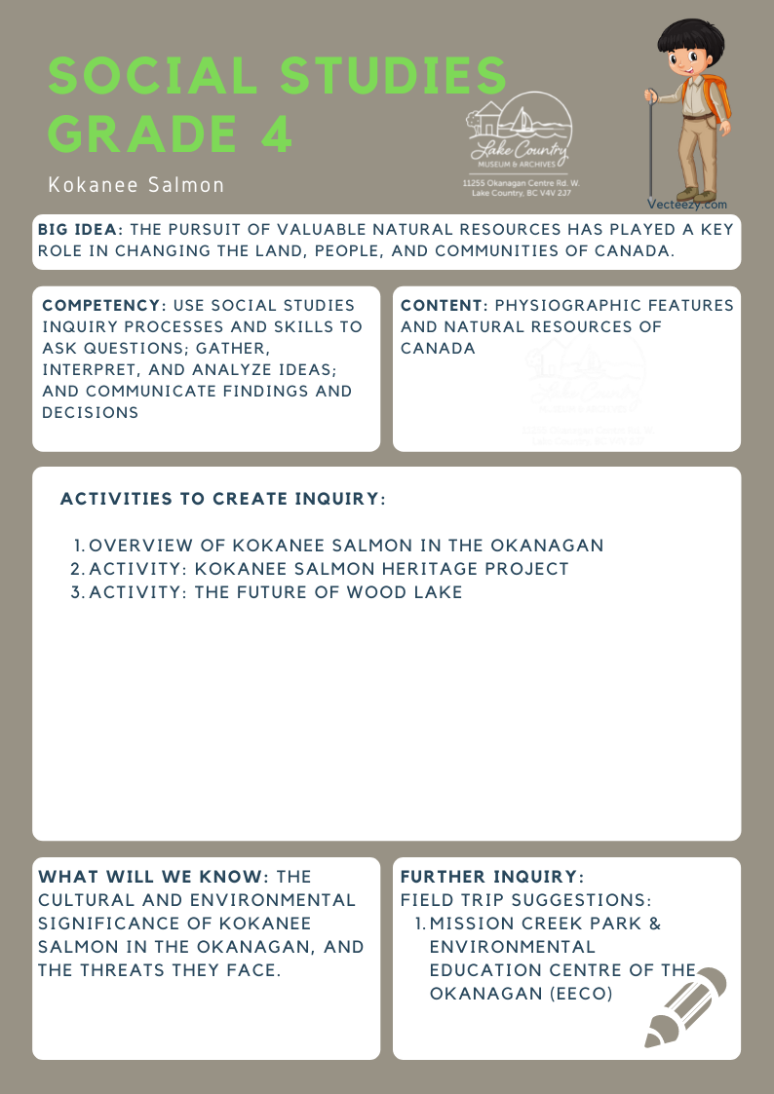
We respectfully acknowledge that the land on which the Lake Country Museum is situated, where this lesson was developed, is on the unceded territory of the Syilx (Okanagan) Peoples.

Copyright © 2021
Lake Country Heritage and Cultural Society
11255 Okanagan Center Road West
Lake Country, BC V4V 2J7

All rights reserved. No part of this publication may be produced, stored in a retrieval system, or transmitted, in any form or by any means, electronic, mechanical, photocopying, recording, or otherwise, without prior written permission of the publisher.
Social Studies Grade 4: Kokanee Salmon
Learning Experience
Students will have the opportunity to learn about Kokanee Salmon in the Okanagan: the Indigenous origins of their name, the local lakes they reside in, the threats they face, and what we can do to help ensure their survival.

Objective | To learn about the history of Kokanee Salmon in the Okanagan (specifically in Wood Lake) and the threats they face.
Historical Reading | Wood Lake Kokanee  Kokanee is a word from the Okanagan Syilx language, kəkn̓ iʔ. It refers to the land-locked lake populations of Sockeye salmon. Most species of salmon travel hundreds or even thousands of miles over a lifetime. Salmon are born in fresh water and live most of their adult lives in the ocean, returning to the freshwater stream to spawn. Only Kokanee salmon do not make this journey. They live their whole lives in a freshwater stream or lake. Stream-spawners migrate into lake tributaries in early September and complete spawning by mid-October. Shore-spawners migrate to spawning beaches along the lake shoreline and spawn from mid-October to mid-November.  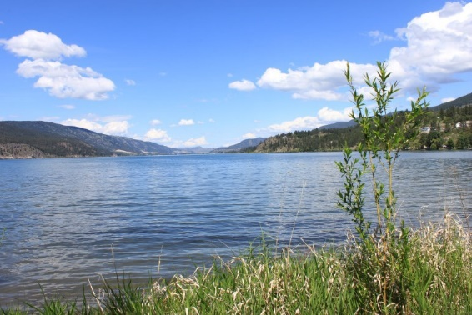  Wood Lake (LCMA)  Wood Lake is one of only three lakes in the Okanagan that has two species of Kokanee salmon, the stream spawners and the shore spawners. Although these two types of Kokanee share the lake, shore-spawning and stream-spawning Kokanee are distinct populations. The other two lakes containing both species of Kokanee are Okanagan Lake and Kalamalka Lake  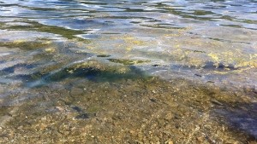  An algae bloom floats on top of Wood Lake, near Kelowna B.C.  (Brady Strachan/CBC)
Activity | Activity #1: The Kokanee Salmon Heritage Project!  http://www.lakecountrymuseum.com/collections-exhibits/the-kokanee-salmon-heritage-project/  The Kokanee Salmon Heritage Project was developed by the Royal BC Museum as a result of the myriad of questions about Kokanee which arose during school and public interpretation talks at the Mission Creek Spawning Channel, Kelowna, BC. The scientific authority for the project is Dr. Peter Dill, a researcher on trout and salmon in Canada for over forty years and on Kokanee in the Okanagan since the mid-1980s.  The website includes the biology and life cycles of stream-spawning and shore-spawning kokanee, local projects and action plan proposals, maps, photographs, news articles, and a Kokanee Kids section.  See Field Trip Suggestions below to extend this activity.  Activity #2: The Future of Wood Lake!  Discussion: What has affected Wood Lake over the past one hundred years? What do you think will affect Wood Lake in the future?  Things to consider:  - Current and potential threats to Kokanee salmon?  - Indications of a healthy or unhealthy lake?  - Development and human encroachment?  - Agricultural activities and water use?  - Pelmewash Parkway and the Rail Trail?  - The proposed reintroduction of sockeye salmon to Okanagan Lake. Will this affect the kokanee?  - Analyze topographical and other maps. Where are/were the orchards?  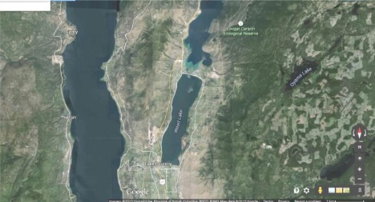  Satellite Image of Wood Lake & Surrounding Area  (LCMA)
Further Inquiry | Field Trip Suggestions:  - Organize a field trip to Mission Creek Park to observe the Kokanee. Visit the Environmental Education Centre of the Okanagan (EECO) for exhibits and discovery kits.  https://www.rdco.com/en/parks-and-trails/environmental-education-centre-for-the-okanagan.aspx  Suggested Resources:  - LCMA website resource: The Kokanee Salmon Heritage Project  - LCMA website resource: Aerial photographs of Lake Country, David Madison Album Topographical map of Wood Lake  - Oceola Fish and Game Club, Lake Country: http://www.oceola.ca  - Okanagan Nation Alliance, Fisheries and Aquatics Department  - Regional District of the Central Okanagan, Environmental Education Centre: http://www.regionaldistrict.com  - Okanagan Basin Water Board: http://www.obwb.ca/outreach

