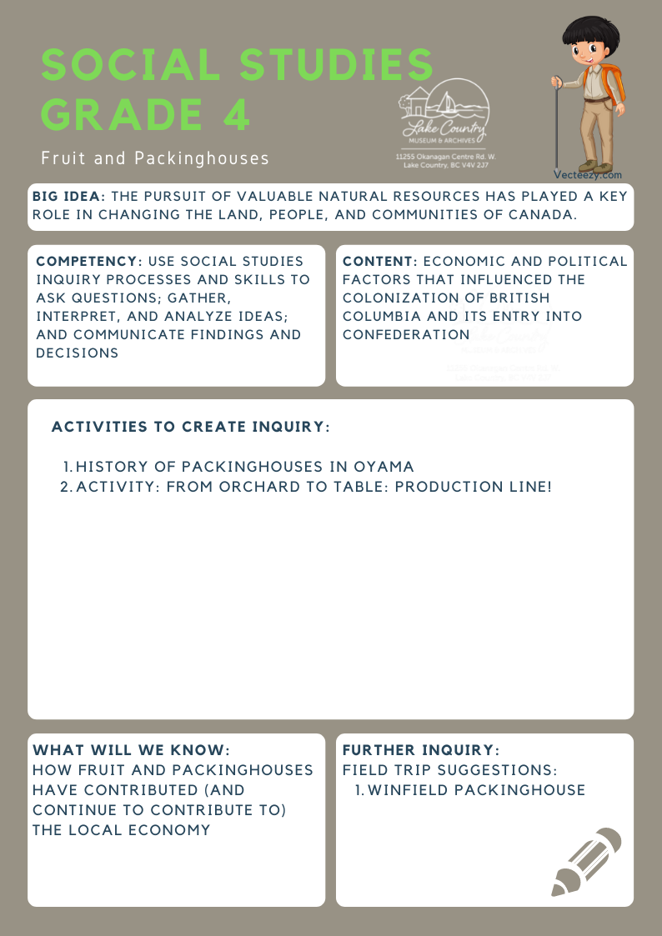
We respectfully acknowledge that the land on which the Lake Country Museum is situated, where this lesson was developed, is on the unceded territory of the Syilx (Okanagan) Peoples.

Copyright © 2021
Lake Country Heritage and Cultural Society
11255 Okanagan Center Road West
Lake Country, BC V4V 2J7

All rights reserved. No part of this publication may be produced, stored in a retrieval system, or transmitted, in any form or by any means, electronic, mechanical, photocopying, recording, or otherwise, without prior written permission of the publisher
Social Studies Grade 4: Fruit & Packinghouses
Learning Experience
Students will learn about the history of packinghouses and their importance to the local economy and culture, and critically analyze varying methods of packing fruit that were/are used.

Objective | To educate students on the importance of fruit and packinghouses on the local economy and culture both historically and in the present. Students will examine different methods of packing fruit that have been used or are still used today and will have the opportunity to visit a local packinghouse to gain more insight into their significance to Lake Country and the Okanagan as a whole.
Historical Reading | The Packinghouses of Oyama  The population of Oyama grew in the early 1900s. The introduction of irrigation changed the economy and local ranches began to switch to orchards. This created a demand for a local packinghouse. Oyama has access to transportation on Kalamalka Lake and the railhead at Vernon and therefore was a logical place for a packinghouse.  In 1913 the Vernon Fruit Union opened as a cooperative packinghouse which was supported by the Oyama growers. Stirling and Pitcairn opened an independent packinghouse on the canal in 1914. By 1916, individual orchardists entered the packing business. Dr. Irvine, W. T. Heddle, Jack Stevens, and Robert Allison all packed their own fruit. Heddle and Irvine had their own packinghouse near Dr. Irvine’s house.  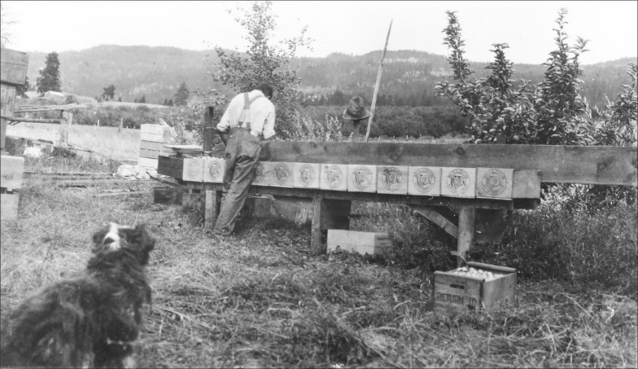  Bob Allison packing ’Bulldog Brand’ apples in his orchard, 1925 (LCMA)  With increased production, hand grading at the Vernon Fruit Union was replaced by two grading machines and a storage plant. The Vernon Storage Co. opened in 1919 and the larger packinghouse was completed in 1921. By 1950, the Vernon Fruit Union packed 3000 boxes per day.  At the packinghouses the fruit was sized and graded, and apples considered not suitable for market due to bruises, blemishes, or poor colour were culled. In the early years, thousands of pounds of culls were dumped and left to rot. By WWI, small companies began dehydrating the culls and can- ning the dried fruit, and in the 1930s companies began processing the culls into apple juice.  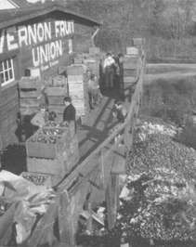  Cull: Something picked out and put aside as inferior.  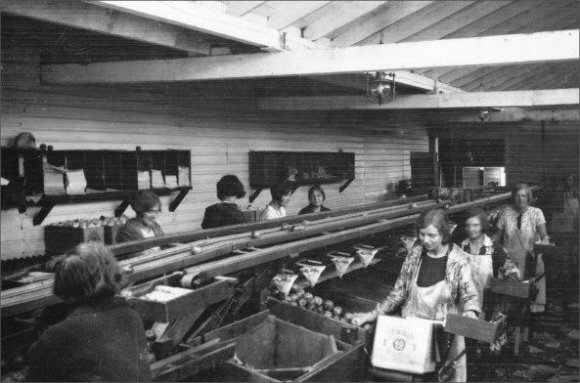  The packing line at the VFU packinghouse in Oyama, 1940 (LCMA)  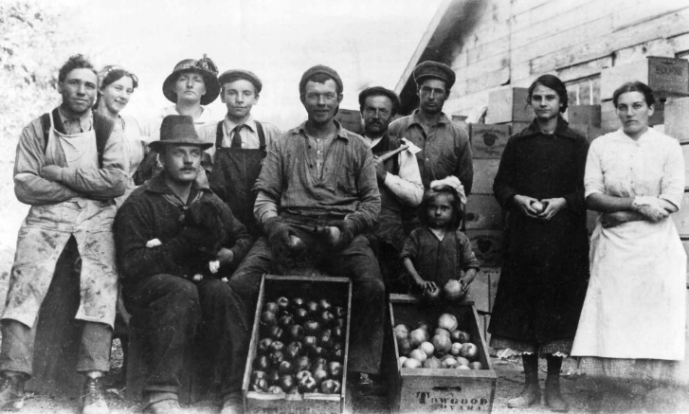  The VFU packing crew operating at the cannery building, 1914 Back Row: Winnie Brown, Mrs. Curfoot, Charlie Phillips, Alec Philips, Sam Tyndall  Front Row: Floyd Whipple, Ted Fudge (Durham), ‘Peggy’ Rowan, Rowan daughter, Martha Getty, Mrs. Rowan  Dumping Apples, 1930 (LCMA)
Activity | From Orchard to Table: Production Line!  In the early years, the fruit industry was labour intensive. Apples were packed in the orchard until growers could afford to build small packinghouses. Soon, larger packinghouses were built by cooperatives and by independent shippers. In these, fruit was drawn by belts along sorting tables to the packing benches. Bench packing employed the principle of the division of labour - dumpers, sorters, packers, pressmen, labellers, and box makers.  In the classroom, role play both methods of packing - the early method, in which the grower was also a box maker, grader, sorter, and packer, and the bench packing method still used today.  Which method would you choose? Why?  Different coloured tissue were used to wrap different grades of apples:  - C-grade = no wrapper  - Fancy grade = red wrapper  - Extra Fancy grade = bluish-purple wrapper
Further Inquiry | Explore:  Using books and the Internet, students can research what happens to apples along each step from orchard to table.  Field Trip Suggestions:  - Winfield packinghouse  - Lake Country Museum and Archives  (The Lake Country Museum and Archives)  The Museum has a wide range of exhibits and activities for your class to take advantage of. There is also a playground and field behind the building and the lake nearby that students can make use of for various activities.  There may be the opportunity for a guest lecturer to visit your classroom or be present at the museum with the knowledge of more local history stories. If interested, please contact the Museum ahead of time.  Suggested Resources:  - LCMA website resources: Student Essays: History of Winfield, various authors, The Story of Waitamata:The Towgood House, by Vera Towgood, The Kalamalka Women’s Institute, by Laura Neame, Conferring the Electoral Franchise upon Women, by Carol Thomson  - Okanagan Historical Society Reports: Apple Packing in the Okanagan Valley, by Clement Battye, 48:16-19,  - Working Women in the Early Packinghouses, by Brianna Shannon, 78:131-134  - Winfield Packinghouse, by Alyssa Parfitt: https://m.youtube.com/watch?v=IzPGhK05xAs&autoplay=1, BC Tree Fruits Winfield Packinghouse - Apple Bags, BC Tree Fruits: https://www.youtube.com/watch? v=A9hgRZM41Oo  - A Rich and Fruitful Land, BC Tree Fruits BC Tree Fruits: http://www.bctree.com

