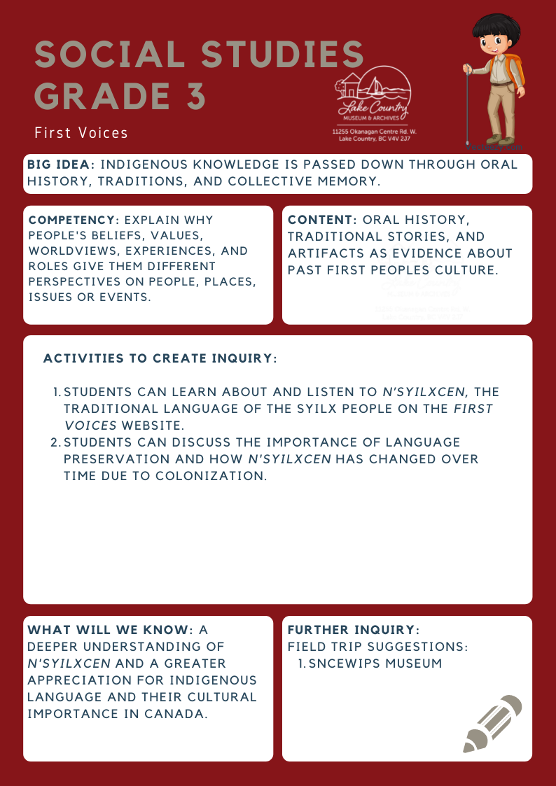
We respectfully acknowledge that the land on which the Lake Country Museum is situated, where this lesson was developed, is on the unceded territory of the Syilx (Okanagan) Peoples.

Copyright © 2021
Lake Country Heritage and Cultural Society
11255 Okanagan Center Road West
Lake Country, BC V4V 2J7

All rights reserved. No part of this publication may be produced, stored in a retrieval system, or transmitted, in any form or by any means, electronic, mechanical, photocopying, recording, or otherwise, without prior written permission of the publisher.

Social Studies Grade 3: First Voices
Learning Experience
Students can explore the Syilx language of n’syilxcen and participate in a discussion about the importance of Indigenous languages in Canada.

Objective | Students will deepen their understanding of n’syilxcen through the First Voices website. Discussion about language preservation will highlight the importance of Indigenous languages as part of Canada’s cultural past, present, and future.
Historical Reading | For background information and language inquiries, contact the Sncewips Museum in West Kelowna.  https://www.sncewips.com/language
Activity | First Voices  The Syilx language, n’syilxcen, is one of over fifty Indigenous languages still spoken in Canada today. Many of these have been carefully recorded and a written alphabet developed. N’syilxcen is now taught as a second language in many schools in the Okanagan.  Discover the Syilx language at First Voices: http://firstvoices.com. The First Voices website is a collection of tools and services designed to support Aboriginal people engaged in language archiving, language teaching & culture revitalization. The First Voices Language Archive contains thousands of text entries in many diverse Indigenous writing systems, enhanced with sounds, pictures and videos. A companion set of interactive online games is designed to present the archived First Voices language data in creative learning activities. Some language archives at FirstVoices are publicly accessible, while others are password protected at the request of the language community.  Discussion Questions:  Why is it important to preserve languages?  The Syilx people today have developed a written alphabet and dictionary of their language - why?
Further Inquiry | Field Trip Suggestions:  - Sncewips Museum  - En’owkin Centre  - Okanagan Heritage Museum  Suggested Resources:  Lake Country Museum & Archives (LCMA): Okanagan Syilx exhibits, website exhibition LCMA website resources: http://www.lakecountrymuseum.com/collections/archives/  LCMA website history index: http://www.lakecountrymuseum.com/history/okanagancentreglacier  Sncəwips Heritage Museum: https://www.sncewips.com/  Okanagan Heritage Museum: https://www.kelownamuseums.ca/museum/okanagan-heritage-museum/  Magic on the Water DVD, by Tracey Bonneau Okanagan Nation Alliance: www.syilx.org  Stories of our sqílxʷ Ways:2016 : Okanagan Indian Band  Okanagan Geology, by Murray Roed and John Greenough  Interior Pictograph Project, by Bruce Goett: www.interiorpicto.com

