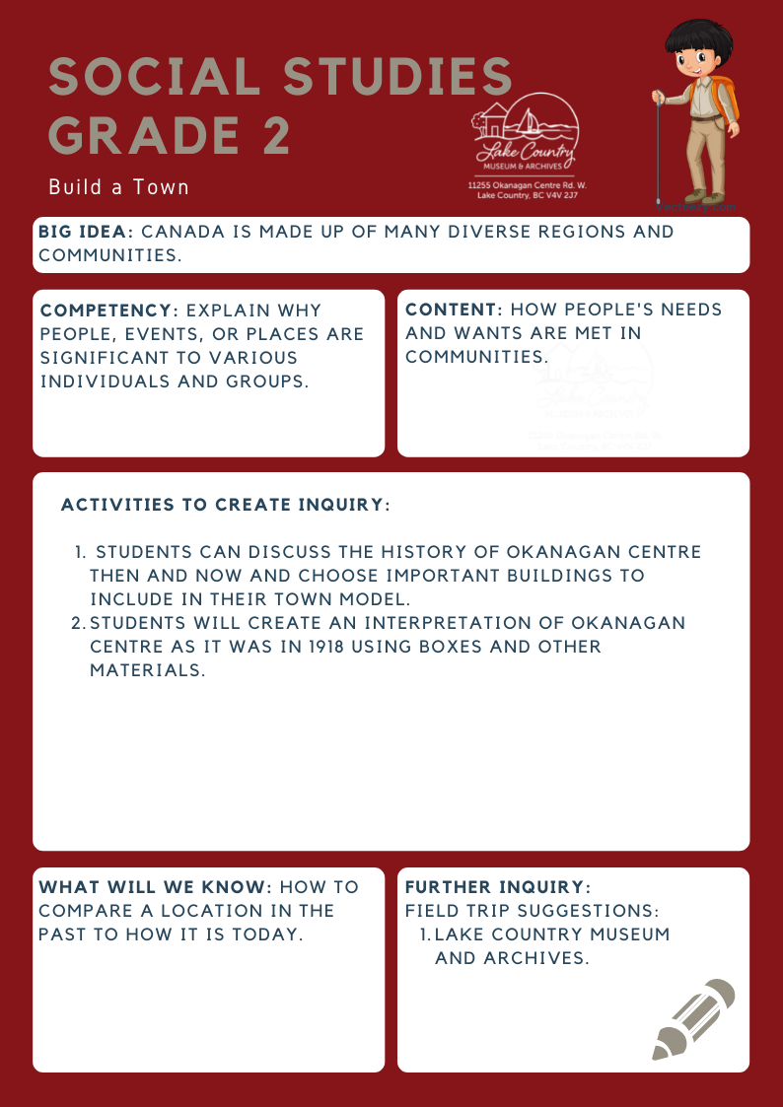
We respectfully acknowledge that the land on which the Lake Country Museum is situated, where this lesson was developed, is on the unceded territory of the Syilx (Okanagan) Peoples.

Copyright © 2021
Lake Country Heritage and Cultural Society
11255 Okanagan Center Road West
Lake Country, BC V4V 2J7

All rights reserved. No part of this publication may be produced, stored in a retrieval system, or transmitted, in any form or by any means, electronic, mechanical, photocopying, recording, or otherwise, without prior written permission of the publisher
Social Studies Grade 2: Build a Town
Learning Experience
Students will further their knowledge of Okanagan Centre in 1918, and decide which stores and amenities are of highest importance to the area. A model of the town based on the student’s choices will be created with various materials.

Objective | Students will learn about Okanagan Centre’s stores and amenities in 1918 and compare it to today. After selecting important locations, students can create an interpretation of Okanagan Centre using various materials.
Historical Reading | Okanagan Centre  For the first three decades of the twentieth century, Okanagan Centre was the commercial hub of the area that later became Lake Country. From the late 1800s to the 1930s, Okanagan Centre was one of the main shipping points for the central Okanagan and a major port for the sternwheelers. From this wharf, local apples, pears, and even cattle were shipped north to the railhead at Okanagan Landing and from there to points all over the world, while mail, supplies, and new settlers arrived.  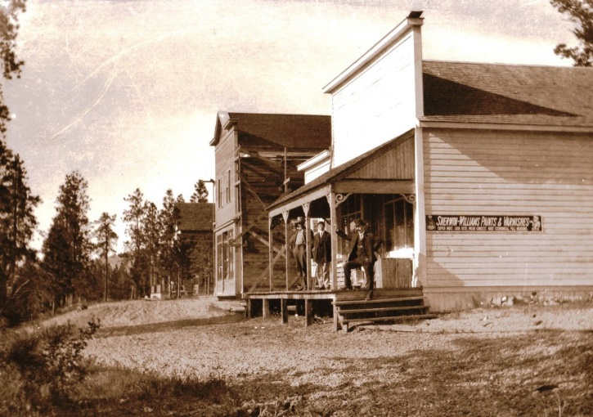  Main Street, Okanagan Centre, 1908 (LCMA)  By 1910, the town of Okanagan Centre had two hotels, the Grandview and the Westbury, a general merchant, and a hardware store. A school was opened in the newly built church, and ground was broken for a packinghouse and a cannery.  In 1925, the Canadian National Railway connected Vernon to Kelowna through a rail line along Wood Lake. Gradually, the transportation corridor moved from Okanagan Lake and Okana- gan Centre into the valley to the east and Winfield, and the rail- way and roads replaced the sternwheelers and freight barges.
Activity | Build a Town  After discussing what makes up a community now and what features a community had in 1918, students build a simulated community using boxes or other materials. Students will select what kind of building to design, such as houses, fire stations, churches, general stores, post offices, hospitals, packinghouses, farms, and ranches, and what features of the landscape were prominent in 1918.  When the student has his/her building complete the class will discuss where each will be placed in the community. Along with the building structures and features, roads and waterways need to be marked. Finally, add people from copies of the photographs.  Extension: Attach town model to a base or backing for a bulletin board display.
Further Inquiry | Field Trip Suggestions:  The Lake Country Museum and Archives  The Museum has a wide range of exhibits and activities for your class to explore. There is also a playground and field behind the building and the lake nearby that students can make use of for various activities.  There may be the opportunity for a guest lecturer to visit your classroom or be present at the museum with the knowledge of more local history stories. If interested, please contact the Museum ahead of time.  Suggested Readings:  LCMA website resource: Okanagan Centre School Days, by Osam Kobayashi  Okanagan Centre Registration List, 1918 (5 pages)  New York Public Library digital collection of menus, 1851 to 1930. Collector, Miss Frank E. Buttolph  http://digitalcollections.nypl.org/collections/buttolph-collection-of-menus

