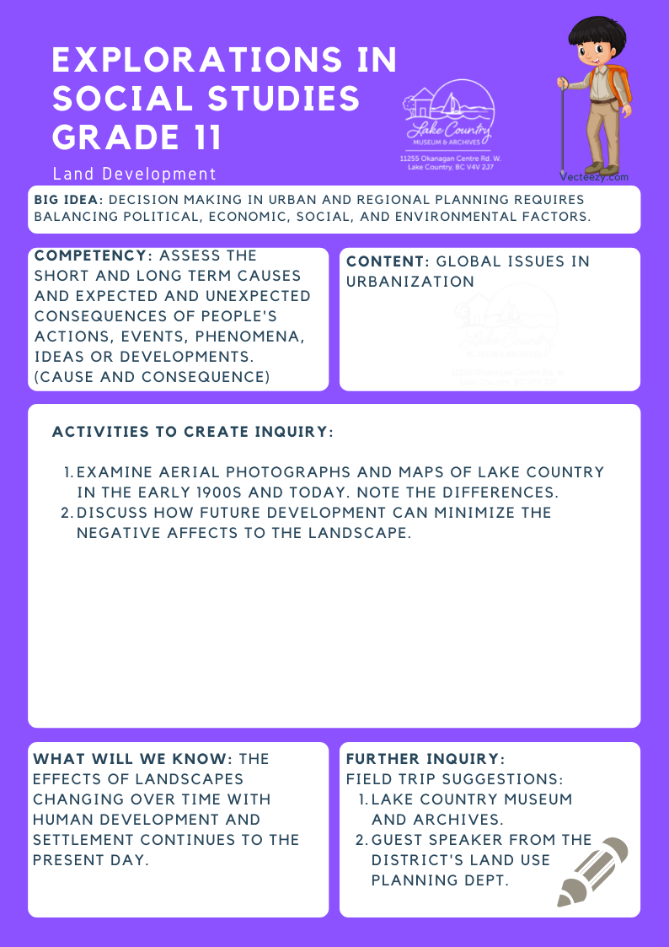
We respectfully acknowledge that the land on which the Lake Country Museum is situated, where this lesson was developed, is on the unceded territory of the Syilx (Okanagan) Peoples.

Copyright © 2021
Lake Country Heritage and Cultural Society
11255 Okanagan Center Road West
Lake Country, BC V4V 2J7

All rights reserved. No part of this publication may be produced, stored in a retrieval system, or transmitted, in any form or by any means, electronic, mechanical, photocopying, recording, or otherwise, without prior written permission of the publisher.
Explorations in Social Studies Grade 11: Land Development
Learning Experience
Students can analyze aerial photographs and topographical maps of Lake Country in order to identify changes in the landscape over time. Discussion can be held on how to mitigate negative effects on the land as a result of future development.

Objective | To strengthen an understanding of how the landscape in Lake Country has changed over time due to human development.
Historical Reading | The Okanagan Valley Land Company  The Okanagan Valley Land Company planted most of the first orchards in Lake Country.  In 1892, two brothers, Homer and Vincent Maddock, bought thousands of acres of land. The land went from the Rainbow Ranche south to McKinley’s Landing, and from Okanagan Lake east to the flats of Winfield and Thomas Wood’s ranch. The brothers were absentee owners, who lived in Eastern Canada. They were active in the development of the area although they didn’t move to Okanagan Centre until 1906.  The two brothers sold their holdings to the Trusts and Guarantee Co. Ltd. of Toronto in 1907. That company set up the Okanagan  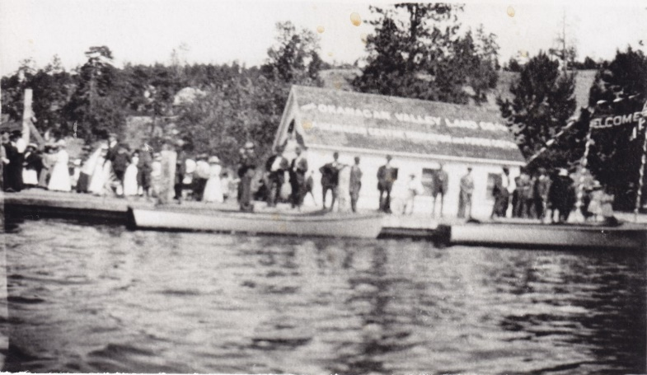  Opening the Okanagan Valley Land Company office, 1908  Valley Land Company Ltd. and the Okanagan Centre Irrigation and Power Company Ltd. to develop and sell the subdivided lands. Property was sold as ten-acre, twenty-acre, or larger lots for apple orchards. In Okanagan Centre, lots sold to build houses were narrow, only twenty-five metres (feet) wide.  There was no water source for the bench lands in Okanagan Centre. The Maddock brothers and the Okanagan Valley Land Company worked hard to find a water supply. At the time, the pumps, which were wind-powered, did not have the power to take the water for very long distances. They decided to run a water line from Beaver Lake. By 1909, the Okanagan Valley Land Company had completed the main line of an irrigation system to Okanagan Centre. This water source became the water system for most of the areas of Winfield and Okanagan Centre. The Maddock brothers played a major role in this important project.  In 1908, the Maddock brothers gave a plot of land to the community for a cemetery.  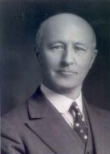  Homer Maddock, LCMA  Sources:  LCMA photographs: wooden irrigation flume, selection of aerial photographs  LCMA website resources: The Winfield, Okanagan Centre Irrigation District, 1908 – 1989, History Index: Irrigation System  LCMA video clip: Winfield Memories, by Hideo Tanaka: https://www.youtube.com/watch?v=D60K4aFyyQM District of Lake Country website resources: Water Services, video Flume: The Story of the Original Irrigation System in Oyama, by Jordie Starling: http://www.okanaganway.ca/municipal/municipal-services/water/  Okanagan Historical Society Report: Irrigation and Water Legislation in the Pioneer Years, by Lydia Baumbrough 43:5-10
Activity | Land Development!  Students can compare historical photographs with current aerial photographs and determine what factors influenced land-use decisions. They can evaluate the impacts of different land uses on an area and consider future changes in land use and the effect these might have on Lake Country.  Using a selection of aerial photographs and archival photographs, students can work in small groups to make note of changes to the landscape. Using a document reader or a projected digital image, groups can present their analysis of the changes, whether these changes are positive or negative and why, and their recommendations for future land use and development.  Discussion: Communities make land-use decisions every day. Take a look at areas surrounding large cities, in redeveloping downtown areas of older cities, and in the countryside and you'll see land-use changes.  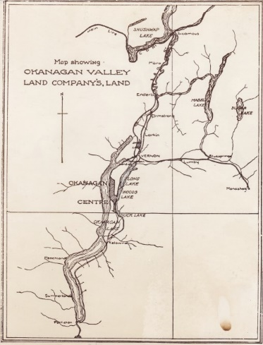  LCMA  Given the impact that humans have already had and continue to have on the land, a major challenge facing communities, both urban and rural, is how to plan for continued growth. What are the best ways to accommodate growth and minimize the negative impact on the existing community and the natural environment?  Extension: Guest speaker from the District of Lake Country, Land Use Planning Department.
Further Inquiry | Field Trip Suggestions:  The Lake Country Museum and Archives  The Museum has a wide range of exhibits and activities for your class to explore. There may be the opportunity for a guest lecturer to visit your classroom or be present at the museum with the knowledge of more local history stories. If interested, please contact the Museum ahead of time.

