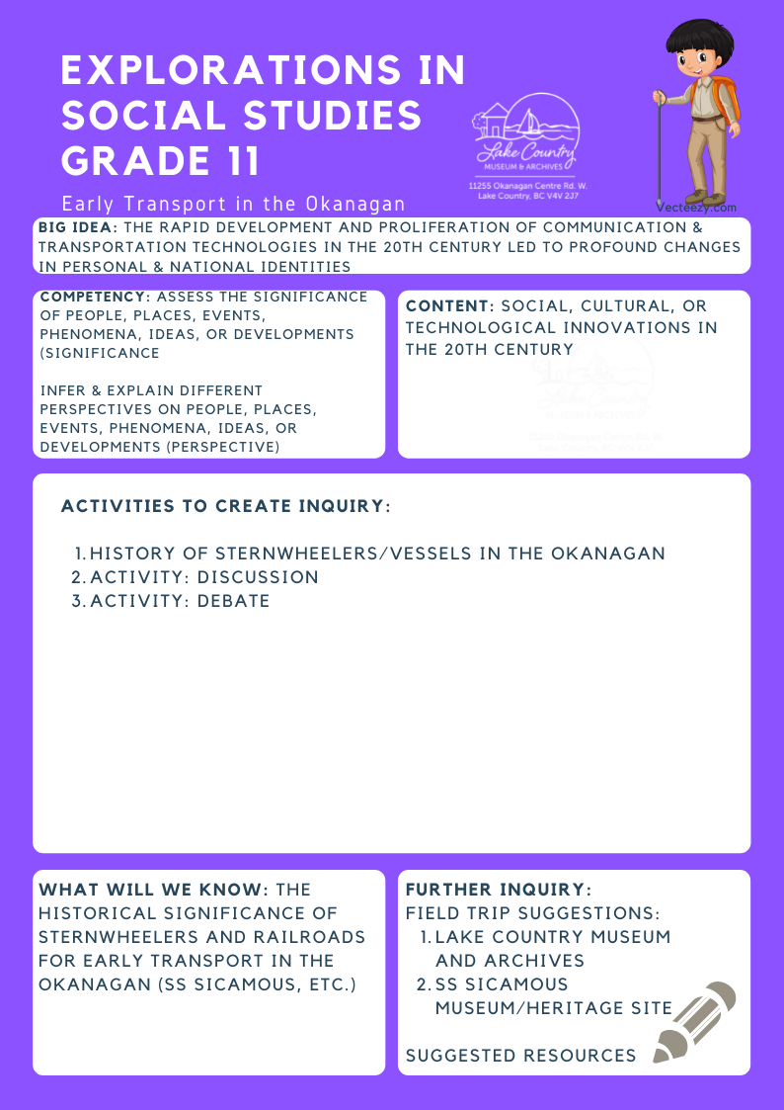
We respectfully acknowledge that the land on which the Lake Country Museum is situated, where this lesson was developed, is on the unceded territory of the Syilx (Okanagan) Peoples.

Copyright © 2021
Lake Country Heritage and Cultural Society
11255 Okanagan Center Road West
Lake Country, BC V4V 2J7

All rights reserved. No part of this publication may be produced, stored in a retrieval system, or transmitted, in any form or by any means, electronic, mechanical, photocopying, recording, or otherwise, without prior written permission of the publisher.
Explorations in Social Studies Grade 11: Early Transport in the Okanagan
Learning Experience
Students will explore the historical significance of boats (such as sternwheelers) in the Okanagan, specifically learning about the SS Sicamous. Additionally, students will explore why vessels like the SS Sicamous were eventually replaced by railways and roads, forming their own opinions based on research and arguing for or against designated modes of transportation.

Objective | To learn about the history and significance of boats (such as sternwheelers) in the Okanagan, as well as gain an understanding of why they were eventually replaced by railways and roads.
Historical Reading | The Sternwheelers of Lake Okanagan  The steamboat days began on April 21, 1886, with a small ship called Mary Victoria Greenhow. She was the first steam-powered vessel on the lake.  At first, the people on the shores of Okanagan Lake depended on the steamboat service provided by local firms, but soon the CPR sternwheelers took over and a new way of life began. For many years the picturesque sternwheeler passenger ships travelled up and down Okanagan Lake. They were a vital means of transport of the era. They are still remembered for their fine meals and comfortable accommodation.  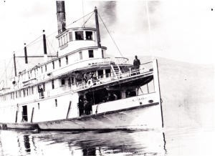  SS Okanagan on Okanagan Lake. This ship was built at Okanagan Landing in 1907. (LCMA)  At this time, the roads were very bad, and the closest rail connection was at Okanagan Landing. The townsfolk, farmers and ranchers used these charming ships as their main means of travel. They went on special excursions and moonlight dance cruises, picnics, regattas, and farm fairs. To the settlers homesteading on the side of a hill, watching the boat coming round the point was a highlight of their daily lives. It meant mail, supplies and perhaps a chance to visit with friends and neighbours on the wharf. As one old-timer put it, it made them feel far less isolated. For many, a round trip was the only vacation they could afford.  It was not uncommon for people to travel down the lake for dances and to socialize with friends and come back the next day. One person recalled that it was an entirely different way of life. People didn’t fret if the boat was late because they knew it would come eventually. The crews were a ‘fine bunch.’ and often helped beyond their duties.  Everyone spoke very highly of the superb meals. The tables were set with gleaming silver, spotless linen, and the CPR’s own monogrammed China and glass. There was always local fresh fruit and vegetables, with milk and cream from Fintry Farms and other lakeside dairies. And the menu was large, with a choice of as many as eight meat courses.  There was a quietness and a serenity in lake travel in those days.  Source: Staff of Vernon Museum. Steamboats of the Okanagan. Vernon, BC: Vernon Museum, 1978. p. 1.  The SS Sicamous  The SS Sicamous was one of three CPR sternwheelers connecting the communities along the shores of Lake Okanagan. Launched in 1914, the SS Sicamous ran for many years. It connected the rail lines at Vernon and Penticton to numerous wharves, including Okanagan Centre. The sternwheeler operated until 1935 and is now permanently beached in Penticton as a part of a heritage shipyard.  Other luxury-class sternwheelers carrying fruit, produce, dry goods, and passengers were the CPR’s SS Aberdeen and the SS Okanagan. Smaller boats, such as the SS Naramata, provided passenger service to other settlements around the lake.  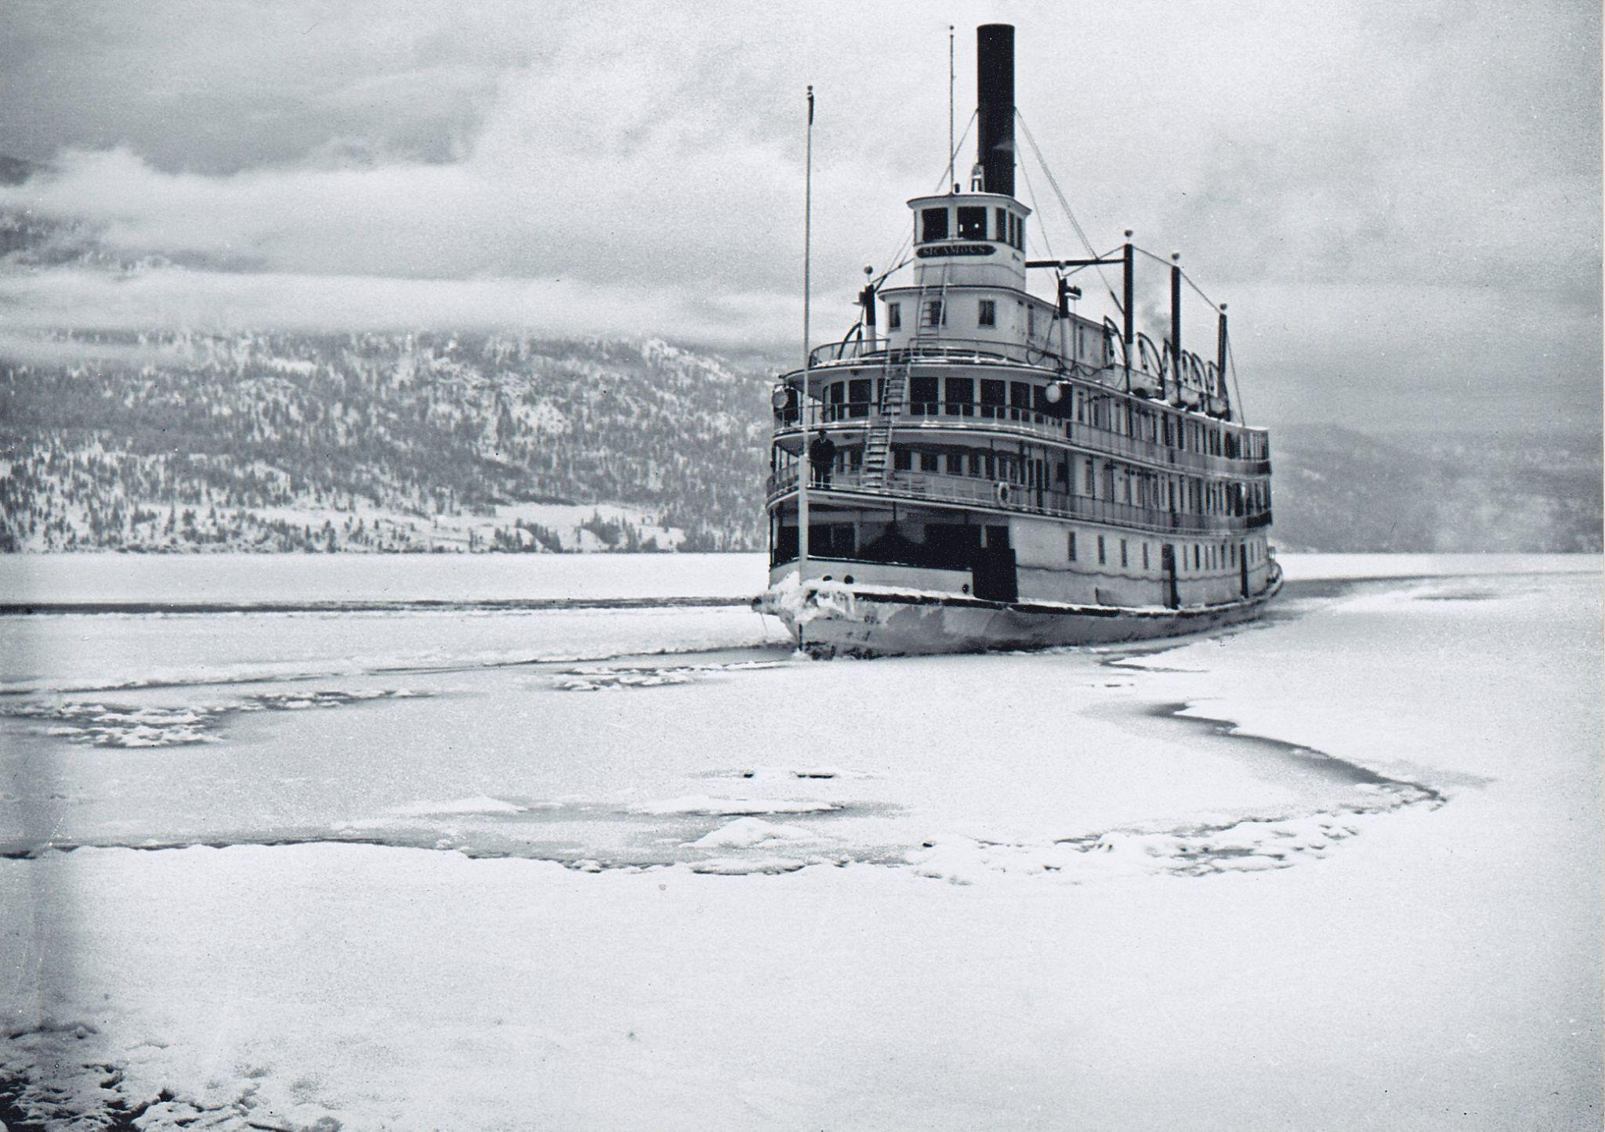  SS Sicamous travelling between the ice on Okanagan Lake, Winter.  (LCMA)  Okanagan Centre  For the first three decades of the twentieth century, Okanagan Centre was the commercial hub of the area that later became Lake Country. From the late 1800s to the 1930s, Okanagan Centre was one of the main shipping points for the central Okanagan and a major port for the sternwheelers. From this wharf, local apples, pears, and even cattle were shipped north to the railhead at Okanagan Landing and from there to points all over the world, while mail, supplies, and new settlers arrived.  By 1910, the town of Okanagan Centre had two hotels, the Grandview and the Westbury, a general merchant, and a hardware store. A school was opened in the newly built church, and ground was broken for a packinghouse and a cannery.  In 1925, the Canadian National Railway connected Vernon to Kelowna through a rail line along Wood Lake. Gradually, the transportation corridor moved from Okanagan Lake and Okana- gan Centre into the valley to the east and Winfield, and the railway and roads replaced the sternwheelers and freight barges.  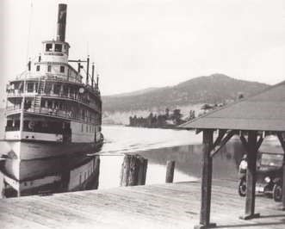  The SS Sicamous at Okanagan Centre wharf, 1926. Mr. James Gleed, postmaster is waiting at the dock to pick up the mail. (LCMA)
Activity | Activity #1: Discussion Prompts  - What were some benefits and drawbacks of using boats to transport people and goods around the Okanagan Valley?  - What were some benefits and drawbacks of using trains to transport people and goods around the Okanagan Valley?  - Which do you think was the better mode of transportation in the Okanagan Valley - boats or trains? Why?  - How did CPR installations (boats and railways) impact the local economy?  Activity #2: Sternwheelers vs. Railway Debate!  In this activity, students will be divided into three groups: sternwheeler stakeholders, railway stakeholders, and local government. Students can take on the role of the group they are placed in and hold a debate on which mode of transportation is better and should be invested in by the local government.  Students in the “sternwheeler stakeholder” and “railway stakeholder” groups can research the benefits and drawbacks of the method of Okanagan transportation they will be defending and begin to formulate arguments.  Students in the “local government” group will act as judges of the debate and should spend their preparatory time familiarizing themselves with background knowledge of the political, economic, and cultural climate of the Okanagan in the early 20th century.  The suggested amount of time to prepare for the debate is one hour.  The debate itself can include the following:  - Time for each stakeholder group to present their argument  - Time for the local government to ask each stakeholder group follow-up questions  - Time for the opposite stakeholder group to present challenges/a rebuttal to the presenting group  - Time for each stakeholder group to present closing statements  - Time for the “local government” to discuss and decide a verdict, and then present the verdict
Further Inquiry | Field Trip Suggestions:  - Lake Country Museum and Archives  - SS Sicamous Museum/Heritage Site (Penticton, BC)  Suggested Resources:  - LCMA website resources: Record of a Life, by Northcote Henry Caesar, Lakeboats of the Okanagan, by R. Bruce Goett  - SS Sicamous Society website: http://sssicamous.ca/about/  - The SS Okanagan, http://www.yourepeat.com/watch/?v=Ae9_OYSe3Q4  - “I Didn’t Enjoy that Meal”, excerpt from The Pioneer Years, by Barry Broadfoot  - Okanagan Historical Society Reports: Greenhow, Mary Victoria, 5:5 6:220, Capt. Thomas Dorland Shorts biography, 29:145-149  - Library and Archives Canada: Detecting the Truth. Critical Challenge - 2, Exploring the Historical Significance: http://collectionscanada.gc.ca/forgery/index-e.html

