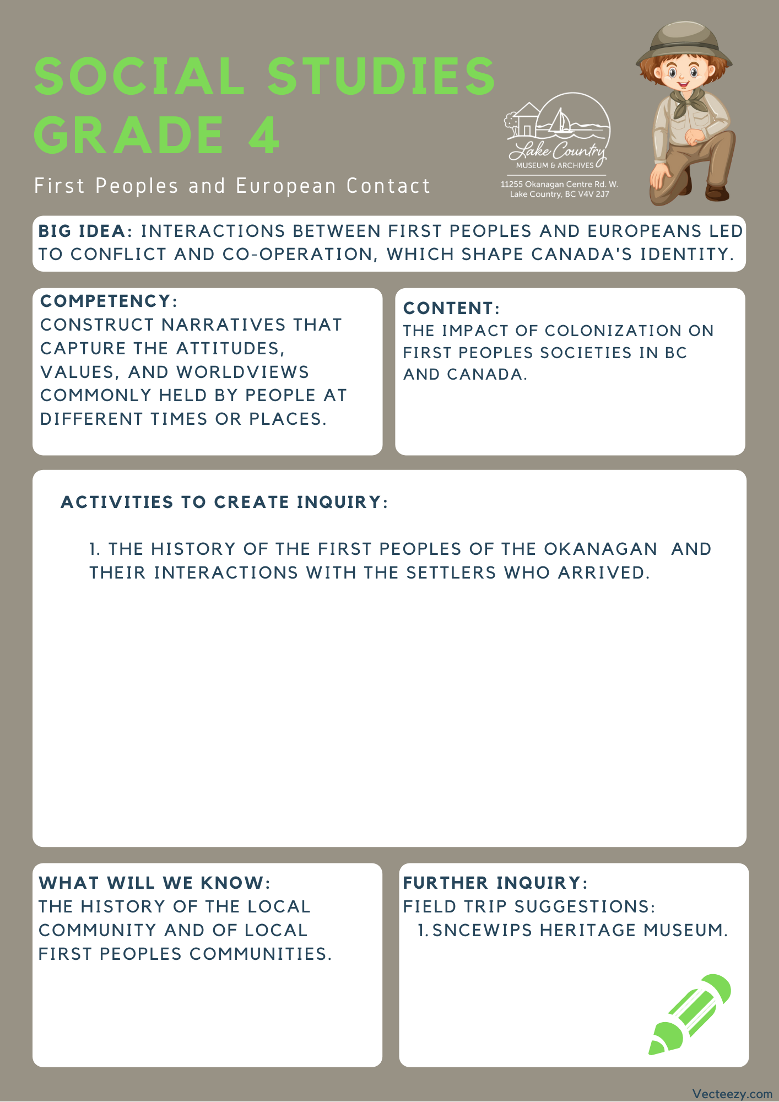

Copyright © 2020
Lake Country Heritage and Cultural Society
11255 Okanagan Center Road West
Lake Country, BC V4V 2J7

All rights reserved. No part of this publication may be produced, stored in a retrieval system, or transmitted, in any form or by any means, electronic, mechanical, photocopying, recording, or otherwise, without prior written permission of the publisher.

Social Studies Grade 4 - Lesson 2: First Contact
Learning Experience
Reading a narrative about the intended and unintended consequences in the pursuit of natural resources that resulted in changes to the land, people, and local community.

Intention | To understand how decisions and developments have a role in how the area changes.
Objective | To contemplate alternative outcomes in the early contact, trade, and conflict between the First Peoples and the European settlers.
Guidance | The Original People of the Okanagan  Before first European contact, Lake Country was home to the Syilx-speaking Okanagan Nation which had occupied the Okanagan Valley as early as 10,000 years ago. Their territory reached approximately 43,000 square miles and was bordered closely by other Syilx-speakers. Historians estimate a pre-contact population of 12,000.  The Syilx name for Winfield is K’lakokum, meaning “small enclosed land” or “the land between” and for the Oyama isthmus is Axts-luchus, meaning, roughly, a narrow crossing with thickly entwined willows. Arrowheads and spearheads of stone have been found on the shores of Carr’s Landing, offering evidence of Okanagan ties to the area.  The Okanagan people were known as great hunters, gatherers, and fishermen. Lake Country’s bottom and riparian lands provided lush vegetation, grasslands, wild fruits, herbs and roots which in turn supported herds of deer and other game. The late Ned Louis stated that “a long time ago the people went to Oyama in the fall to fish in Wood Lake”. Lake Country provided everything the Okanagan People needed during the warm months and they were able to gather, preserve, transport, and store food items for the winter months. They were a semi-nomadic tribe and  did not make a permanent home in the Lake Country area, but moved freely throughout Okanagan territory.  The Okanagan people had and still have a strong sense of family and community identity. They are a matrilineal people, keeping very close ties with their mother’s and grandmother’s lineages. The Okanagan Nation is well known for its precision tools and finely woven baskets made of birch bark or cedar roots.  The Okanagan people were great story tellers, using oral techniques to teach children and adults about their land and traditions. One of the central characters of their stories is  Coyote, or Sen’klip, who helped teach the people how to survive on this land. Thousands of years later, this knowledge is still embedded in the language.  After white men settled in the area, the government set aside reserve lands throughout the Okanagan, including one at the north end of Duck Lake. After 1877, many of the Okanagan people left Lake Country for other reserves. The Commonage, land between Okanagan Lake, Kalamalka, and Wood lakes  and as far south as Okanagan Centre, was set aside in 1876  as common grazing ground for cattle and horses belonging  to the Okanagan people and the settlers. A land claim of the Okanagan Indian Band #1 for title to the Commonage has yet  to be resolved.  The Okanagan people were known for their generosity and kindness. They were not a war-like nation and treated the early traders and missionaries with consideration, protecting them and sharing their store of food when they were in need. Unfortunately, the reserve system was used as a form of social control that allowed missionaries and governments to force religious and social values on the Okanagan people. From this treatment the Okanagan people are recovering and they still desire to live cooperatively and equitably with their neighbors.  (Written by Nikki Marchand in “The Original People of the Okanagan” from Spirit of Lake Country: Heritage and Culture)
Activity | Discussion Prompts:  - How has the Lake Country area since changed?  - How is the land being used now?  - Does the land still promote sharing and community?
Further Inquiry | Field Trip Suggestions:  The Lake Country Museum and Archives  The Museum has a wide range of exhibits and activities for your class to take advantage of. There is also a playground and field behind the building and the lake nearby that students can make use of for various activities.  There may be the opportunity for a guest lecturer to visit your classroom or be present at the museum with the knowledge of more local history stories. If interested, please contact the Museum ahead of time.  Visit the Sncewips Heritage Museum in Westbank to learn  more about the living history and heritage of the Syilx  Okanagan People. Set up a tour through the museum’s website: https://www.sncewips.com/  For further exploration and education, we recommend that you contact the Okanagan Indian Band Education Services Department. (link)

