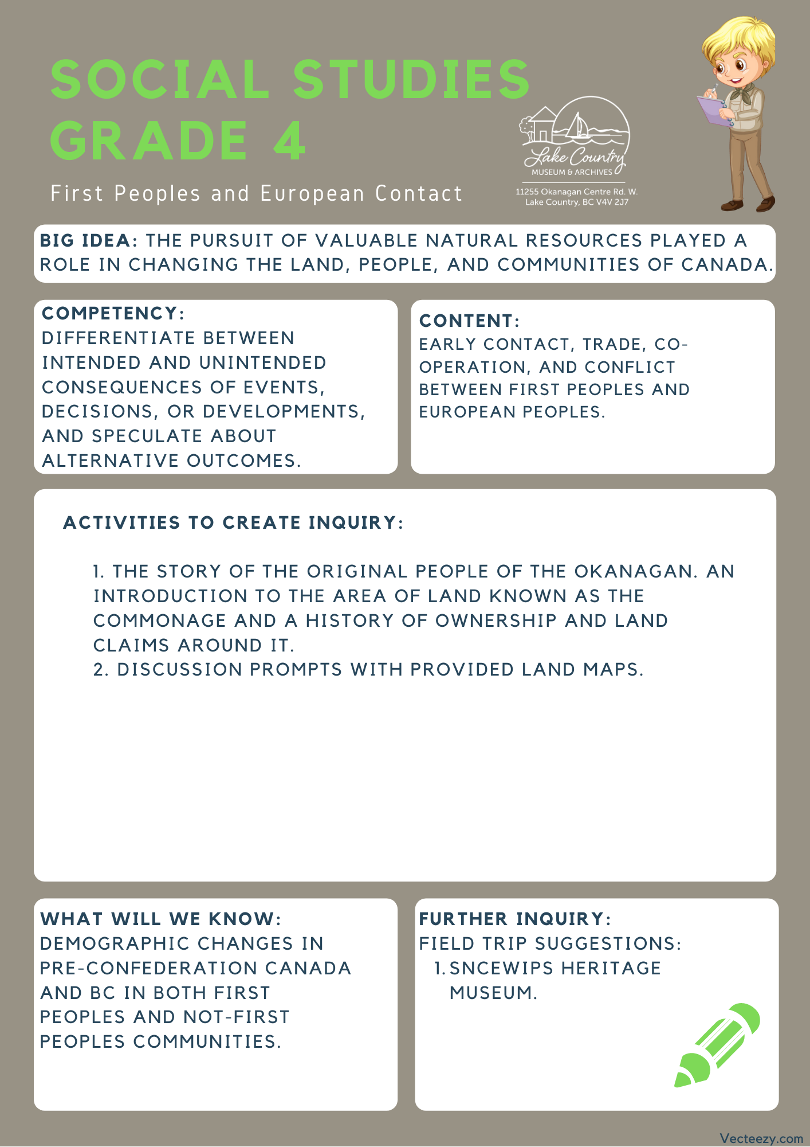

Copyright © 2020
Lake Country Heritage and Cultural Society
11255 Okanagan Center Road West
Lake Country, BC V4V 2J7

All rights reserved. No part of this publication may be produced, stored in a retrieval system, or transmitted, in any form or by any means, electronic, mechanical, photocopying, recording, or otherwise, without prior written permission of the publisher.

Social Studies Grade 4 - Lesson 1: The Commonage
Learning Experience
Reading a narrative on the impact of colonialization towards the First Peoples that captures the complex attitudes, values, and worldviews held by Canada at different times. Disclaimer: to share with the class, some of the terms used within The Commonage story reflect the beliefs and values at the time when referencing the people who lived there. The term “Indian” is no longer correct when referencing Indigenous nations, though it is still used in governmental policies and roles.

Intention | To understand the interactions between First People’s and European settlers, by looking specifically at the relations between settlers and the First Peoples of the area.
Objective | To look at how the government historically handled issues around land and the ongoing issues facing land claims and see how they are rooted in Canada’s history.
Guidance | The Commonage  The word ‘Commonage’ was derived from the contraction of ‘Common’ and ‘Pasturage’, meaning common pasturage. This means "... a large tract of land set aside for grazing purposes".  Many white settlers were arriving in the Okanagan valley. It was important to provide both the settlers and the Syilx Okanagan people, the First Peoples of Lake Country, a place to pasture their livestock. The Commonage area was, at that time, the vacant land available in the area. The area of the land planned for the Commonage was 25,114 acres. It extended from Okanagan Lake to Long Lake (Kalamalka and Wood lakes), north to today’s boundary of Vernon, and south to Okanagan Centre.  On May 8, 1876 an agreement was made that the Commonage was to be reserved from pre-emption for the use of the Syilx people and the settlers for pastureland. This agreement was signed by Indian Reserve Commissioner A. C. Anderson;  Dominion Commissioner Archibald McKinley, Commissioner for British Columbia; and Joint Commissioner G. M. Sproat.  However, in 1889, a new agreement was reached between British Columbia’s Chief Commissioner of Land and Works and P. O'Reilly and the Indian Reserve Commissioner. The new agreement stated that the provincial government would take over the Commonage and in return it would establish an Indian Reserve on the west side of Okanagan Lake.  In 1893, the government had the land on the Commonage surveyed into quarter sections which were then put up for sale. This land attracted speculators, developers and farmers to locations on Okanagan Lake. Small farming communities developed on the Commonage, including Sunnywold (Carr’s Landing) and Oyama.  Okanagan Indian Band Chief Murray Alexis of the Syilx Nation first brought its land claim for the Commonage lands forward  in 1989. The land claim for title to the Commonage has yet  to be resolved.  Pre-emption: A plot of land the settler could claim before the land was surveyed.  Land claim: A legal declaration by a First Nations band or government of desired control over areas of land. In Canada, land claims fall into two broad categories: comprehensive, known as modern treaties, and specific, which make claims based on pre-existing treaties, agreements, or reserves.  (Excerpt from Lake Country: Origins in Time and Place)
Activity | Introduction:  - Read the story of the commonage with the class.  - Display the Lake Country Museum’s Commonage map on page 4 and the closer version on page 5 to see how the area was used. The red line outlines the section used for the commonage while the yellow squares indicate how the land was divided up and who owned it.  - Next, display the maps provided on the West Bank First Nations website title Land Ownership & Roads Map (either an interactive map or downloadable PDF) to show where the reserve was moved to and how much of the land they were given. Bonus: can observe the Okanagan Nation Territory Map to see the traditional territory of the Syilx/Okanagan people.  Link: https://www.wfn.ca/business-development/maps-gis.htm  - Notice the changes to the land and follow the discussion prompts to encourage conversation.  Discussion Prompts:  - How has the land since changed?  - How is the land being used now?  - Does the land still promote sharing and community?
Further Inquiry | Field Trip Suggestions:  The Lake Country Museum and Archives  The Museum has a wide range of exhibits and activities for your class to take advantage of. There is also a playground and field behind the building and the lake nearby that students can make use of for various activities.  There may be the opportunity for a guest lecturer to visit your classroom or be present at the museum with the knowledge of more local history stories. If interested, please contact the Museum ahead of time.  Visit the Sncewips Heritage Museum in Westbank to learn  more about the living history and heritage of the Syilx  Okanagan People. Set up a tour through the museum’s website: https://www.sncewips.com/
(Images taken from Lake Country Museum and Archives.)
