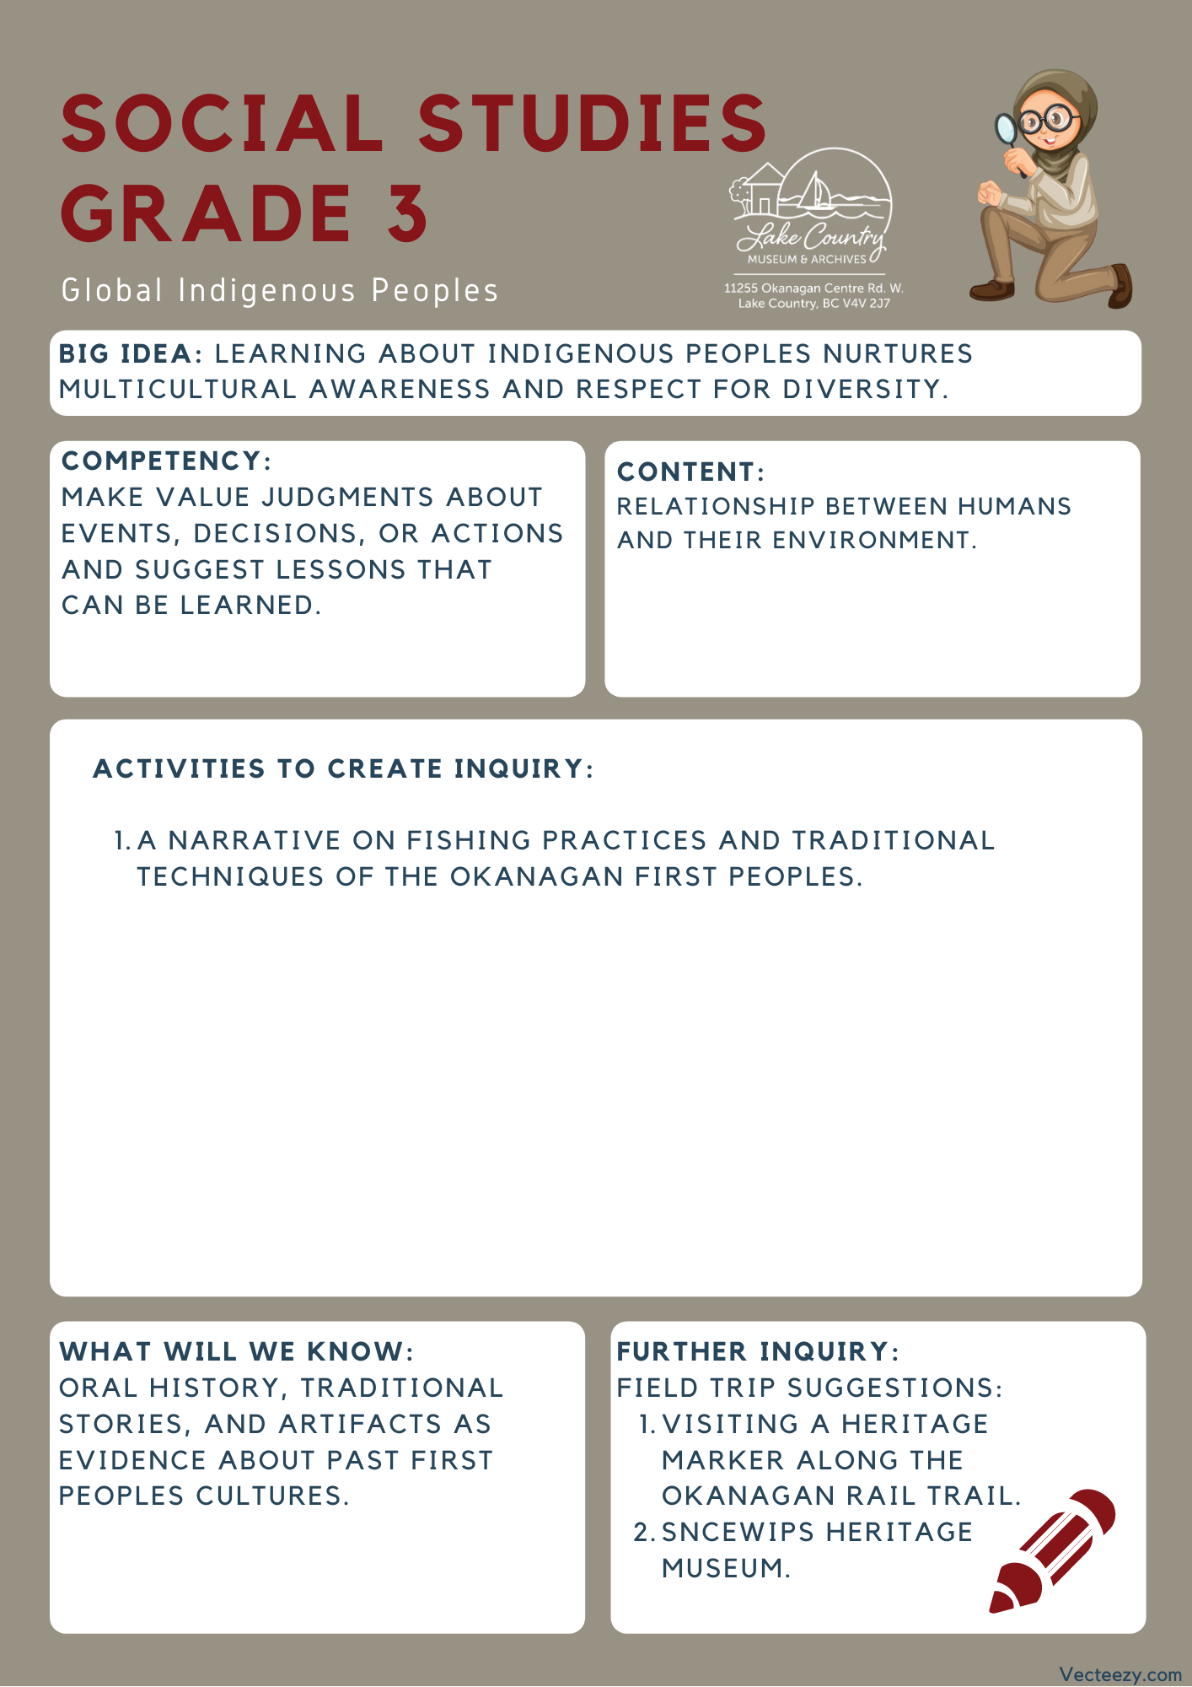

Copyright © 2020
Lake Country Heritage and Cultural Society
11255 Okanagan Center Road West
Lake Country, BC V4V 2J7

All rights reserved. No part of this publication may be produced, stored in a retrieval system, or transmitted, in any form or by any means, electronic, mechanical, photocopying, recording, or otherwise, without prior written permission of the publisher.

Social Studies Grade 3 - Lesson 2: Kikinee Fishing
Learning Experience
Through a narrative, students are exposed to accounts of how the Okanagan First Peoples used the environment to fish the lakes. Disclaimer: to share with the class, some of the terms used within this article reflect the beliefs and values at the time when referencing the people who lived there. The term “Indian” is no longer correct when referencing Indigenous nations, though it is still used in governmental policies and roles.

Intention | Through a historical narrative, students can learn more about the tools used and developed by the First Nations Peoples of the area.
Objective | Introducing the fishing practices of the Okanagan First Peoples, how they used the environment to created their equipment, and how they worked with nature to gather what they needed.
Guidance | Kikinee fishery at Ribbleworth Falls.  Okanagan Indian fishers caught Kikinee (Kokanee) all around Wood (formerly Pelmewash) Lake, including along the shoreline on both sides of Ribbleworth Falls. These fish were shore spawners that differed from their stream spawning cousins in a variety of ways, including the time of their spawn. Stream spawners generally returned to their natal gravel beds in September and shore spawners in late October. Okanagan Indian fishers took advantage of both fisheries, moving their camps to participate in the progressive harvest.  Two or three types of fishing technologies likely occurred along the eastern shore of Wood Lake, these in response to changing circumstances. To understand this evolution, one must consider the changing spawning habitat available to Wood Lake Kikinee.  Traditional Okanagan Fishing techniques  Immediately south of Ribbleworth Falls it is easy to imagine a shallow bay with a rock and gravel lakebed suitable for shore spawning. Shore spawners did not linger at the spawning site. Rather, large schools of Kikinee would descend upon the shore, females would lay eggs in gravel and in cracks between rocks, males would spread milt to fertilize them and the entire school would quickly leave in order to avoid predators such as Mergansers, Ling Cod and Lake Trout. Males might linger in the area for up to ten days after spawning.  This was a perfect environment for fishing with a mesh or seine net. An archaeological dig of a village site on the southwest corner of Wood Lake revealed a number of stone weights used to hold a net close to the bottom of the lake. The mesh nets and the floats used to keep the nets at the surface have not survived because of the vegetative nature of these instruments, but they are natural complements to the stone weights. The plant material used to make the mesh nets was, and still is, readily available along the shoreline of Wood Lake.  Pierre Logan of the Okanagan Indian Band, in an interview in 1950, recalled net fishing:” …Caught fish by getting a large net with men at each end, go out in water and sweep it into shore. Hemp for nets came from a weed, Spitsen….”  Louie Lewis, of Spahomin, elaborated on net construction: “In fall, they caught Kikinee with nets. Nets made out of weeds, Spitsen. Cords twisted on leg to make twine. Spitsen was the only plant used to make twine.”  Keith Louis, of the Okanagan Indian Band, still uses a seine net to capture shore spawners for research purposes.  There has also been evidence to suggest of using a throw net tossed from a rowboat in this vicinity. This was likely a lesser used fishing methodology suitable for shallow water fishing when fish were densely schooling.  Another method of canoe fishing was to use a three-pronged spear to plunk over a Kikinee and then to lift it into one’s canoe. Sometimes a torch was used to attract the fish to the immediate area. Two Lerman informants report on this method of fishing for Kikinee.  Gideon Eneas of Penticton recalled fishing from a canoe as a boy: “…The Kikinee spawn on Okanagan Lake along the shore –they do not go up the streams. Two men and a boy get in a canoe – one man to paddle and one to spear the fish. The boy carries a torch of pitch–pine sticks that are bound into a bundle with red willows or Saskatoon berry bush branches. He holds the torch behind the man with the spear so the light does not blind him. [Gideon] held the light when he was a boy and they camped near Peachland.”  Pierre Logan offers further detail: “Fishing – use pitch from top of a pine tree by cutting off the top of the tree and cut into sticks [that are then bound] together. One man holds the torch and another spears them. [The t]orch attracts some fish and shows others who are sleeping. Kikinees are [also] speared from the shore [sometimes] with the use of a torch….” Pierre made further comment: “For salmon --- dugout canoe. Get a bundle of pitch sticks, put in front of boat and light it and spear them. Wooden spear.”  Article written by Dr. Duane Thomson, the president of the Lake Country Heritage and Cultural Society and an Associate Professor Emeritus of History at the University of British Columbia. The Thomson family are long-time residents of the Oyama area of Lake Country.
Activity | Field Trip:  The Okanagan Rail Trail – Woodsdale Rd to Oyama boat launch.  There are historical markers along the Okanagan Rail Trail that talk more about the fish and fishing practices of the area. Visit the markers and trail to imagine what early life was like while opening room for class discussions.  Discussion Prompts:  - What considerations did the developers have when creating the Rail Trail? Possible suggestions would be land ownership or environmental impact.  - Is the trail an example of making something that goes with the environment, or an example of changing the environment to meet your needs? Why?  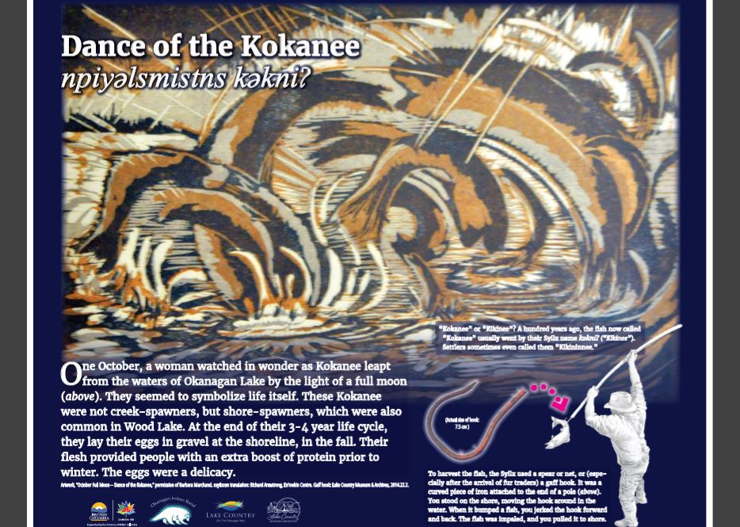  - How does the trail meet the needs of the local community today?
Further Inquiry | Field Trip Suggestions:  The Lake Country Museum and Archives  The Museum has a wide range of exhibits and activities for your class to take advantage of. There is also a playground and field behind the building and the lake nearby that students can make use of for various activities.  There may be the opportunity for a guest lecturer to visit your classroom or be present at the museum with the knowledge of more local history stories. If interested, please contact the Museum ahead of time.  Visit the Sncewips Heritage Museum in Westbank to learn  more about the living history and heritage of the Syilx  Okanagan People. Set up a tour through the museum’s website: https://www.sncewips.com/  For further exploration and education, we recommend that you contact the Okanagan Indian Band Education Services Department. (link)

