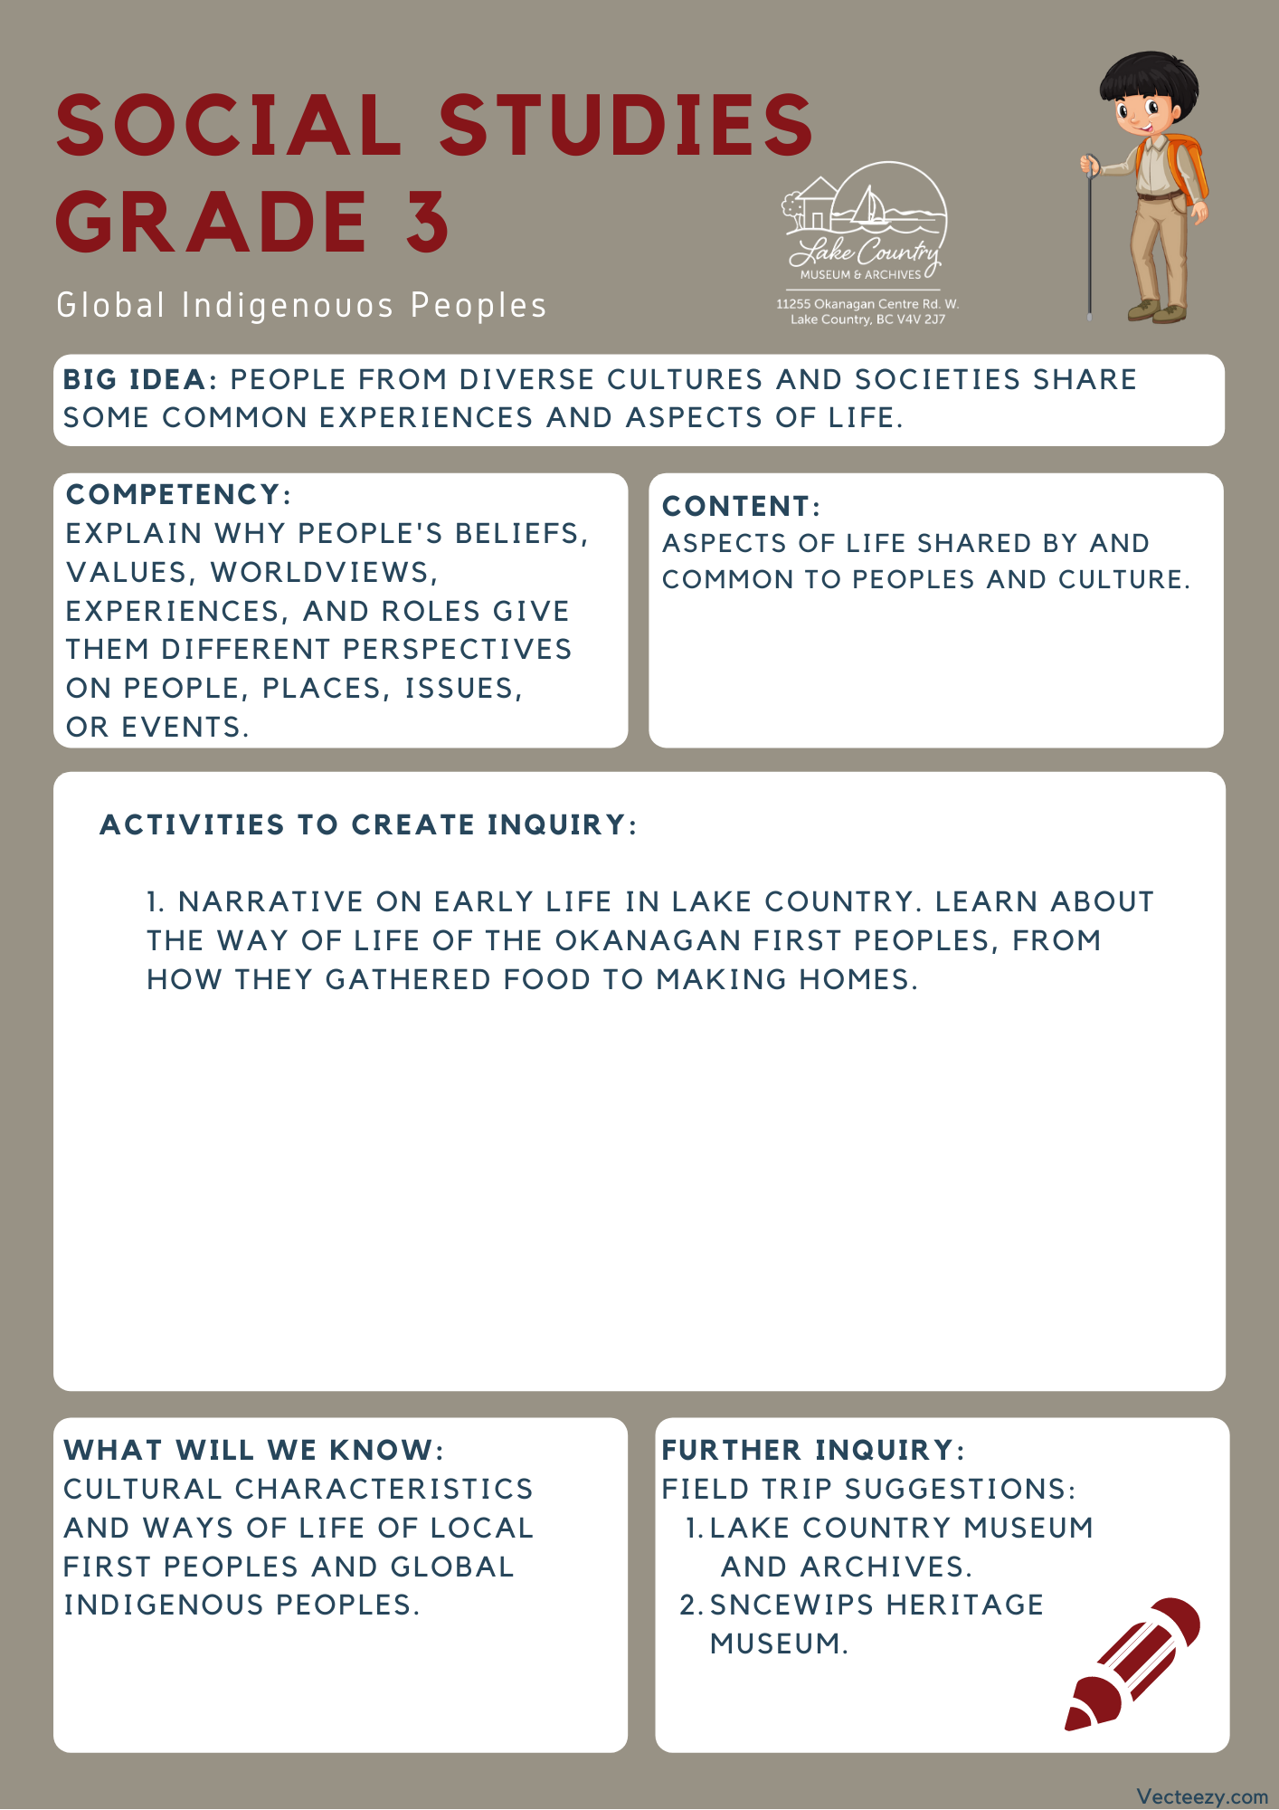

Copyright © 2020
Lake Country Heritage and Cultural Society
11255 Okanagan Center Road West
Lake Country, BC V4V 2J7

All rights reserved. No part of this publication may be produced, stored in a retrieval system, or transmitted, in any form or by any means, electronic, mechanical, photocopying, recording, or otherwise, without prior written permission of the publisher.

Social Studies Grade 3 - Lesson 1: Kekuli
Learning Experience
Students will learn from a narrative written about the early life of the First Nations Peoples in the Lake Country area. Disclaimer: to share with the class, some of the terms used within this article reflect the beliefs and values at the time when referencing the people who lived there. The term “Indian” is no longer correct when referencing Indigenous nations, though it is still used in governmental policies and roles.

Intention | To provide students with a greater understanding of the Okanagan First Peoples early life here in Lake Country, before settlers arrived.
Objective | Students will learn a narrative on how the Okanagan First Nations People gathered food and made their housing in the environment that surrounded them.
Guidance | Early Life in Lake Country  Before the coming of the white man, the fertile bottom land of Winfield was dense forest, with occasional oases of small natural meadows, while the present orchard benchlands were covered with pine trees, etc. Large herds of deer roamed the ranges and bunch grass was plentiful everywhere, and grew so tall and lush that anyone passing through left a trail of bent grass.  The lakes and creeks were abundantly stocked with fish, and there was a prolific supply of all kinds of wild fruits, herbs and roots, so that conditions were ideal for the earliest inhabitants — the First Nations People of the Salish tribe.  They were a nomadic people, following the seasonal berry and harvest, fish and game. As dwellings they used a lean-to made from saplings, chiefly evergreens or a mound-like dwelling covered with pile matting. Contrary to general belief, the tepee was not used by the Okanagan First Nations Peoples. Their winter habitations were of a more permanent nature, situated on or near the banks of a creek or adjacent to a lake.  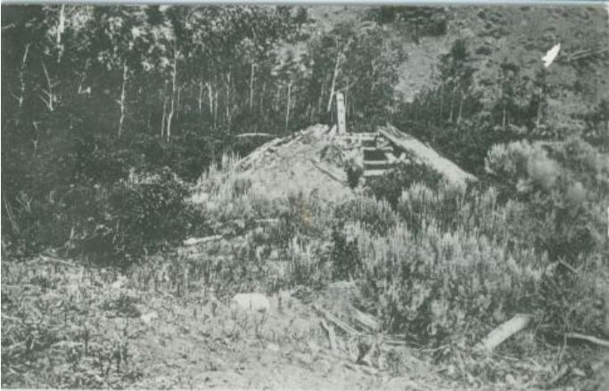  Kekuli or Pit House  In making these winter homes they excavated a circle from three to five feet deep, over which a framework of pole was erected. This formed the roof and was covered with coarse pile matting with earth laid on top of this. The sole entrance was from the centre of the roof, which served also as a smoke exit or chimney. A single pole, notched in the manner of steps, served as a ladder.  Less than 200 years ago the Salish Indians were in the same primitive state as were our for[e]bears, 2000 years ago in Western Europe!  (This article can be found on the Lake Country Museum and Archives website and is by Powley, Mrs. W. R. “Indian Life” in Winfield, 1958. Early days of Winfield. Mrs. W. R. Powley, comp. Winfield, BC: Winfield Women’s Institute for British Columbia Centenary, 1958. pp. 5-8.)  Discussion Prompts:  - How has this way of life changed for First Nations Peoples in the Okanagan now in comparison to the life described within the article?  - Looking at how the First Nations Peoples of the Okanagan lived, what can we gather about their resourcefulness?  - What are the differences between the houses the First Nations Peoples built and the ones we build now? Which use more resources? How is the environment affected by the construction of houses?
Further Inquiry | Field Trip Suggestions:  The Lake Country Museum and Archives  The Museum has a wide range of exhibits and activities for your class to take advantage of. There is also a playground and field behind the building and the lake nearby that students can make use of for various activities.  There may be the opportunity for a guest lecturer to visit your classroom or be present at the museum with the knowledge of more local history stories. If interested, please contact the Museum ahead of time.  Visit the Sncewips Heritage Museum in Westbank to learn  more about the living history and heritage of the Syilx  Okanagan People. Set up a tour through the museum’s website: https://www.sncewips.com/  For further exploration and education, we recommend that you contact the Okanagan Indian Band Education Services Department. (link)

