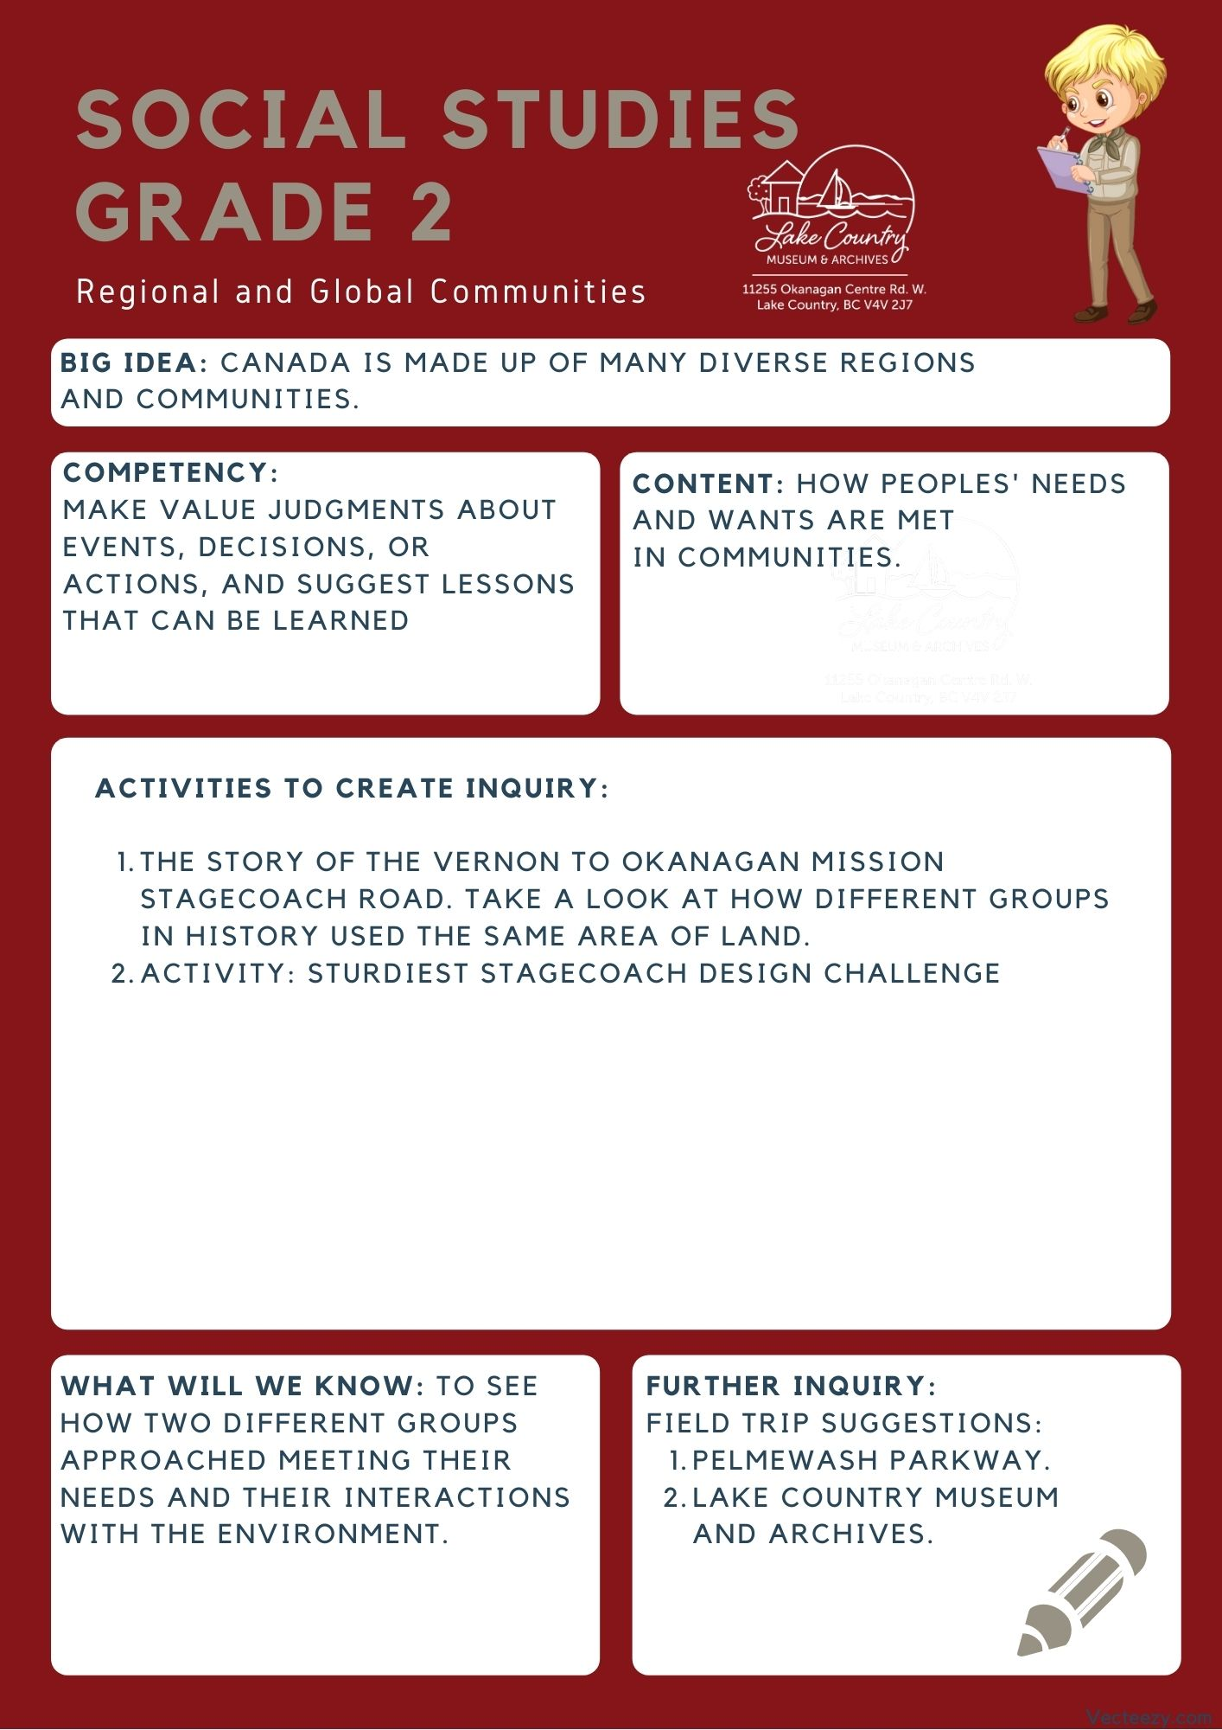We respectfully acknowledge that the land on which the Lake Country Museum is situated, where this lesson was developed, is on the unceded territory of the Syilx (Okanagan) Peoples.

Copyright © 2021
Lake Country Heritage and Cultural Society
11255 Okanagan Center Road West
Lake Country, BC V4V 2J7

All rights reserved. No part of this publication may be produced, stored in a retrieval system, or transmitted, in any form or by any means, electronic, mechanical, photocopying, recording, or otherwise, without prior written permission of the publisher.

Social Studies Grade 2: Stagecoach Road
Learning Experience
Reading a narrative about the development of the Stagecoach road and learning about how two groups interacted differently with the environment. As well as designing their own stagecoach that can traverse a road with obstacles.

Intention | To see how two different groups approached meeting their needs and their interactions with the environment.
Objective | Reading the different approaches the Okanagan Syilx people and the early settlers took to interacting with the environment.
The Story | Link to video narration: https://youtu.be/zKxTnvk2pLY  Today, if we wanted to drive from Kelowna to Vernon how would we get there? For most people, they would use a car and drive along the Highway. A smooth paved road, meant for a car to travel very quickly from one place to the other. What would that trip look like 100 hundred years ago? The same route would have been used, but it would have looked very different!  The Okanagan Syilx people, the first people to live in the Okanagan valley, made use of a route that followed the edges of all the Lakes between Kelowna and Vernon. This route today would be known as Highway 97. But back then it was called the “Stagecoach Road.” Ranchers, settlers, and Syilx people all used the same route going up and down the valley. How they used it was very different though!  The Syilx people moved with the environment, traveling along natural pathways to reach their destination to suit the needs of their people. The early settlers, in contrast, worked to make the land adapt to their needs. Building roads and cutting routes to other settlements to make travel easier and connect their communities. So if there was a hill, the Syilx people would go over or around it while the settlers would try to flatten it to make it easier to travel over. The Syilx people tried to keep the environment as it is, changing as little as possible. However, the Settlers were eager to repurpose the land around them.  Today, the most common way of travel is by car or by bus. That wasn’t the same a hundred years ago! Back then, traveling the Stagecoach Road would have been done most commonly with a horse and a stagecoach.  A Stagecoach is sort of like a car, but instead of it being powered by gasoline or electricity it was pulled by horses. Riding in one would certainly make for a bumpier ride that being in a car. Not to mention, road trips in a stagecoach would take significantly longer. But, that’s what these people had back then and they made good use of it!  A lot has changed between now and then. The Stagecoach road is now a highway. The route has even changed some, replacing the Pelmewash Parkway with a part of the highway that goes up over the hill. But, a lot has still stayed the same. Sure the method of travel has changed with cars. But we still go along a very similar route that our ancestors did hundreds of years ago.
Historical Context | The Vernon to Okanagan Mission Stagecoach Road  This route was first used by the Okanagan Syilx people following the contour of the lakes. Ranchers and settlers travelling up and down the valley used the same route. Late in the nineteenth century, the BC Government selected the route as one of the Okanagan first roadways. It was ‘to be completed by January 1st, 1876’.  The road was completed in 1875 and followed a high-level route. The road went south from Vernon over the Commonage and along Kalamalka Lake through to the Mission in Kelowna. The upper section of the route through Lake Country went from what is now Okanagan Centre Road East in Winfield to the Old Mission Road in Oyama. The mail stage along this route was operated by Walter Pritchard, Michael Healy, Sam Munson, William Scott (1907), and then by Jack Wyatt (1916).  (Excerpt from Lake Country: Origins in Time and Place, A Teacher’s Guide)  The story of the stagecoach road reflects the different approaches taken by the Okanagan Syilx people and the settlers. The Syilx people moved with the environment, traveling along natural pathways to reach their destination to suit the needs of their people. The early settlers, in contrast, worked to make the land adapt to their needs. Building roads and cutting routes to other settlements to make travel easier and connect their communities.  By manipulating the environment, they lived in, the settlers changed the use and purpose of the land around them  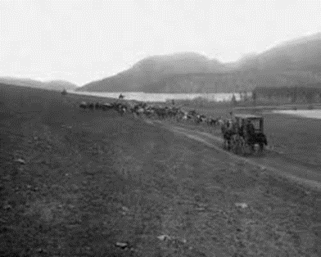  The Vernon to Okanagan Mission Stagecoach Road in 1890  When the Oyama Canal was built in 1908, the water levels in Wood Lake dropped by about 4 feet, this exposed a natural shelf along the lake that was then developed into an easier road route. This lakeshore route is along the area that is now known as the Pelmewash Parkway. The old stagecoach route became part of what is now known as Highway 97.
Activity | Before the activity starts:  - Have a plan in place for what obstacles the stagecoach road you build will have. This will completely depend on the resources you have available to you. Maybe you draw your stagecoach road in chalk out in the playground and have a few small rocks on the path? Maybe you bring things into your class to create the road? Completely up to you and what works well for your class.  - Aswell depending on the materials you have the students use, a talk about safely using them may be needed.  Materials needed:  - Popsicle sticks  - Wood glue or another adhesive  - Cardboard  - A few circular things for wheels (bottlecaps, milk caps, CD's, etc) (each group will need 4 wheels)  - Skewers or other thin wooden rods for the stagecoach axles (each group will need 2)  - String  - Sheet of paper so they can make paper dolls from  Sturdiest Stagecoach Activity:  Start the activity with a discussion on how people would have travelled between Vernon and Kelowna before cars were invented.  - What transport methods were used?  - What would the paths used have looked like back then?  Introduction:  - After sharing the story of the old stagecoach road with the class and asking some discussion questions, tell the students their goal for this activity is to build a stagecoach that can both hold 2 passengers (paper dolls, which they can draw and cut out themselves), and make it down the road you made by pulling their stagecoach by a string, without losing a passenger or breaking in the process.  - Students can work in groups for this activity if need be.  - Hand out the materials needed to make their stagecoach and paper dolls and let them work on designing their passengers and stagecoach in whatever way they think will bring the best result.  - If a student says they are ready to try the road, let them go for it. If it fails the test, ask them how they could make it better and have them work to update their stagecoach design to better suit the problem they are faced with. If they pass you could ask them how it would change their design if the road had more or different obstacles, or even get them to try to create another stagecoach/update theirs to make it better for a more challenging road.  (Because this is also about how we interact with our environment, if students decide that their passengers can move an obstacle or something along those lines, let them and ask them about it afterwards.)  For some steps on how to make a nice stagecoach out of these materials you can visit this website: https://thecraftyclassroom.com/crafts/pioneer-crafts-for-kids/covered-wagon-craft/
Further Inquiry | Field Trip Suggestion:  Field Trip to Pelmewash Parkway:  Pelmewash Parkway is a newly developed bike and walk-way located along Wood Lake. It follows along parts of the old Stagecoach road and the old Highway 97, and also serves as an example of how people continue to interact and alter the environment. Historical origins can be found on the Museum’s Pelmewash Parkway blog post.  - Is the Parkway an example of making something that goes with the environment, or an example of changing the environment to meet your needs? Why?  - How does the Parkway meet the needs of the local community today?  The Lake Country Museum and Archives  The Museum has a wide range of exhibits and activities for your class to take advantage of. There is also a playground and field behind the building and the lake nearby that students can make use of for various activities.  There may be the opportunity for a guest lecturer to visit your classroom or be present at the museum with the knowledge of more local history stories. If interested, please contact the Museum ahead of time.

