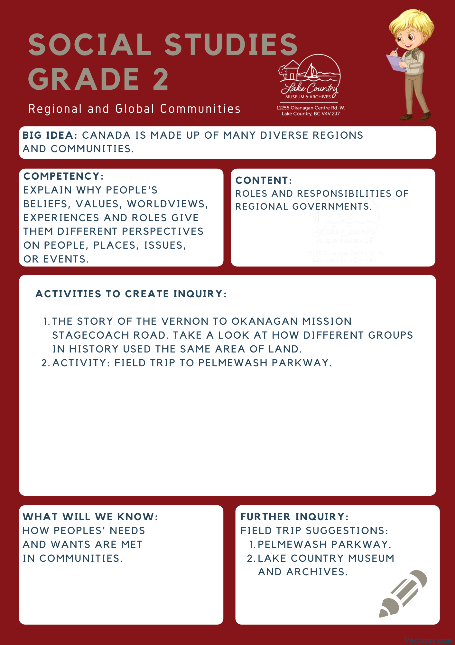

Copyright © 2020
Lake Country Heritage and Cultural Society
11255 Okanagan Center Road West
Lake Country, BC V4V 2J7

All rights reserved. No part of this publication may be produced, stored in a retrieval system, or transmitted, in any form or by any means, electronic, mechanical, photocopying, recording, or otherwise, without prior written permission of the publisher.

Social Studies Grade 2 - Lesson 2: Stagecoach Road
Learning Experience
Reading a narrative about the development of the Stagecoach road and learning about how two groups interacted differently with the environment.

Intention | To see how two different groups approached meeting their needs and their interactions with the environment.
Objective | Reading the different approaches the Okanagan Sylix people and the early settlers took to interacting with the environment.
Guidance | The Vernon to Okanagan Mission Stagecoach Road  This route was first used by the Okanagan Syilx people following the contour of the lakes. Ranchers and settlers travelling up and down the valley used the same route. Late in the nineteenth century, the BC Government selected the route as one of the Okanagan first roadways. It was ‘to be completed by January 1st, 1876’.  The road was completed in 1875 and followed a high-level route. The road went south from Vernon over the Commonage and along Kalamalka Lake through to the Mission in Kelowna. The upper section of the route through Lake Country went from what is now Okanagan Centre Road East in Winfield to the Old Mission Road in Oyama. The mail stage along this route was operated by Walter Pritchard, Michael Healy, Sam Munson, William Scott (1907), and then by Jack Wyatt (1916).  (Excerpt from Lake Country: Origins in Time and Place, A Teacher’s Guide)  The story of the stagecoach road reflects the different approaches taken by the Okanagan Syilx people and the settlers. The Sylix people moved with the environment, traveling along natural pathways to reach their destination to suit the needs of their people. The early settlers, in contrast, worked to make the land adapt to their needs. Building roads and cutting routes to other settlements to make travel easier and connect their communities.  By manipulating the environment, they lived in, the settlers changed the use and purpose of the land around them  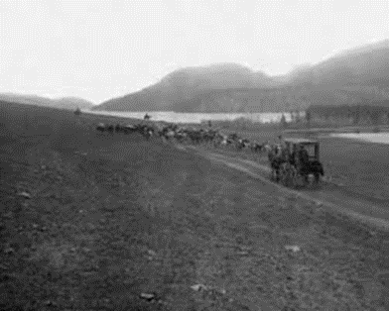  The Vernon to Okanagan Mission Stagecoach Road in 1890  When the Oyama Canal was built in 1908, the water levels in Wood Lake dropped by about 4 feet, this exposed a natural shelf along the lake that was then developed in to an easier road route. This lakeshore route is along the area that is now known as the Pelmewash Parkway. The old stagecoach route became part of what is now known as Highway 97.
Activity | Field Trip to Pelmewash Parkway:  Pelmewash Parkway is a newly developed bike and walk-way located along Wood Lake. It follows along parts of the old Stagecoach road and the old Highway 97, and also serves as an example of how people continue to interact and alter the environment. Historical origins can be found on the Museum’s Pelmewash Parkway blog post.  Discussion Prompts:  - What considerations did the developers have when creating Pelmewash Parkway? Possible suggestions would be land ownership or environmental impact.  - Is the Parkway an example of making something that goes with the environment, or an example of changing the environment to meet your needs? Why?  - How does the Parkway meet the needs of the local community today?
Further Inquiry | Field Trip Suggestion:  The Lake Country Museum and Archives  The Museum has a wide range of exhibits and activities for your class to take advantage of. There is also a playground and field behind the building and the lake nearby that students can make use of for various activities.  There may be the opportunity for a guest lecturer to visit your classroom or be present at the museum with the knowledge of more local history stories. If interested, please contact the Museum ahead of time.

