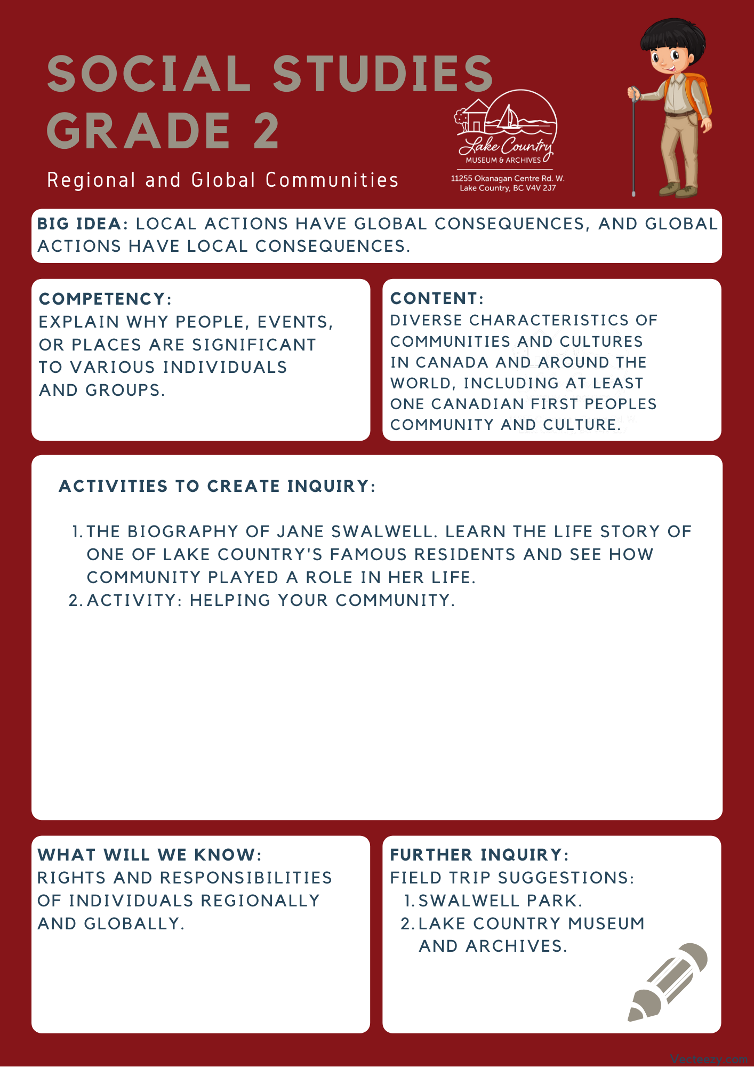

Copyright © 2020
Lake Country Heritage and Cultural Society
11255 Okanagan Center Road West
Lake Country, BC V4V 2J7

All rights reserved. No part of this publication may be produced, stored in a retrieval system, or transmitted, in any form or by any means, electronic, mechanical, photocopying, recording, or otherwise, without prior written permission of the publisher.

Social Studies Grade 2 - Lesson 1: The Biography of Jane Swalwell
Learning Experience
Reading a biography on one of Lake Country’s residents, Jane Swalwell, and learning about the impact she had on the community.

Intention | To learn about Eliza Jane Swalwell and the role she played in her community.
Objective | To learn how people and places can be significant to a community.
Guidance | Eliza Jane (nee Simpson) Swalwell was a well-known and much-respected Central Okanagan pioneer. She was born in the Okanagan on December 14, 1868, eldest child of George William Simpson (c1821-1902) and Sara Stepetsa (c1853-1901).  At the time of Jane’s birth, George and Sarah Simpson were living in what is now Vernon. The Simpson family moved to the south end of Duck Lake in 1870 where they had purchased property. Eliza and her family lived at the south end of Duck Lake until 1872, when the Postill family purchased that property and the Simpsons then moved to property to the south on Old Vernon Road, near what is now the Kelowna Springs Golf Course.  Growing up, Jane attended the Central Okanagan School (which is now known as the Lake Country Museum). Jane’s mother was a member of the Syilx nation; growing up Jane was fluent in both the English and Nsyilx’cen languages.  Jane Simpson was married twice: (1) Thomas Jones (circa 1839-1892) on April 6, 1884; (2) William Pellissier Swalwell (1855-1926; he was a cousin of the Postill family) on May 10, 1895. She had one child, Thomas William Jones, by her first husband.  Jane had different roles within the community. She assisted the local midwife and helped deliver children into the community and looked after the mothers during childbirth, but her main focus was always on her family. She kept close ties with her extended family (including the families of her siblings) and the community in the Duck Lake Reserve #7.  Jane Swalwell was also a talented writer, she contributed to the Okanagan Historical Society of Vernon, writing a piece for their eighth annual report. Her piece, entitled  Girlhood Days in Okanagan is a well thought out and reflective piece on life in her time and indigenous issues. Her writing showed us that Jane, herself, was quite the adept rider and horse handler; able to hold her own against any cowboy of the day. She was also extremely insightful towards matters involving the treatment of First Nation’s people, speaking for an equality that was almost unheard of in her time. She wrote in detail against the unfair treatment the First Nation’s peoples received at the hands of the provincial government.
Activity | The activity is to help students start thinking about how they can make an impact within their community. For the purpose of this lesson, the school will act as the role of the community in order to narrow down the focus. With guidance they will identify an issue within their school and its impact on their school community. They will draw their own conclusions on the issue and be given a variety of ways in which they can share their ideas.  Key Questions:  - What is a problem within the school? (i.e. litter, bullying, etc.)  - Who does this problem affect?  - How can I help?  Activity:  - Discuss some current issues in the local community. The students may need some guidance so have a few examples ready.  - Once a problem has been identified, ask the students who they think this problem affects. Write their answers on the board or anywhere where they can have a visual reminder.  - If you find they need more information to see how the issue affects others in the school; send the students in teams to go and ask specific individuals. For example, with littering, sending a couple of students to go and speak to a playground supervisor, another teacher, or the principal would be a great way for them to practice information gathering skills and to get another perspective of the school community needs.  - Next, have the students start to find a solution to the problem they chose. Some possible solutions for littering could be organizing school yard clean ups, helping gather recycling every week, etc.  - The main focus of this activity should be to help the students start to become aware that they are part of a larger community, and each and every member plays a role towards that community’s well-being.
Further  Inquiry | Field Trip Suggestions:  Swalwell Park in Lake Country – 9950 Bottom Wood Lake Rd.  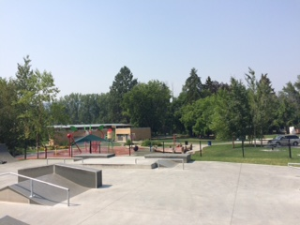  The park is a great location for outdoor activities and is within walking distance of Peter Greer Elementary school. The historical significance is also relevant as it was named after Jane Swalwell in 1992 in honor of her memory and the role she played in the community. The house she had built once stood near the entrance of where the park is today. For further reading on Jane Swalwell, please visit the following link:  The House that Jane Built  The Lake Country Museum and Archives  The Museum has a wide range of exhibits and activities for your class to take advantage of. There is also a playground and field behind the building and the lake nearby that students can make use of for various activities.  There may be the opportunity for a guest lecturer to visit your classroom or be present at the museum with the knowledge of more local history stories. If interested, please contact the Museum ahead of time.

