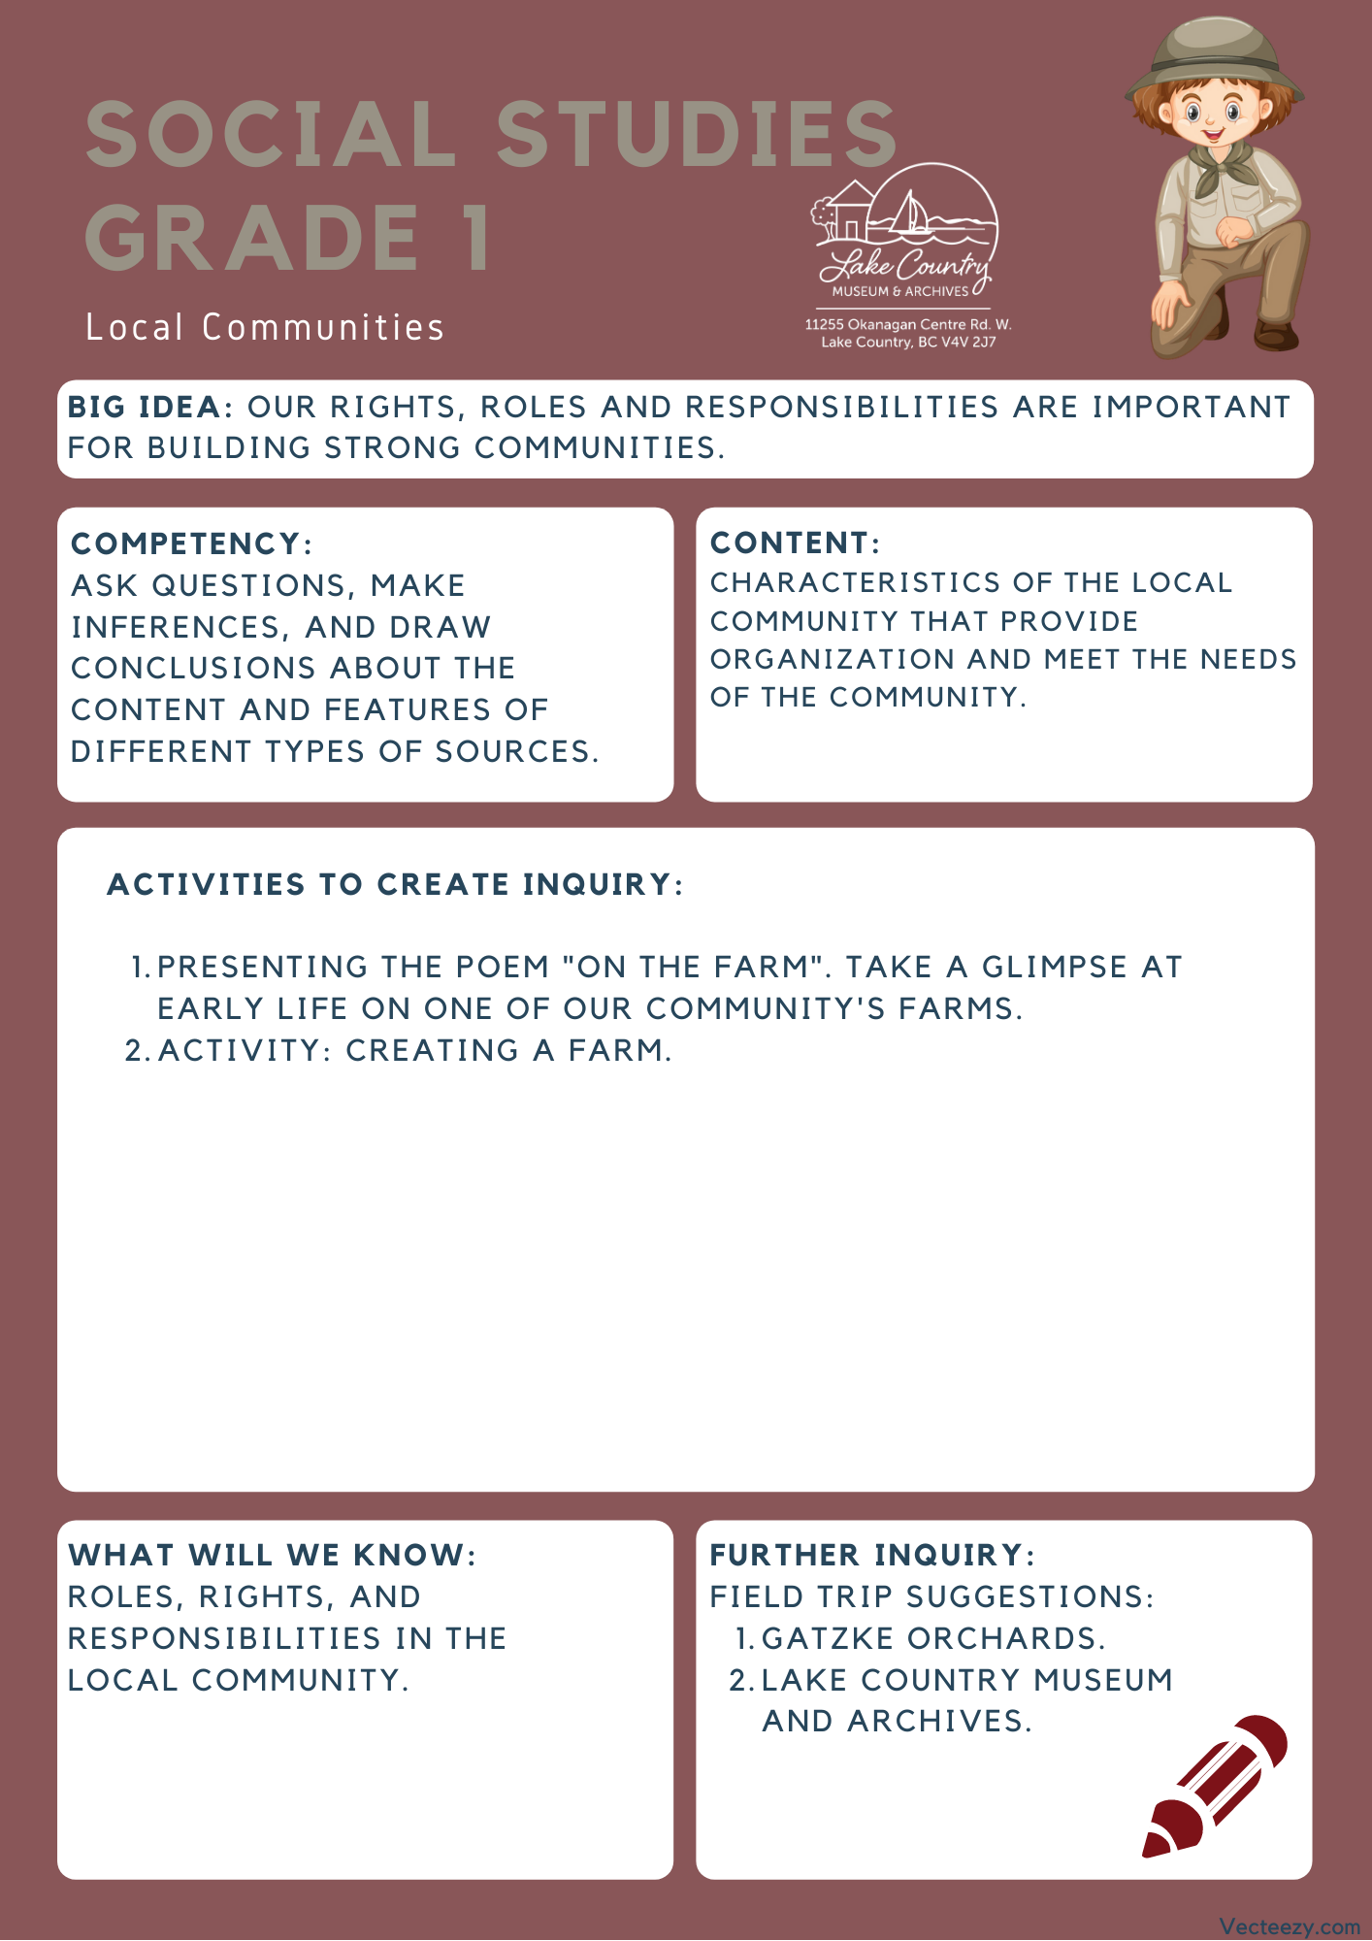

Copyright © 2020
Lake Country Heritage and Cultural Society
11255 Okanagan Center Road West
Lake Country, BC V4V 2J7

All rights reserved. No part of this publication may be produced, stored in a retrieval system, or transmitted, in any form or by any means, electronic, mechanical, photocopying, recording, or otherwise, without prior written permission of the publisher.

Social Studies Grade 1 – Lesson 3: On the Farm
Learning Experience
Reading “A Day on the Farm” poem. The students will inquire and explore what role a farm plays in its community and continue to learn about the diverse culture within Lake Country.

Intention | To have students think about what roles need to be played to meet the needs within a community.
Objective | Students will be introduced to the role farms play within a community through a poem written by one of Lake Country’s earliest residents.
Guidance | “A DAY WITH DAD ON THE FARM”  by Meiri (Koyama) Itami for Eijiro Koyama  A Day with Dad on the Farm  As certainly as dawn crept over the hills  he was awake. No clock rang by Dad’s bed;  Only that inner sense of knowing at the barn  the cows were waiting to be milked and fed.  But first the kitchen fire was carefully made,  Heaped high with wood from the bin beside the door;  The huge tea kettle filled, and placed just so  there would be water hot for breakfast time and more.  Upstairs I lay, half dozing, half awake,  knowing that soon I too must face the day;  Then footsteps, and the clank of milk pails came;  And I could hear Dad call, “Wake up!” no more delay.  ‘Twas quite the same, some toast of homemade bread,  and jam, from prunes that grew across the creek.  And milk, and tea, we’d eat together mostly,  through summer’s sunny hours, and winters bleak.  The old cream separator’s hum, I hear it now,  As round and round, the boys would daily turn;  and from the separator’s spouts the streams would flow,  Skim milk for calves, and cream for butter’s churn.  This chore, twice daily, we the girls would do,  To wash and dry the separator parts  Shake out the disks, put up the pails to dry,  We did it like all else, with all our hearts.  The fresh turned soil that called for seeding time,  And Dad and hired help obeyed that call.  With heart and hands and head, bent to the need  They toiled, rejoicing as the seeds would fall.  The love of earth, the love of life itself  Was in these men who toiled unselfishly;  ‘Til call to lunchtime came, to break their toil,  And bring a midday rest, relaxed and free.  Before night milking time, Dad homeward came  and laid his tools back in the shed once more.  Then off to milk, the cows must know his steps,  with pails in hand he tended to this chore.  We filled the bath with water from the creek,  The fire fed with wood we’d gathered ’round.  Dad first, the order never changed, we last.  Then on the steps, pick spears his socks had found.  The day near done, bathed, fed, and time for sleep;  A little reading rests the wearied mind,  Some apples from the cellar, crispy fresh,  Before we leave the toils of day behind.  Day in, day out, the months and years have passed  And chapters written thus in Dad’s life span  Have yielded life itself to us who come  Behind; to do our very best, we must, we can.  The little ups and downs we cannot know,  And greater things these pioneers of old  faced, solved, and worked to a successful end.  We know so little, so much yet untold.  The paths Dad trod, now dim, the footsteps still;  But memory lingers strong in us today;  We catch the gleam of a silvered brow held high  That dared to face the future, come what may.  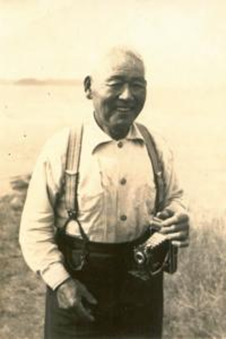  Eijiro Koyama  This poem was written in honour of the poet's father, Eijiro Koyama. Eijiro immigrated to Canada in 1899. He worked as a commercial fisherman on the coast and for the railroad. In 1904, he moved to Vernon to work at the Coldstream Ranch and eventually became the Ranch foreman. He married Fumi Fujioka in 1912. After several years at the Coldstream Ranch, Eijiro and Fumi moved to Winfield in 1916, purchasing 20 acres of land.  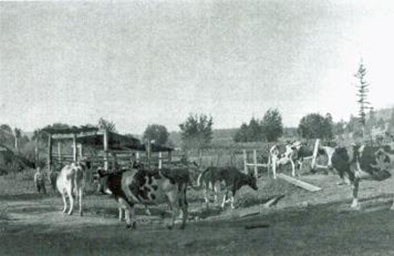  Koyama Farm
Activity | Start the activity with questions of what the students wonder and know about farms.  Introduction:  - Ask the students: “What do you wonder?” and “What do you know?”  - Explore their ideas and introduce ideas of what farms may provide for their communities.  - Write down on the board or a large sheet of paper the student’s explorations.  Create a Farm Activity  - After reviewing the previous discussion about farms, decide how creative you wish the students to be, from having them draw a farm to building one using materials such as plasticine, Lego, paint, etc.  - Hand out any required materials and give the students time to work (suggestion 20-30 min.).  - When finished have the students describe to you what they have created and ask them what their farm makes for  the community.
Further Inquiry | Field Trip Suggestions:  Gatzke Orchards  A local farm and business that has a long history in the Lake Country community.  The Lake Country Museum and Archives  The Museum has a wide range of exhibits and activities for your class to take advantage of. There is also a playground and field behind the building and the lake nearby that students can make use of for various activities.  There may be the opportunity for a guest lecturer to visit your classroom or be present at the museum with the knowledge of more local history stories. If interested, please contact the Museum ahead of time.

