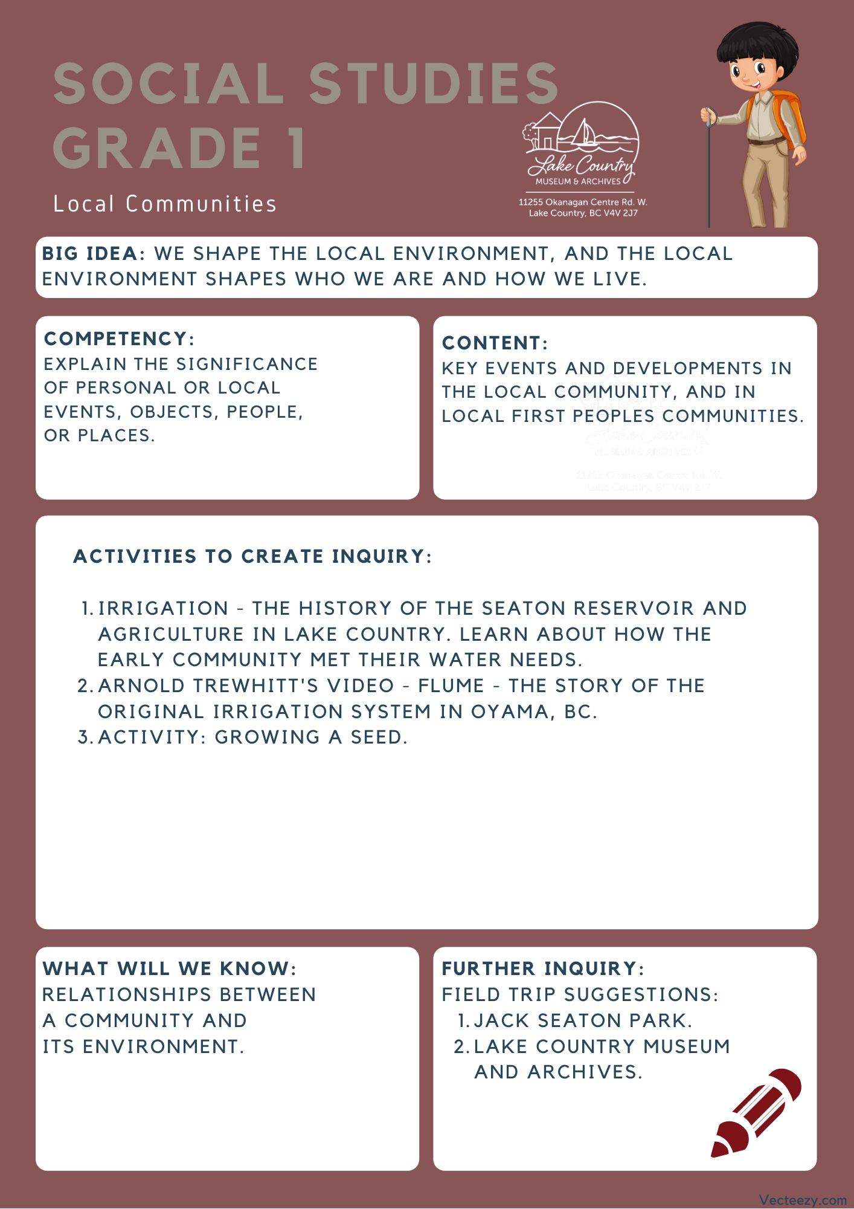

Copyright © 2020
Lake Country Heritage and Cultural Society
11255 Okanagan Center Road West
Lake Country, BC V4V 2J7

All rights reserved. No part of this publication may be produced, stored in a retrieval system, or transmitted, in any form or by any means, electronic, mechanical, photocopying, recording, or otherwise, without prior written permission of the publisher.

Social Studies Grade 1 - Lesson 2: Irrigation
Learning Experience
Reading a narrative on the Lake Country settlers establishing their irrigation for the farms and community with an activity for students to learn about the process of growing and caring for a seed.

Intention | Looking at local history to see how the community interacts with the environment, with a focus on the early irrigation system and its importance to the community.
Objective | Students will learn about the Seaton Reservoir and its importance to the Lake Country community. They will also learn about the Oyama flume and watch a video of the original flume irrigation system in Oyama, BC as told by Arnold Trewhitt, the Wood Lake Water Company's former Director and Water Bailiff.
Guidance | Lake Country’s Irrigation  The key to growing agricultural crops in the Okanagan Valley was, and is, water. Without it, the land reverts back to its natural state of bunch grass and pine trees.  Government water policy was first formed back in the placer gold mining days of the 1850s and was changed and added to over the years as necessitated by conditions. As agricultural settlement increased, in fact boomed, after 1890 so did the need for irrigation water in the Interior Dry Belt of which the Okanagan was part. Since the amount of water was limited, competition for it was intense, and, as before, the first to apply got the first water right from that source.  With a poor, or non-existent, infrastructure, the British Columbia Government did not really have control of the water as it lacked an agency devoted to water rights. This changed in 1909, when the revised Water Act provided for a Water Rights Branch.  At first, agricultural water rights were generally taken out by individuals. This changed in the Okanagan as development companies came on the scene at the beginning of the twentieth  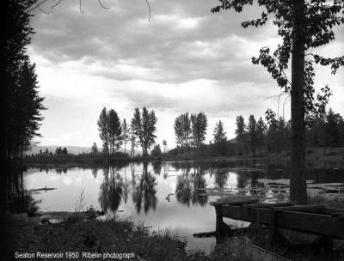  century opened up blocks of land for settlement. In order to sell the lands, these companies had to provide irrigation water and so applied for water rights. Usually these rights were turned over to water companies composed of the land purchasers thus giving those users control of their water.  Seaton Reservoir 1950  There was a reservoir near the top of the ridge on Camp Road just west of the entrance to Seaton Park. It is overgrown now. An old section of wooden irrigation pipe leading from this reservoir can still be seen sticking out of the bank above Tyndall Road near Camp Road.  (Written by Ken V. Ellison in “Irrigation” from Spirit of Lake Country: Heritage and Culture)  This reservoir was essential to the Lake Country Community, as it was the source of irrigation for many of the local crops. Having a secure, dependable irrigation water supply is important to maintaining production in dry years.  Ken Ellison’s story of the Lake Country Flumes on YouTube  Search: Flume - The story of the original irrigation system in Oyama, BC by Starling Video  Background from the Museum’s Blog:  Fourteen years ago (2000) Ken Ellison published a book, Irrigation is King: A Century of Water in Oyama, BC. 1892-2000. This work exhaustively examined and interpreted the land, water and irrigation records of Oyama, BC. Now, a complementary video, Flume. The story of the original irrigation system in Oyama, BC, has been produced by Jordy Starling of Oyama.  Starling’s presentation features and honours his grandfather, Arnold Trewhitt, who was the last water bailiff for the Wood Lake Water Company. It is a compelling video presenting Trewhitt’s narrative and is supported by excellent photographs, maps and graphics.  Trewhitt focuses on the community of fruit farmers who established Oyama and who were bound together by the water distribution system of open flumes. Water was the life-blood of the community and Trewhitt prides himself as being the water bailiff or custodian who visited every farmer every day, regulating, conserving, and efficiently delivering precious water to each farm. He reminisces about an era of farmer democracy and community involvement.  This video is a wonderful celebration of the historic community of Oyama. While Oyama has changed with the arrival of numerous non-farmers, the character of Oyama remains.  The Lake Country Heritage and Cultural Society thanks Jordy Starling for this thoughtful video presentation.
Activity | Water plays an essential role for both the environment and human needs. Have the students brainstorm and discuss what they need water for to lead into a conversation about the environment and the world’s relationship with it. Start with having the children think about what water can be used for and then expand from there.  Showing the value of water when it comes to growing seeds in the following activity will help students start to make connections to the importance of reservoirs and irrigation. It may also be beneficial to give the students something to compare their  seed growth with, like having a seed without giving it water to highlight the value water plays.  Growing a Seed:  Paper towels, filter paper or even newspaper provides an excellent environment for growing seeds. They are pathogen-free and make it easy to control the moisture content for proper germination and allows for the students to easily observe them throughout the full process.  Materials Needed:  - Paper towels or filter paper  - Ziplock Sandwich Bags  - Live seeds (about 5 per student), like peas, beans, or squash which are fast-growers  Introduction:  - Gather the students and review previous discussions about water and what we need it for.  - Read a story/song/activity that focuses on needing water to grow. A suggestion would be “The Carrot Seed” by Ruth Krauss. Here is a link to a Youtube reading of the story that would be appropriate for a class of children: https://www.youtube.com/watch?v=t_bKqYUc-2M  - Afterwards tell the children that today they are going to start growing a seed of their very own.  Teacher Example:  - Tear a paper towel in half and moisten one of the halves.  - Place four or five seeds on half of the paper and fold the other half over the seeds.  - Blow open a clear, sandwich size zip-close bag.  - Place the paper with seeds inside and reseal the bag.  - Set the bag anywhere out of direct sunlight that stays at room temperature. The bag acts like a miniature greenhouse that retains heat and moisture. You should observe seeds sprouting in about five to seven days.  Students Practice:  - Make sure every student has paper towel, seeds, and a Ziplock bag at their desk.  - Guide students through the steps that you went through, this may require moving around and assisting with the moistening of half of the paper towels.  - Take time, making sure the students are all on the same step as you move them through and once they all have their seeds in the bags, you can take the bags to the sunlight area individually (or in small groups).  Tracking Seed Growth:  - You want to make sure that the seeds are still visible in the bags so the students can observe them grow. How the students can track the progress is up to you, one suggestion could be that they write weekly observations (or daily if you prefer) in a class journal.  - The timeline of the seed’s growth should be as follows:  - Within 24 hours: Seeds should show signs of sprouting (starting to ‘pop’ out of their shells)  - 3 to 7 days: Seeds should be fully sprouted  - 7 to 10 days: leaves start to emerge
Further Inquiry | Field Trip Suggestion:  Jack Seaton Park in Lake Country: 1960 Camp Rd.  There was a reservoir near the top of the ridge on Camp Road just west of the entrance to Seaton Park, though it is now overgrown. An old section of wooden irrigation pipe leading from this reservoir can still be seen sticking out of the bank above Tyndall Road near Camp Road. Jack Seaton Park is also a great area for a number of outdoor activities do with the class.  Lake Country Museum and Archives  The Museum has a wide range of exhibits and activities for your class to take advantage of. There is also a playground and field behind the building and the lake nearby that students can make use of for various activities.  There may be the opportunity for a guest lecturer to visit your classroom or be present at the museum with the knowledge of more local history stories. If interested, please contact the Museum ahead of time.

