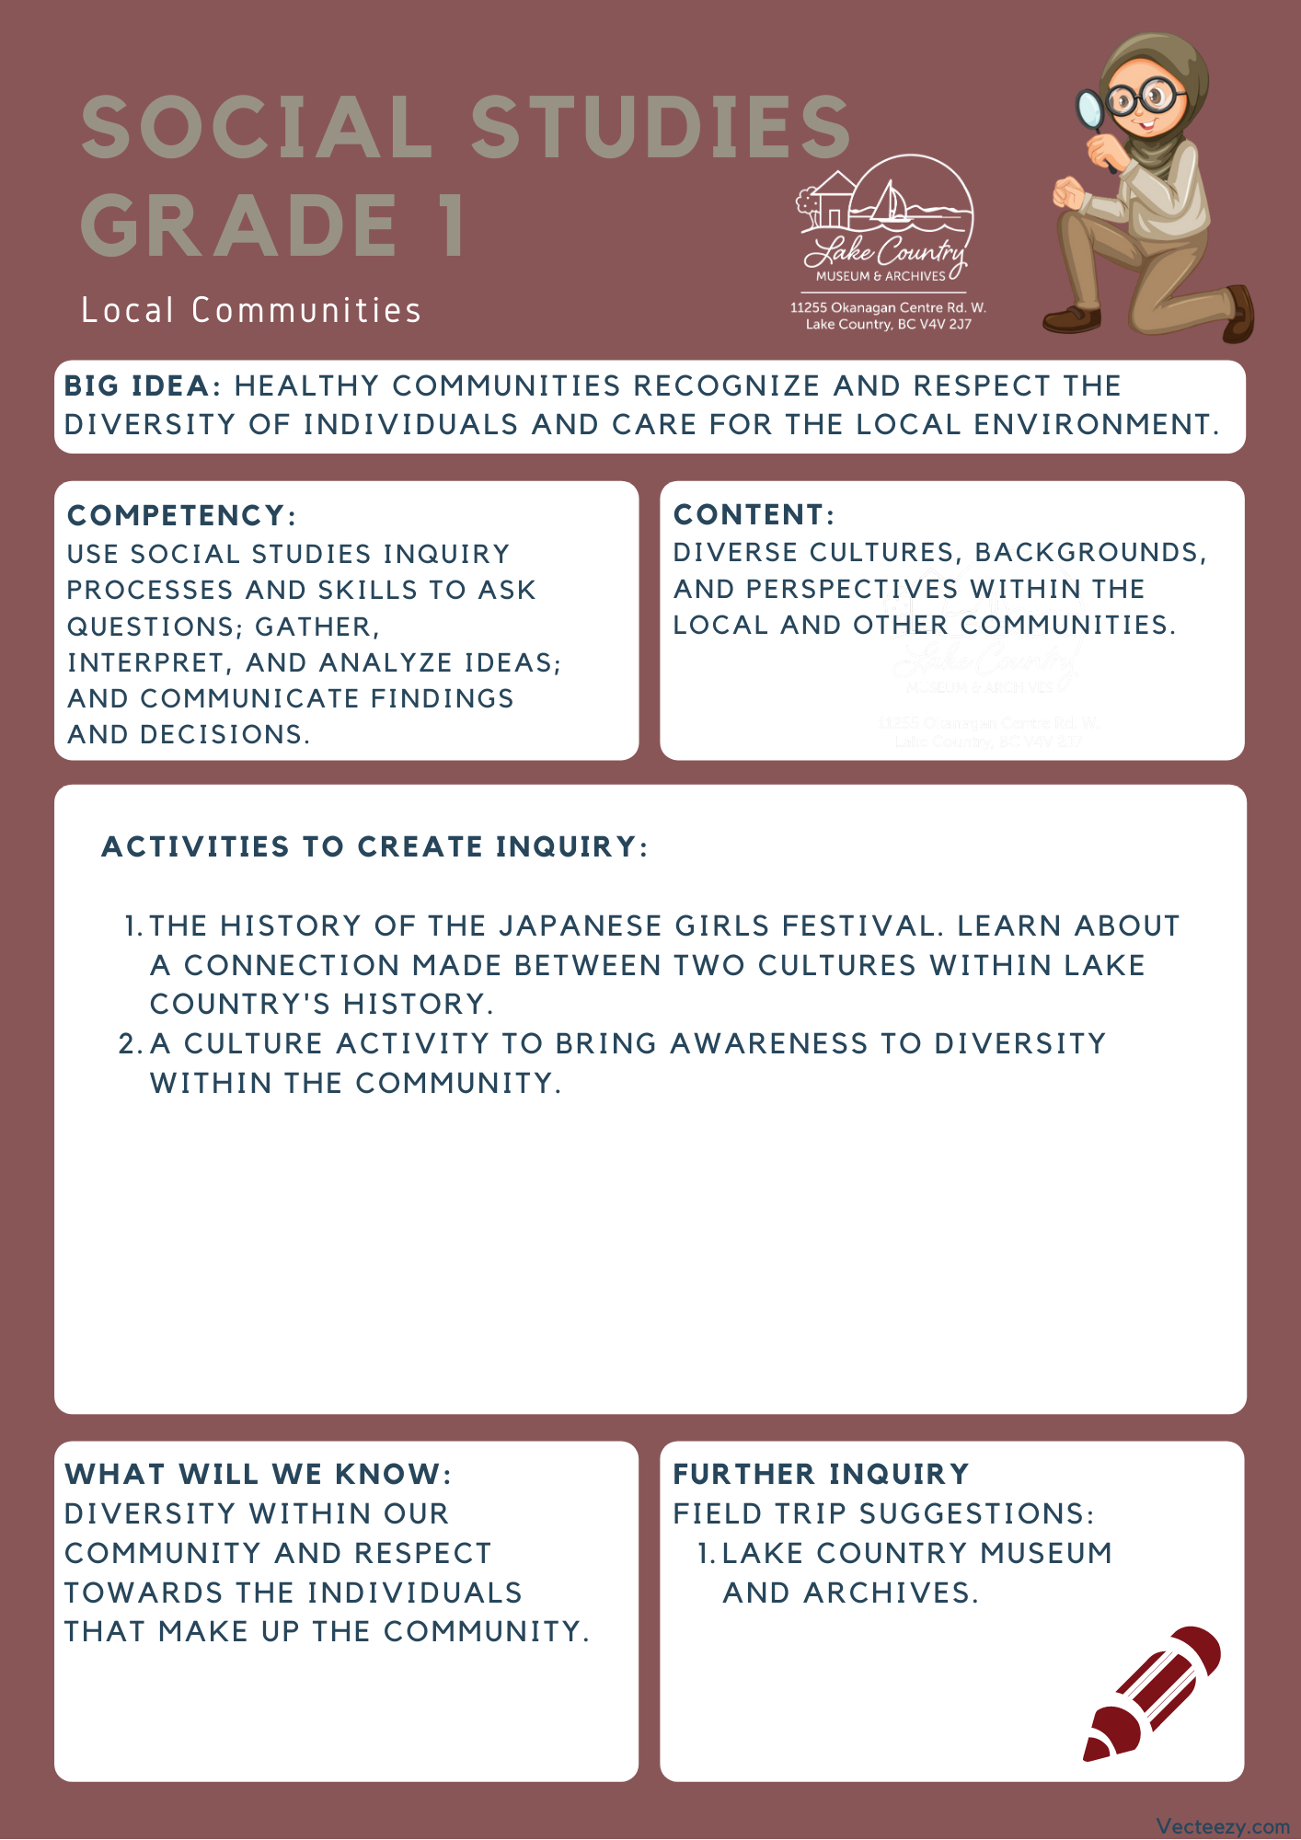

Copyright © 2020
Lake Country Heritage and Cultural Society
11255 Okanagan Center Road West
Lake Country, BC V4V 2J7

All rights reserved. No part of this publication may be produced, stored in a retrieval system, or transmitted, in any form or by any means, electronic, mechanical, photocopying, recording, or otherwise, without prior written permission of the publisher.

Social Studies Grade 1 - Lesson 1: Girl’s Day Festival
Learning Experience
Reading a narrative on the Japanese festival known as Girl’s Day (Hinamatsuri), and learning about an exhibit at the Lake Country Museum that relates to the festival. The narrative and the activities are designed to expose students to the diverse cultures that exist within our community.

Intention | To learn more about Japanese culture and bring awareness to what makes individuals unique.
Objective | The students will be introduced to the Girls’ Day Festival and learn how it became connected to Lake Country, they will also be introduced to recognizing diversity within themselves and others.
Guidance | Girls Day Festival (Hinamatsuri)  The way the festival is celebrated today began at the beginning of the Edo period in the 1600s. The celebration serves to pray and wish good health and happiness on the daughters’ futures in each family. On March 3rd, the dolls are assembled and displayed upon seven levels in their proper order of hierarchy. The dolls can be very expensive and sometimes are passed down from generation to generation.  During the early 1900s many Japanese families moved to the Okanagan for work. One such family was that of Mits Hikichi. Mits’ family worked at the Rainbow Ranche which was in the Oceola Road/Okanagan Centre Road East area. Mits started school at Okanagan Centre School (now the Lake Country Museum & Archives) in 1934 and then went on to work at the Rainbow Ranche himself.  Mits’ boss was married to a lady named Eileen MacArthur who had a Japanese pen pal. Back in the 1950s the pen pal asked Eileen if she would like some dolls and Eileen said yes, imagining she would receive a doll or two like we often see displayed here in Canada. To Eileen’s amazement, many boxes started to arrive at her house until she received the entire  collection. What Eileen didn’t realize was that she had received a complete set of hina ningyo dolls (otherwise known as hina dolls) which are set up for an annual festival called Hinamatsuri or Girl’s Day.  The dolls represent aspects of culture within Japanese society and show how unique and special the tradition is. A central idea behind the festival is that the dolls represent the hopes and dreams of parents for their children’s futures. The following activities and lessons are designed to respect and understand the diversity that makes up Canadian society and the community in Lake Country.  Photos of the dolls and exhibit at the Lake Country Museum can be found here: https://www.lakecountrymuseum.com/our-collections/feature-exhibit-steeped-in-our-traditions-japanese-doll-display/
Activities | This lesson is centered around the students recognizing what makes themselves and their families unique and special. Opening up a dialog will help them recognize and respect the aspects that make other members within their community unique and special, as well as, their own.  What Makes Me Unique  Materials Needed:  - Worksheet (provided on page 5)  - White Board/Large Paper to write on for class to see  - Pencils and/or coloring markers  Introduction:  The goal of this lesson is to have students think about the things that make them unique. By turning their attention inward and having them recognize the diversity they bring, they will be able to recognize and respect the diversity within their communities.  Begin by gathering the students together and sharing information about yourself and what makes you unique.  Step One:  Write on the board (or a large piece of paper): “What Makes Me Special?” Then add the following categories: Music, Play, Food, Clothing.  Under each category, share with the class an example of something that is unique to you and the culture you identify with (ex. traditional foods, ceremonial dress for special festivals, etc.).  After you have at least one example for each category, ask the students if any have something that would fit those categories about themselves.  Step Two:  Hand the worksheet to the students and explain how they are going to complete the exercise, but this time they will be more specific to themselves. For each category (Music, Play, Food, Clothing) they are to write down one thing that they think is special or unique about themselves and their family. After that, they can draw and color a picture of themselves and their family showing some of their unique qualities.  Conclusion:  Have the students work separately at their work areas and walk around to aid when needed. The main goal is to have children start to identify what it is that makes them unique, so for assessment purposes you could have each child show you their picture and explain what the things they identify with are.
Further Inquiry | Field Trip Suggestion:  The Lake Country Museum & Archives – The Museum has the Girls Day Festival exhibit, and other items in relation to our Japanese Canadian pioneers. There is also a playground and field behind the building and the lake nearby that students can make use of for various activities.  There may be the opportunity for a guest lecturer to visit your classroom or be present at the museum with the knowledge of more local history stories. If interested, please contact the Museum ahead of time.
