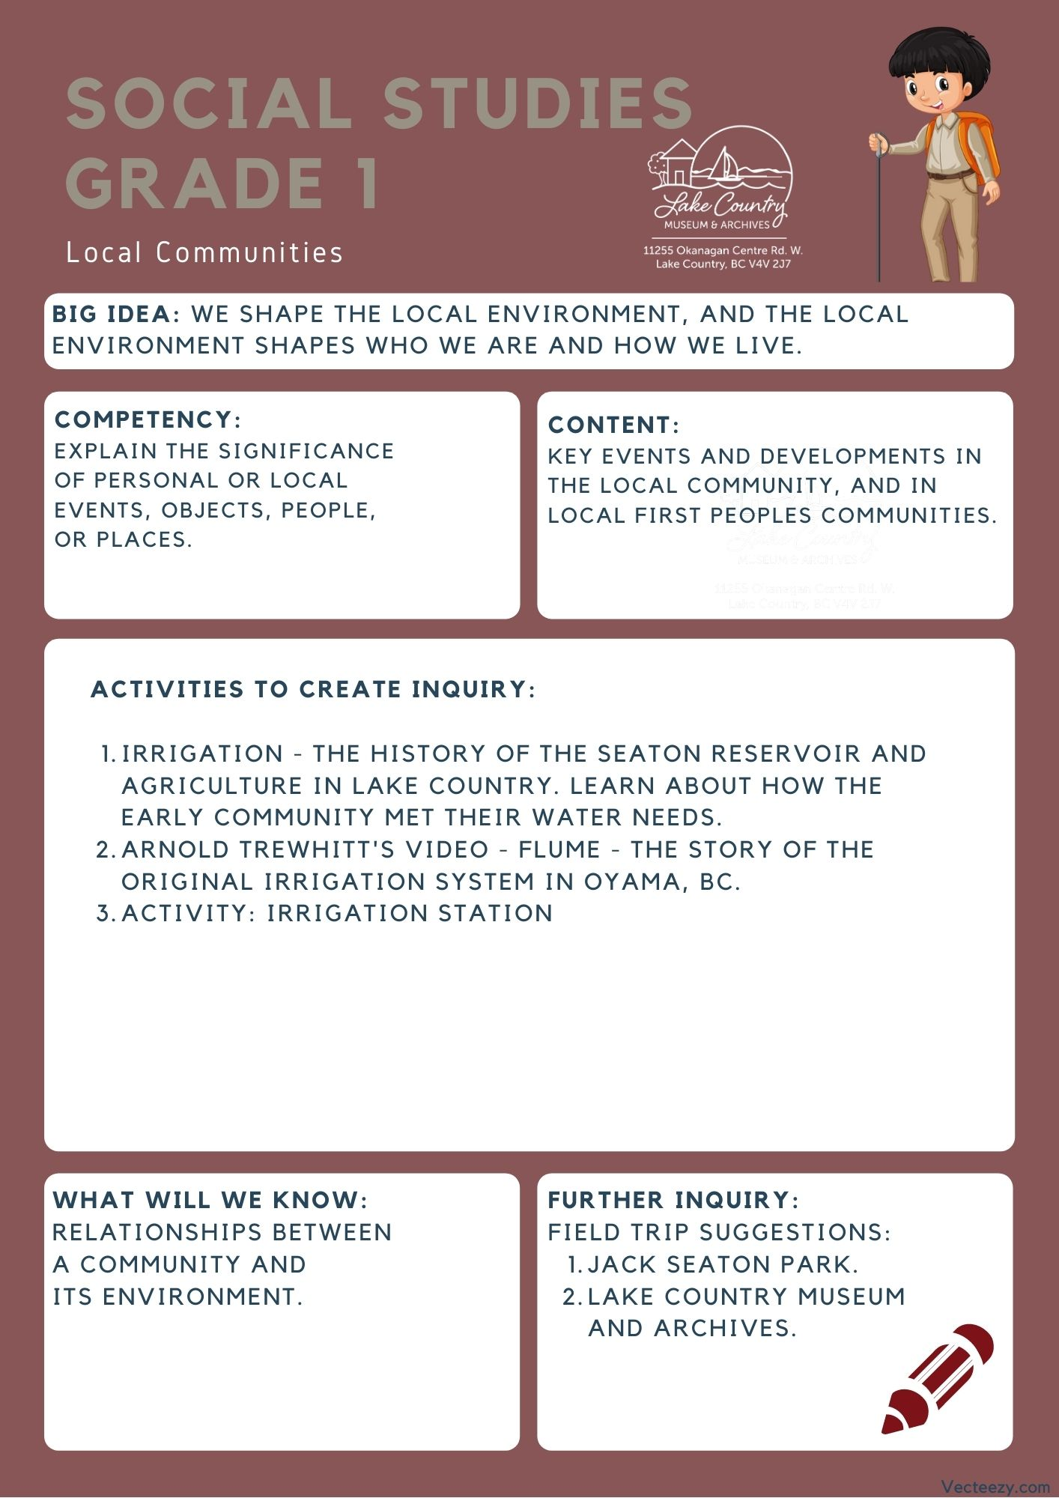
We respectfully acknowledge that the land on which the Lake Country Museum is situated, where this lesson was developed, is on the unceded territory of the Syilx (Okanagan) Peoples.

Copyright © 2021
Lake Country Heritage and Cultural Society
11255 Okanagan Center Road West
Lake Country, BC V4V 2J7

All rights reserved. No part of this publication may be produced, stored in a retrieval system, or transmitted, in any form or by any means, electronic, mechanical, photocopying, recording, or otherwise, without prior written permission of the publisher.
Social Studies Grade 1: Irrigation
Learning Experience
Reading a narrative on the Lake Country settlers establishing their irrigation for the farms and community with an activity for students to attempt making their own irrigation system.

Intention | This lesson is meant to give students not only a look at local history and how irrigation shaped our valley, but to allow them to troubleshoot how they would have designed a system to move water around the valley.
Objective | Looking at local history to see how the community interacts with the environment, with a focus on the early irrigation system and its importance to the community.  Students will learn about the Seaton Reservoir and its importance to the Lake Country community. They will also learn about the Oyama flume and can watch a video of the original flume irrigation system in Oyama, BC as told by Arnold Trewhitt, the Wood Lake Water Company's former Director and Water Bailiff.
The Story | Link to video narration: https://youtu.be/8BMGBHlLBp8  In 1860, over a hundred years ago, settlers began planting fruit trees in the Okanagan. This was tricky for them because the land was so dry. Actually the Okanagan area was so dry it became known as the “Interior Dry Belt!” This meant that the farmers had a big challenge to deal with. How were they going to water their trees?  The farmers had access to an incredibly large body of water known as the Okanagan Lake. But, the problem was getting the water to the trees. The Okanagan, especially in the areas around Lake Country, has tons of long and incredibly tall hills. As we know, the water from the lake can’t flow uphill. So the farmers had to come up with another plan.  At the top of the hills, there were some hollowed lakes, one of them is where Jack Seaton park is now. Instead of taking water from Okanagan Lake at the bottom of the hill, they took water from these smaller lakes at the top of the hill. To bring the water where it needed to go, these farmers built streams using ditches, pipes, and a special contraption called a flume.  A flume is an above ground trench meant to transport water from one place to another.  One of the people behind building these new water flumes was a man known as John Wesley Arnold. John was born in Ontario and traveled all the way across Canada to the Lake Country area in 1910. He was married to a lovely woman named Lucinda Yott and had two young sons, Arthur and Nelson. What is really amazing is that during the day he built the flumes to transport the water all around Lake Country and then at night he worked on building a home for him and his family.  Without the flumes and other waterways, Lake Country could not have had any orchards or fruit trees that we have today. This was truly an amazing accomplishment.
Historical Context  (For Teacher Background) | Lake Country’s Irrigation  The key to growing agricultural crops in the Okanagan Valley was, and is, water. Without it, the land reverts back to its natural state of bunch grass and pine trees.  Government water policy was first formed back in the placer gold mining days of the 1850s and was changed and added to over the years as necessitated by conditions. As agricultural settlement increased, in fact boomed, after 1890 so did the need for irrigation water in the Interior Dry Belt of which the Okanagan was part. Since the amount of water was limited, competition for it was intense, and, as before, the first to apply got the first water right from that source.  With a poor, or non-existent, infrastructure, the British Columbia Government did not really have control of the water as it lacked an agency devoted to water rights. This changed in 1909, when the revised Water Act provided for a Water Rights Branch.  At first, agricultural water rights were generally taken out by individuals. This changed in the Okanagan as development companies came on the scene at the beginning of the twentieth century opened up blocks of land for settlement. In order to sell the lands, these companies had to provide irrigation water and so applied for water rights. Usually these rights were turned over to water companies composed of the land purchasers thus giving those users control of their water.  Seaton Reservoir 1950  There was a reservoir near the top of the ridge on Camp Road just west of the entrance to Seaton Park. It is overgrown now. An old section of wooden irrigation pipe leading from this reservoir can still be seen sticking out of the bank above Tyndall Road near Camp Road.  (Written by Ken V. Ellison in “Irrigation” from Spirit of Lake Country: Heritage and Culture)  This reservoir was essential to the Lake Country Community, as it was the source of irrigation for many of the local crops. Having a secure, dependable irrigation water supply is important to maintaining production in dry years.  Arnold Trewhitt’s story of the Lake Country Flumes on YouTube  Search: Flume - The story of the original irrigation system in Oyama, BC by Starling Video  Background from the Museum’s Blog:  Fourteen years ago (2000) Ken Ellison published a book, Irrigation is King: A Century of Water in Oyama, BC. 1892-2000. This work exhaustively examined and interpreted the land, water and irrigation records of Oyama, BC. Now, a complementary video, Flume. The story of the original irrigation system in Oyama, BC, has been produced by Jordy Starling of Oyama.  Starling’s presentation features and honours his grandfather, Arnold Trewhitt, who was the last water bailiff for the Wood Lake Water Company. It is a compelling video presenting Trewhitt’s narrative and is supported by excellent photographs, maps and graphics.  Trewhitt focuses on the community of fruit farmers who established Oyama and who were bound together by the water distribution system of open flumes. Water was the life-blood of the community and Trewhitt prides himself as being the water bailiff or custodian who visited every farmer every day, regulating, conserving, and efficiently delivering precious water to each farm. He reminisces about an era of farmer democracy and community involvement.  This video is a wonderful celebration of the historic community of Oyama. While Oyama has changed with the arrival of numerous non-farmers, the character of Oyama remains.  The Lake Country Heritage and Cultural Society thanks Jordy Starling for this thoughtful video presentation.  Further Reading:  https://www.lakecountrymuseum.com/irrigation-and-the-beginning-of-agriculture/#top  https://www.lakecountrymuseum.com/our-collections/exhibit-the-arnold-family/#top
Activity | Water plays an essential role for both the environment and human needs. Have the students brainstorm and discuss what they need water for to lead into a conversation about the environment and the world’s relationship with it.  Showing the value of irrigation through the following activity will allow students to explore what people like John Wesley Arnold had to design and build in order to make the land in the valley right for growing other plants.  Irrigation Station:  In this design challenge students will build some form of irrigation system to transport water from a reservoir down to a plot of farmland that is a decent distance away.  Materials Needed:  - 2 paper/styrofoam cups for each group  - plastic straws  - popsicle sticks  - tape  - glue  - any other materials that you think would aid students in their design  Introduction:  - After going through the lesson on the flume with the class tell them that you are giving them the challenge to move water from one cup to another while one is on a desk (reservoir) and the other is on the floor (farmland), and once the water is poured into the reservoir that it can't be moved.  - Students can work in groups or individually for this activity and need to build a design that they think will work to move the water before the water is poured into the first cup.  Teacher Example:  - Before the designing begins ask your students a few questions  - Which way does the water move? towards the top or bottom?  - How can we influence the movement of the water?  - How can we make sure all the water gets down to the bottom safely?  - As you and the students go through these questions, draw up a visual on the board and relate that to the items they have available to them. (ex: the cup that starts with the water is your reservoir at the top of the hill)  - Make sure the students know that since we are trying to conserve water that their transport system has to be relatively spill proof. (we don't want to waste such a precious resource)  - finally tell the students all the materials you have for them to work with, if needed talk about safety with the materials the class is using.  Students Practice:  - Have the students start their work by just letting them come up with their design on their own or with a group. Let them work for 20-30 minutes on the task, and let them know they are open to ask questions.  - Tell the students that once they are done with their design to have a teacher or other adult in the room to pour water in their reservoir cup and see if it makes it to the bottom.  - As a extension piece have students try to design a way to get the water into two different cups
Further Inquiry | Field Trip Suggestion:  Jack Seaton Park in Lake Country: 1960 Camp Rd.  There was a reservoir near the top of the ridge on Camp Road just west of the entrance to Seaton Park, though it is now overgrown. An old section of wooden irrigation pipe leading from this reservoir can still be seen sticking out of the bank above Tyndall Road near Camp Road. Jack Seaton Park is also a great area for a number of outdoor activities to do with the class.  Lake Country Museum and Archives  The Museum has a wide range of exhibits and activities for your class to take advantage of. There is also a playground and field behind the building and the lake nearby that students can make use of for various activities.  There may be the opportunity for a guest lecturer to visit your classroom or be present at the museum with the knowledge of more local history stories. If interested, please contact the Museum ahead of time.

