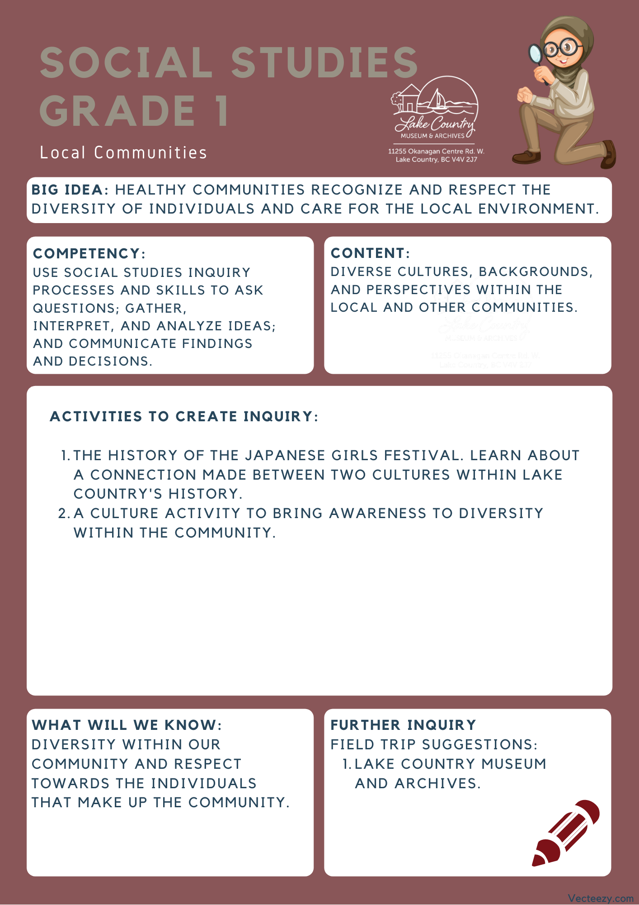

We respectfully acknowledge that the land on which the Lake Country Museum is situated, where this lesson was developed, is on the unceded territory of the Syilx (Okanagan) Peoples.

Copyright © 2021
Lake Country Heritage and Cultural Society
11255 Okanagan Center Road West
Lake Country, BC V4V 2J7

All rights reserved. No part of this publication may be produced, stored in a retrieval system, or transmitted, in any form or by any means, electronic, mechanical, photocopying, recording, or otherwise, without prior written permission of the publisher.
Social Studies Grade 1 - Lesson 1: Girl’s Day Festival
Learning Experience
Reading a narrative on the Japanese festival known as Girl’s Day (Hinamatsuri), and learning about an exhibit at the Lake Country Museum that relates to the festival. The narrative and the activities are designed to expose students to the diverse cultures that exist within our community.

Intention | To learn more about Japanese culture and bring awareness to what makes individuals unique. This lesson is great to bring some Social and Emotional learning to your class and create connections between students early on, as they learn to appreciate their classmates' differences.
Objective | The students will be introduced to the Girls’ Day Festival and learn how it became connected to Lake Country, they will also be introduced to recognizing diversity within themselves and others.
The Story | Girls Day Festival (Hinamatsuri)  Link to video narration: https://youtu.be/Syl7IaA2gz4  Over 50 years ago, Eileen MacArthur received a most wonderful gift from her Japanese pen pal. Back in the 1950s Eileen’s pen pal asked her if she would like some dolls. Eileen said “of course I would love a doll from you.” Who wouldn’t want to receive a nice gift from a good friend? Eileen imagined she would receive one doll, maybe two. She thought it would be a doll like the ones we have in Canada. Maybe it would be soft, have long hair, and colourful clothes. Instead, her pen pal sent her something Elieen did not expect. It was something wonderful.  It wasn’t long until Eileen had a box arrive at her front door. Then another box. And another, and another. Eileen had a pile of boxes, filled with dolls from her Japanese friend. Instead of receiving one or two dolls, Eileen had an entire collection of dolls from her Japanese pen pal. What Eileen didn’t know at the time was that these dolls were very special to her friend. These dolls were called hina ningyo dolls. which are set up for an annual festival called Hinamatsuri or Girl’s Day festival.  The Girl’s Day festival is celebrated every 3rd of March by displaying dolls upon seven different layers. Each doll has their own special spot in the display. Usually these dolls are past down from generation to generation. The whole point of the festival is about parents wishing happiness for their daughter’s future.  These dolls are very important to Japanese culture. The Girl’s Day festival is still celebrated today. It was so incredibly kind that Eileen’s pen pal shared this part of her culture by sending the dolls across the world. The dolls eventually got given to Eileen’s friend Mits Hikichi, who lovingly gave the dolls to the Lake Country Museum so this story could be shared with even more people.  This story can be read with the accompanying Google slide here:https://docs.google.com/presentation/d/1LPxWZfsFYg7qJW66ZKlOLnO0H-qpWA7dPiBHqHi1y2A/edit?usp=sharing  Or there is a video that has the story narrated along with it here:
Historical Context  (For Teacher Background) | The way the festival is celebrated today began at the beginning of the Edo period in the 1600s. The celebration serves to pray and wish good health and happiness on the daughters’ futures in each family. On March 3rd, the dolls are assembled and displayed upon seven levels in their proper order of hierarchy. The dolls can be very expensive and sometimes are passed down from generation to generation.  During the early 1900s many Japanese families moved to the Okanagan for work. One such family was that of Mits Hikichi. Mits’ family worked at the Rainbow Ranche which was in the Oceola Road/Okanagan Centre Road East area. Mits started school at Okanagan Centre School (now the Lake Country Museum & Archives) in 1934 and then went on to work at the Rainbow Ranche himself.  Mits’ boss was married to a lady named Eileen MacArthur who had a Japanese pen pal. Back in the 1950s the pen pal asked Eileen if she would like some dolls and Eileen said yes, imagining she would receive a doll or two like we often see displayed here in Canada. To Eileen’s amazement, many boxes started to arrive at her house until she received the entire collection. What Eileen didn’t realize was that she had received a complete set of hina ningyo dolls (otherwise known as hina dolls) which are set up for an annual festival called Hinamatsuri or Girl’s Day.  The dolls represent aspects of culture within Japanese society and show how unique and special the tradition is. A central idea behind the festival is that the dolls represent the hopes and dreams of parents for their children’s futures.  The following activities and lessons are designed to respect and understand the diversity that makes up Canadian society and the community in Lake Country.  Photos of the dolls and exhibit at the Lake Country Museum can be found here: https://www.lakecountrymuseum.com/our-collections/feature-exhibit-steeped-in-our-traditions-japanese-doll-display/
Activities | This lesson is centered around the students recognizing what makes themselves and their families unique. While also having the students see how their class is unique and how they fit into their community. Opening up a dialog will help them recognize and respect the aspects that make other members within their community unique and special.  Class Jigsaw  Materials Needed:  - Puzzle piece Worksheet (provided on last page)  - Pencils and/or coloring markers  Introduction:  The goal of this lesson is to have students think about the things that make them unique. By turning their attention inward and having them recognize the diversity they bring, they will be able to recognize and respect the diversity within their communities.  Begin by gathering the students together and sharing information about yourself and what makes you unique.  Step One:  Draw up a Puzzle piece on the board and explain to the students that each one of us in our local community make up a large puzzle of sorts, and all of our pieces are unique. explain that together the class is going to make a class puzzle. Write your name in the Puzzle piece and begin to present to your class a few things that you think you and your family bring to the community. Some examples could be Music, Hobbies, Food, Clothing, Traditions. Ask the students if they could even think of other categories that make people unique and share that about yourself as well. As you go through them draw something that symbolizes that example in the puzzle piece.  After you have given a few examples of yourself, move on to step 2.  Step Two:  Hand the Puzzle pieces to the students, and explain that they are now going to draw and colour in their own piece with what makes them unique! Before they start, have them all write their name in the piece somewhere. Have the students work in the way that best suits your classes needs(in groups or separately) and walk around to aid when needed. Have them cut out their piece when they are finished.  Conclusion:  The main goal is to have children start to identify what it is that makes them unique, as well as have them appreciate what makes the other students in their class unique. Once all the students have their pieces done, you can get each student to present to the class what's in their puzzle piece and why they feel it makes them unique and have them put it up on a bulletin board to eventually create the whole class puzzle!
Further Inquiry | Field Trip Suggestion:  The Lake Country Museum & Archives – The Museum has the Girls Day Festival exhibit, and other items in relation to our Japanese Canadian pioneers. There is also a playground and field behind the building and the lake nearby that students can make use of for various activities.  There may be the opportunity for a guest lecturer to visit your classroom or be present at the museum with the knowledge of more local history stories. If interested, please contact the Museum ahead of time.

<a href="https://www.vecteezy.com/free-vector/vector">Vector Vectors by Vecteezy</a>

