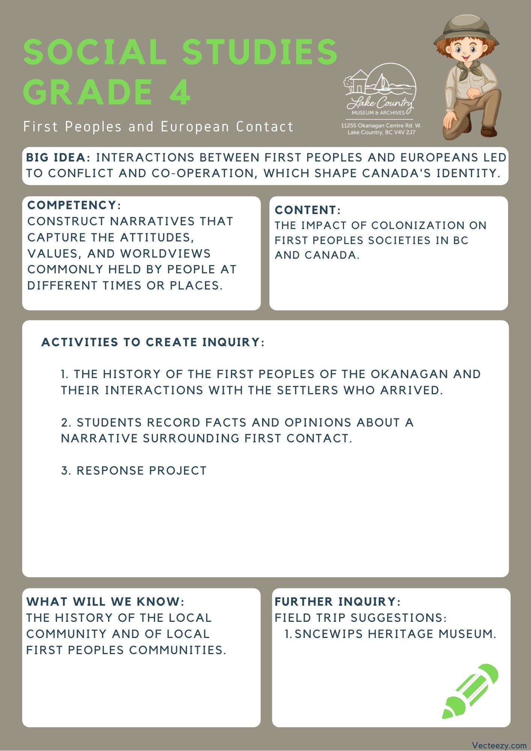
We respectfully acknowledge that the land on which the Lake Country Museum is situated, where this lesson was developed, is on the unceded territory of the Syilx (Okanagan) Peoples.

Copyright © 2021
Lake Country Heritage and Cultural Society
11255 Okanagan Center Road West
Lake Country, BC V4V 2J7

All rights reserved. No part of this publication may be produced, stored in a retrieval system, or transmitted, in any form or by any means, electronic, mechanical, photocopying, recording, or otherwise, without prior written permission of the publisher.

Social Studies Grade 4: First Contact
Learning Experience
Reading a narrative about the intended and unintended consequences in the pursuit of natural resources that resulted in changes to the land, people, and local community.

Intention | To use factual information and the students own opinion/feelings of a narrative to fuel a personal response of the teachers or students choice.
Objective | To contemplate first contact between the First Peoples and the European settlers, and to respond accordingly based on their own opinions.
Historical Reading | The Original People of the Okanagan  (see printable version below)  Before first European contact, Lake Country was home to the Syilx-speaking Okanagan Nation which had occupied the Okanagan Valley as early as 10,000 years ago. Their territory reached approximately 43,000 square miles and was bordered closely by other Syilx-speakers. Historians estimate a pre-contact population of 12,000.  The Syilx name for Winfield is K’lakokum, meaning “small enclosed land” or “the land between'' and for the Oyama isthmus is Axts-luchus, meaning, roughly, a narrow crossing with thickly entwined willows. Arrowheads and spearheads of stone have been found on the shores of Carr’s Landing, offering evidence of Okanagan ties to the area.  The Okanagan people were known as great hunters, gatherers, and fishermen. Lake Country’s bottom and riparian lands provided lush vegetation, grasslands, wild fruits, herbs and roots which in turn supported herds of deer and other game. The late Ned Louis, one of the Indian Band Chiefs in the 1970s, stated that “a long time ago the people went to Oyama in the fall to fish in Wood Lake.” Lake Country provided everything the Okanagan People needed during the warm months and they were able to gather, preserve, transport, and store food items for the winter months. They were a semi-nomadic tribe and  did not make a permanent home in the Lake Country area, but moved freely throughout Okanagan territory.  The Okanagan people had and still have a strong sense of family and community identity. They are a matrilineal people, keeping very close ties with their mother’s and grandmother’s lineages. The Okanagan Nation is well known for its precision tools and finely woven baskets made of birch bark or cedar roots.  The Okanagan people were great storytellers, using oral techniques to teach children and adults about their land and traditions. This meant that the Okanagan people primarily spoke their stories out insteading of printing them in a book. One of the central characters of their stories is Coyote, or Sen’klip, the trickster hero of the Syilx people. Sen’klip, through his adventurous mishaps, helped teach the people how to survive on this land. Thousands of years later, this knowledge is still embedded in the Nsyilxcen language.  In 1877, The BC Commissioners passed a Decision to establish Commonage in the Lake Country area, among other reserves for the Indigenous people. The Commonage was reserved for winter grazing by the cattle of both the Syilx people and the European settlers. No system for policing the cattle grazing on the Commonage was established. The system worked well, but did not last too long.  In 1889, a new agreement was reached within British Columbia’s Chief Commissioner of Land and Works and the Indian Reserve Commissioner. The new agreement stated that the BC government would take over the Commonage and in return it would establish an Indian Reserve on the west side of Okanagan Lake. This meant that the land was no longer available for the Syilx people to use. The problem was, in the conversations that made this decision, only the European Settlers were represented, not the Syilx people  Just over a hundred years after the change, Okanagan Indian Band leader, Murray Alexis of the Syilx Nation, brought a land claim for the Commonage area forward to the BC government. The land claim for title to the Commonage has yet to be resolved.  The Okanagan people were known for their generosity and kindness. They were not a war-like nation and treated the early traders and missionaries with consideration, protecting them and sharing their store of food when they were in need. Unfortunately, the reserve system was used as a form of social control that allowed missionaries and governments to force religious and social values on the Okanagan people. From this treatment the Okanagan people are recovering and they still desire to live cooperatively and equitably with their neighbors.  (Adapted from the writing of Nikki Marchand in “The Original People of the Okanagan” from Spirit of Lake Country: Heritage and Culture)
Activity | Facts and Opinions sheet:  (see graphic organizer below)  - Have students explore the "Original People of the Okanagan" reading (print out sheets on last pages of this lesson plan)  - As they read have them pull factual information from the reading and write it on the facts side of the sheet  - Once all of the students have their facts, have them discuss how they feel about the facts they wrote down with one or two other students.  - The thinking that comes from this discussion, plus any other personal connections, questions and opinions can then be recorded on the opinions side of the sheet  Response options: Have students then use their Facts and Opinions graphic organizer to respond in any way you see fit. A few examples are as follows! You could either pick an option that you think would work best for the class or have the students decide on how they want to present their response.  - Historical Fiction Short Story (Option to make a story book for their story)  - Individual Written Reflection  - Diorama  - Illustration or Painting.  - Infographic / Poster
Further Inquiry | Field Trip Suggestions:  Visit the Sncewips Heritage Museum in Westbank to learn  more about the living history and heritage of the Syilx  Okanagan People. Set up a tour through the museum’s website: https://www.sncewips.com/  The Lake Country Museum and Archives  The Museum has a wide range of exhibits and activities for your class to take advantage of. There is also a playground and field behind the building and the lake nearby that students can make use of for various activities.  There may be the opportunity for a guest lecturer to visit your classroom or be present at the museum with the knowledge of more local history stories. If interested, please contact the Museum ahead of time.  For further exploration and education, we recommend that you contact the Okanagan Indian Band Education Services Department. (link)

Fact and Opinion Graphic Organizer

Fact  Questions to consider:  What happened?  When did it happen?  What is important? | Opinion  Questions to consider:  What do you think about what happened?  How do you feel about this history?  What do you wonder about after reading this?
The Original People of the Okanagan

Before first European contact, Lake Country was home to the Syilx-speaking Okanagan Nation which had occupied the Okanagan Valley as early as 10,000 years ago. Their territory reached approximately 43,000 square miles and was bordered closely by other Syilx-speakers. Historians estimate a pre-contact population of 12,000.

The Syilx name for Winfield is K’lakokum, meaning “small enclosed land” or “the land between'' and for the Oyama isthmus is Axts-luchus, meaning, roughly, a narrow crossing with thickly entwined willows. Arrowheads and spearheads of stone have been found on the shores of Carr’s Landing, offering evidence of Okanagan ties to the area.

The Okanagan people were known as great hunters, gatherers, and fishermen. Lake Country’s bottom and riparian lands provided lush vegetation, grasslands, wild fruits, herbs and roots which in turn supported herds of deer and other game. The late Ned Louis, one of the Indian Band Chiefs in the 1970s, stated that “a long time ago the people went to Oyama in the fall to fish in Wood Lake.” Lake Country provided everything the Okanagan People needed during the warm months and they were able to gather, preserve, transport, and store food items for the winter months. They were a semi-nomadic tribe and
did not make a permanent home in the Lake Country area, but moved freely throughout Okanagan territory.

The Okanagan people had and still have a strong sense of family and community identity. They are a matrilineal people, keeping very close ties with their mother’s and grandmother’s lineages. The Okanagan Nation is well known for its precision tools and finely woven baskets made of birch bark or cedar roots.

The Okanagan people were great storytellers, using oral techniques to teach children and adults about their land and traditions. This meant that the Okanagan people primarily spoke their stories out insteading of printing them in a book. One of the central characters of their stories is Coyote, or Sen’klip, the trickster hero of the Syilx people. Sen’klip, through his adventurous mishaps, helped teach the people how to survive on this land. Thousands of years later, this knowledge is still embedded in the Nsyilxcen language.

In 1877, The BC Commissioners passed a Decision to establish Commonage in the Lake Country area, among other reserves for the Indigenous people. The Commonage was reserved for winter grazing by the cattle of both the Syilx people and the European settlers. No system for policing the cattle grazing on the Commonage was established. The system worked well, but did not last too long.

In 1889, a new agreement was reached within British Columbia’s Chief Commissioner of Land and Works and the Indian Reserve Commissioner. The new agreement stated that the BC government would take over the Commonage and in return it would establish an Indian Reserve on the west side of Okanagan Lake. This meant that the land was no longer available for the Syilx people to use. The problem was, in the conversations that made this decision, only the European Settlers were represented, not the Syilx people

Just over a hundred years after the change, Okanagan Indian Band leader, Murray Alexis of the Syilx Nation, brought a land claim for the Commonage area forward to the BC government. The land claim for title to the Commonage has yet to be resolved.

The Okanagan people were known for their generosity and kindness. They were not a war-like nation and treated the early traders and missionaries with consideration, protecting them and sharing their store of food when they were in need. Unfortunately, the reserve system was used as a form of social control that allowed missionaries and governments to force religious and social values on the Okanagan people. From this treatment the Okanagan people are recovering and they still desire to live cooperatively and equitably with their neighbors.

(Adapted from the writing of Nikki Marchand in “The Original People of the Okanagan” from Spirit of Lake Country: Heritage and Culture)

