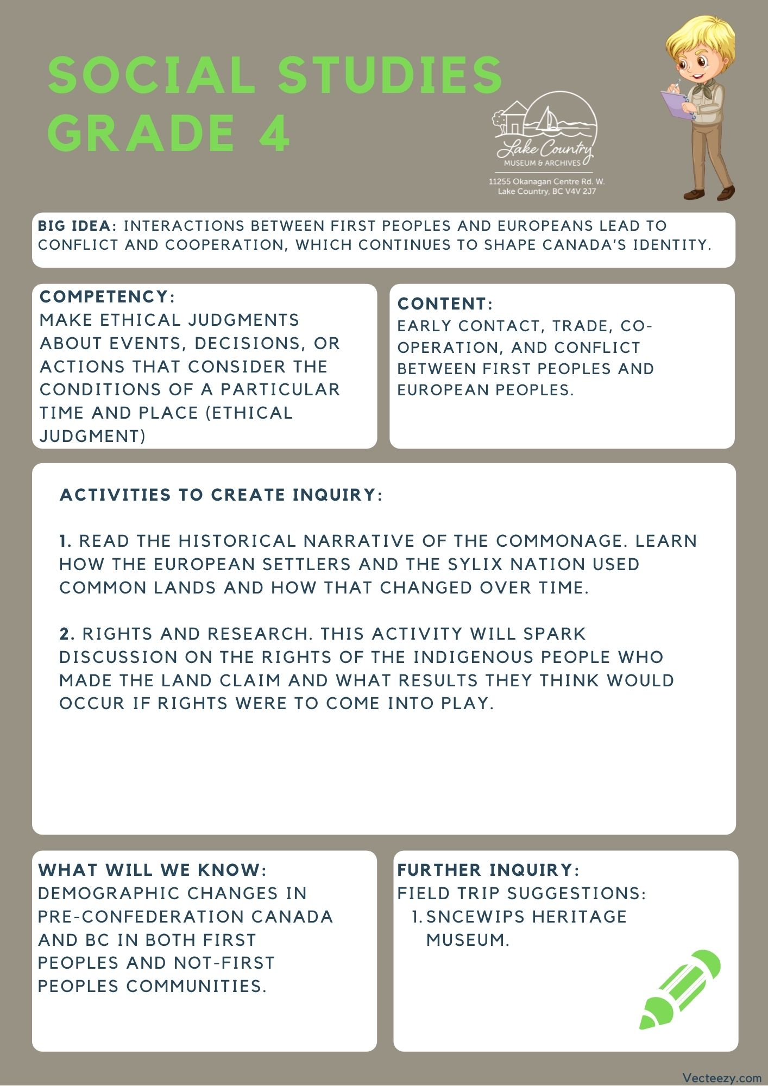
We respectfully acknowledge that the land on which the Lake Country Museum is situated, where this lesson was developed, is on the unceded territory of the Syilx (Okanagan) Peoples.

Copyright © 2021
Lake Country Heritage and Cultural Society
11255 Okanagan Center Road West
Lake Country, BC V4V 2J7

All rights reserved. No part of this publication may be produced, stored in a retrieval system, or transmitted, in any form or by any means, electronic, mechanical, photocopying, recording, or otherwise, without prior written permission of the publisher.
Social Studies Grade 4: The Commonage
Learning Experience
Reading a narrative on the impact of colonialization towards the First Peoples that captures the complex attitudes, values, and worldviews held by Canada at different times. Disclaimer: to share with the class, some of the terms used within The Commonage story reflect the beliefs and values at the time when referencing the people who lived there. The term “Indian” is no longer correct when referencing Indigenous nations, though it is still used in governmental policies and roles.

Intention | To understand the interactions between First People’s and European settlers, by looking specifically at the relations between settlers and the First Peoples of the area.
Objective | To look at how the government historically handled issues around land and the ongoing issues facing land claims and see how they are rooted in Canada’s history.
Activity | Introduction:  - Disclaimer: This activity is inspired by the following fnesc documents  - http://www.fnesc.ca/wp/wp-content/uploads/2019/08/7.1-Blackline-Masters-Unit-5-1.pdf (Page 1)  - http://www.fnesc.ca/wp/wp-content/uploads/2019/08/7.-UNIT-5-Grades-4-12-Reconciling-Indigenous-Rights-and-Title-Treaties-and-Alternatives.pdf (Pages 9-10)  Rights and Research:  - This activity will help student build an idea of what rights are, some of the rights they have, and then using the story of the commanage they should be able to answer a few discussion questions on the rights of the indigenous people who made the land claim and what results they think would occur if rights were to come into play.  - First students will discuss the meaning of rights,  - You may want to discuss the difference between something that is right (correct) and a right (something we are entitled to)  - Check to see if the class can give you examples of rights, put their examples up on the board and discuss them as they come up.  - Second, get students to have a discussion with each other about what their rights are as children.  - Put up a small list of children's rights on the board so they can read them over as a group.  - The right to go to school  - The right to practice a religion  - The right to a decent home  - The right to eat  - The right to medical care  - The right to play  - The right to express your ideas  - The right to safety  - The right to rest  - The right to a clean environment  - The right to live with your parents  - The right to privacy  - Have the class answer what each of them mean so you know the class has an understanding of all of them before continuing.  - Finally once your class understands these rights you could have each student write down the right they think is the most important for them to have on an anonymous slip of paper.  - Tally up the slips and discuss why the ones that are most important to the class were voted for.  Once the discussion about rights is over you can tell the students the story of the commonge.
The Story | Link to video narration: https://youtu.be/VVg-lvyn-Nw  Many European settlers were arriving in the Okanagan valley. Before any European arrived, the Syilx nation was present in the area. To both groups, it was important to provide a place to pasture their livestock. Meaning, they needed a place to keep their livestock fed. Between Lake Country and Wood Lake, there was a large stretch of land that was open not being used. That land was turned into what they called “The Commonage.”  Before we continue, commonage is a combination of two words. “Common” and “Pasturage.” Meaning that this area was a common pasture for everyone to use.  In 1877, The BC Commissioners passed a decision to establish Commonage in the Lake Country area, among other reserves for the Indigenous people. The Commonage was reserved for winter grazing by the cattle of both the Syilx people and the European settlers. No system for policing the cattle grazing on the Commonage was established. The system worked well, but did not last too long.  In 1889, a new agreement was reached within British Columbia’s Chief Commissioner of Land and Works and the Indian Reserve Commissioner. The new agreement stated that the BC government would take over the Commonage and in return it would establish an Indian Reserve on the west side of Okanagan Lake. This meant that the land was no longer available for the Syilx people to use. The problem was, in the conversations that made this decision, only the European Settlers were represented, not the Syilx people.  After, the government had the Commonage surveyed and then divided into quarter sections. Then they put those up for sale, which attracted a variety of farmers and business people to develop and use the land how they saw fit. This became very different from the shared land it used to be.  No agreement was ever made with the Syilx nation to change the usage of the commange. All the decisions were made without their consent. Just over a hundred years after the change, Okanagan Indian Band leader, Murray Alexis of the Syilx Nation, brought a land claim for the Commonage area forward to the BC government. The land claim for title to the Commonage has yet to be resolved. This is one example of why we call the Okanagan area the unceded territory of the Syilx nation. Because the land was taken away from the Sylix people, without any kind of agreement or discussion. When it comes to working with people and making agreements, this is why communication and respect between all the people involved is so important, especially with big deals involving people’s possessions.  Discussion Questions:  - What are land claims? Why are they important to bring forward?  - Did the government have the right to give away the land of the commange without the Syilx’s consent?  - Who should the commonage belong to today?
Historical Context | The Commonage  The word ‘Commonage’ was derived from the contraction of ‘Common’ and ‘Pasturage’, meaning common pasturage. This means "... a large tract of land set aside for grazing purposes".  Many white settlers were arriving in the Okanagan valley. It was important to provide both the settlers and the Syilx Okanagan people, the First Peoples of Lake Country, a place to pasture their livestock. The Commonage area was, at that time, the vacant land available in the area. The area of the land planned for the Commonage was 25,114 acres. It extended from Okanagan Lake to Long Lake (Kalamalka and Wood lakes), north to today’s boundary of Vernon, and south to Okanagan Centre.  On May 8, 1876 an agreement was made that the Commonage was to be reserved from pre-emption for the use of the Syilx people and the settlers for pastureland. This agreement was signed by Indian Reserve Commissioner A. C. Anderson;  Dominion Commissioner Archibald McKinley, Commissioner for British Columbia; and Joint Commissioner G. M. Sproat.  However, in 1889, a new agreement was reached between British Columbia’s Chief Commissioner of Land and Works and P. O'Reilly and the Indian Reserve Commissioner. The new agreement stated that the provincial government would take over the Commonage and in return it would establish an Indian Reserve on the west side of Okanagan Lake.  In 1893, the government had the land on the Commonage surveyed into quarter sections which were then put up for sale. This land attracted speculators, developers and farmers to locations on Okanagan Lake. Small farming communities developed on the Commonage, including Sunnywold (Carr’s Landing) and Oyama.  Okanagan Indian Band Chief Murray Alexis of the Syilx Nation first brought its land claim for the Commonage lands forward  in 1989. The land claim for title to the Commonage has yet  to be resolved.  Pre-emption: A plot of land the settler could claim before the land was surveyed.  Land claim: A legal declaration by a First Nations band or government of desired control over areas of land. In Canada, land claims fall into two broad categories: comprehensive, known as modern treaties, and specific, which make claims based on pre-existing treaties, agreements, or reserves.  (Excerpt from Lake Country: Origins in Time and Place)  For more information and historical timeline visit: https://www.lakecountrymuseum.com/wp-content/uploads/2012/03/Northern-Okanagan-Commonage.pdf
Further Inquiry | Field Trip Suggestions:  Visit the Sncewips Heritage Museum in Westbank to learn  more about the living history and heritage of the Syilx  Okanagan People. Set up a tour through the museum’s website: https://www.sncewips.com/  The Lake Country Museum and Archives  The Museum has a wide range of exhibits and activities for your class to take advantage of. There is also a playground and field behind the building and the lake nearby that students can make use of for various activities.  There may be the opportunity for a guest lecturer to visit your classroom or be present at the museum with the knowledge of more local history stories. If interested, please contact the Museum ahead of time.

