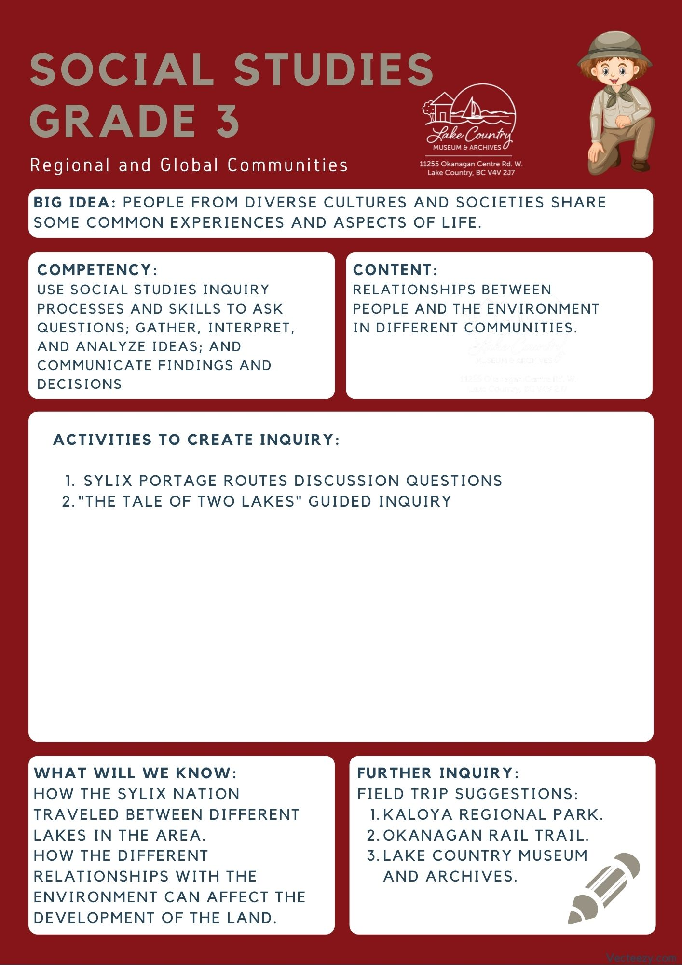
We respectfully acknowledge that the land on which the Lake Country Museum is situated, where this lesson was developed, is on the unceded territory of the Syilx (Okanagan) Peoples.

Copyright © 2021
Lake Country Heritage and Cultural Society
11255 Okanagan Center Road West
Lake Country, BC V4V 2J7

All rights reserved. No part of this publication may be produced, stored in a retrieval system, or transmitted, in any form or by any means, electronic, mechanical, photocopying, recording, or otherwise, without prior written permission of the publisher.
Social Studies Grade 3: The Oyama Isthmus and Canal
Learning Experience
Reading the history of the Oyama Isthmus and the creation of the Oyama Canal and visiting the area to further explore human interactions
with the environment.

Intention | To look at the Oyama Isthmus and see how it has been used and changed over the years.
Objective | To have students recognize how the Syilx Nation traveled between different lakes in the area. Students will also know how the different relationships with the environment can affect decisions and the development of the land.
The Story  and  Discussion Questions | Lake Country is home to the Okanagan Syilx people who have occupied the Okanagan valley for approximately 9,000 years. They travelled Okanagan Lake between winter villages at Penticton and Vernon. The Syilx people were known for a lot of things. Most commonly they were known as talented hunters, gatherers, and fishermen. Lake Country’s lands provided lush vegetation, grasslands, wild fruits, herbs and roots which in turn supported herds of deer and other animals. Okanagan, Kalamalka, and Wood lakes provided abundant sources for fishing. The Syilx name for Lake Country is K’lakokum, meaning “small enclosed land” or “the land between”. This is because it is right in between three lakes. Lake Country provided everything the Okanagan People needed during the warm months and they were able to gather, preserve, transport and store food items for the winter months. The Syilx people were semi-nomadic people. This means they traveled around the area a lot, having homes in multiple places in the Okanagan. Because they had to move their camps and heavy goods they did a lot of transport with canoe-like boats. But, there was one problem they had to overcome. All the Lakes the Syilx people traveled on was separated by land. They had to figure out how they were going to get their canoes from one lake to the other.  One route they had to travel through regularly was across the Oyama Isthmus since it was right in the middle of both Kalamalka and Wood Lake, but they had to bring their boats with them to the other side of the Isthmus.  [Pause story for discussion questions]  - If you were in this situation, what do you think is the best way to transport your boat and goods across the land to the other lake? (get students to share their ideas with a partner.  - Once they are done, ask around the class and gather a few ideas to put on the board.)  [Story Continues]  Between Okanagan and Wood lake, there is a path that the Syilx people would use to carry their boats. They looked for points where there was the least amount of land between the two lakes. This is known as a portage route. There is one between Wood and Kalamalka lake, which is called the Oyama Isthumus. This route was used for thousands of years to transport cottonwood canoes from the shore of Okanagan Lake to the shore of Wood Lake. They called this path the Axts-luchus, meaning a narrow crossing with thickly entwined willows. Which is exactly how they built it! The Syilx people made this path by putting down willow, saplings, and other parts of trees so they could transport boats easier.  After European contact, this site was renamed ’The Railroad’ by the European settlers, a translation of Axts-luchus and referring to the willow ‘rails’ found there. Some time after, the settlers decided to dig out part of the Isthmus to create a Canal between the two lakes. This allowed for transport by boat to be much easier between the two, as they now didn't have to bring their boats over the land. It also allowed for produce, and lumber to be shipped between the top of Kalamalka lake and the bottom of Wood lake much quicker.  On top of this they also built a bridge to go over the canal! The bridge was rightfully called the Oyama Canal Bridge, and helped settlers still be able to transport goods within Oyama after the canal was made.  (Now that students know the story of how the Syilx and the Settlers got around the Isthmus in different ways, you may want to ask them the following discussion questions)  Discussion Prompt Suggestions:  - How does development affect the environment for the Isthmus?  - What do you think were some of the benefits of making the canal between the two lakes? What were some of the consequences?  - Should there be a concept of “acceptable consequences” when it comes to land development? If so, what is acceptable? If not, how do we balance needs of a community with respect to the environment?
Historical Context | The Oyama Isthmus  “The Railroad” was the name used on the earliest colonial maps, before the settlement in Lake Country, to refer to the isthmus at Oyama. The term certainly did not refer to any European-made feature; it had to refer to either a natural or an Okanagan Syilx structure. What was it?  Until the late eighteenth century, the First People’s, maintained winter villages on Okanagan Lake, the major one being Penticton. Okanagan hunting, fishing and gathering activities occurred over a wide territory, including the littoral of Okanagan Lake and Long Lake (a former name for the combined Kalamalka and Wood lakes). The Okanagan Syilx people transported the surplus animal and vegetable products that they had gathered and processed during the summer and fall to Penticton where they were used for winter consumption. Heavy goods such as loads of dried venison, fish and berries were transported there from as far away as the Coldstream valley and Silver Star mountain. Water transport, using dugout canoes or rafts, was the most efficient means of conducting this long-distance transport of bulk goods.  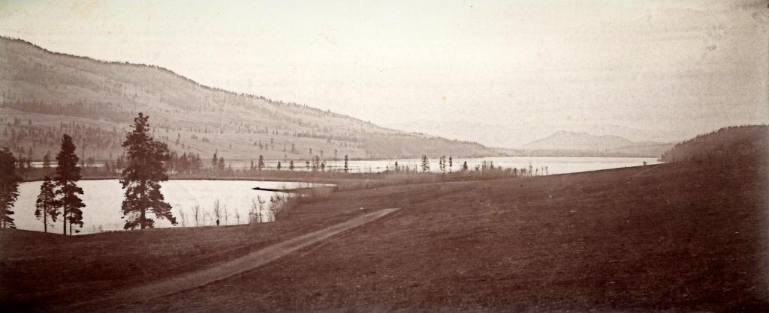  (The Oyama isthmus, looking south.)  In a pre-horse economy, what was the most efficient route over which to transport heavy goods? Water transport from Coldstream to the Oyama isthmus was straight forward, but then the canoes and their loads had to be hiked over the isthmus and up four feet in elevation to float on Wood (formerly Pelmewash) Lake. We know that the Okanagan Syilx people used corduroy or logs to bring canoes over the mud on to land at Okanagan Landing.¹  It seems likely that they used a “rail road” as a slip to pass between the lakes. The Syilx name for the Oyama isthmus was acyuʔc̕us (Ac yutz oos) meaning a narrow crossing with thickly entwined willows (or anything closely intertwined). “The Railroad” likely referred to a rail (corduroy) road made by the Okanagan people by cutting and laying down closely intertwined poles or willows to facilitate their crossing of the isthmus.  The easiest connection between Wood and Okanagan lakes was over the saddle in the mountain range at the south end of Wood Lake. Last year an archaeological team found evidence of a small Okanagan village located at the south west corner of Wood Lake, just where the goods would have been loaded on the backs of Okanagan people and packed over to Okanagan Lake. Undoubtedly the early settlers also used this well-trodden Okanagan Syilx trail and later widened it to become Oceola Road.  The Railroad was an important link in this transport route connecting the North Okanagan to Penticton.  (Excerpt taken from the Lake Country Museum Website)  - H. B. Kennard. “Indian Place Names.” Third Annual Report of the Okanagan Historical Society, 1929, p. 16.  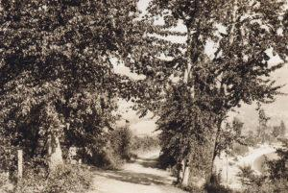  Oyama isthmus between Wood Lake and Long (Kalamalka) Lake  Before the navigation canal was built in 1908, a creek drained Wood Lake into Long (Kalamalka) Lake. Wood Lake was initially four feet higher than Kalamalka, perhaps five or six feet higher during the spring freshet. In some years the water gushed down the creek making passage across the isthmus exceedingly dangerous. Two news items in the Vernon News illustrate:  “There came near a drowning accident last week at the creek between Wood’s Lake and Long Lake, at the place known as the “railway.” J. Shore attempted to ford the creek, which is much swollen, and his horses were swept off their feet, and he was carried down for some distance by the stream, getting out with much difficulty. A road and bridge is badly needed by the settlers of that vicinity, and we trust that it will be among the first work of its kind after this year.”  1902-06-05  Two weeks later the newspaper reported another incident. “A. Cary had a narrow escape last week from losing a valuable horse in the creek at the “railroad,” between Long Lake and Wood’s Lake….” 1902-06-05  (Taken from the Lake Country Museum and Archives website)  The Canal  By 1908, a canal was dug at the end of the isthmus, connecting Kalamalka and Wood Lakes and allowing boat access between the two lakes. The canal was of great benefit to the early settlers, with produce shipped by boat from Wood Lake to the north end of Kalamalka Lake at Vernon, and logs towed through the canal by boats such as the Maud Allan. A bridge was built for traffic to cross the canal, engineered in a style known as “camel-back” which allowed boats to pass underneath.  (Excerpt taken from Spirit of Lake Country: Heritage and Culture, 2011, Lake Country Museum and Archives)  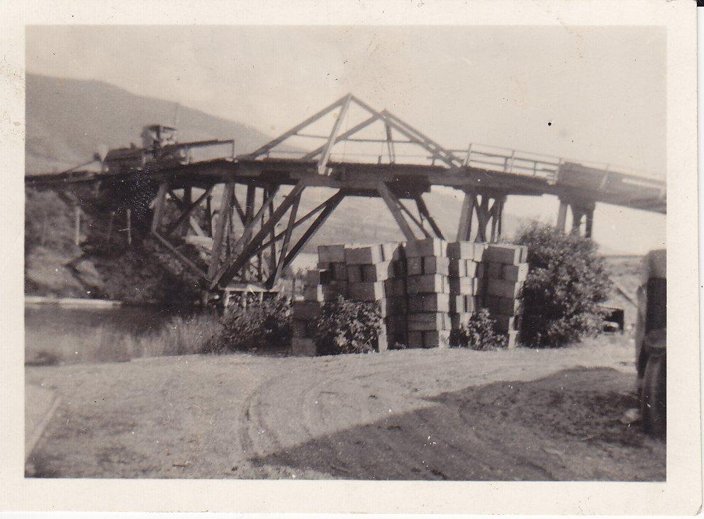  Oyama Canal Bridge – image source Lake Country Museum and Archives, Dorthea Allison Collection.  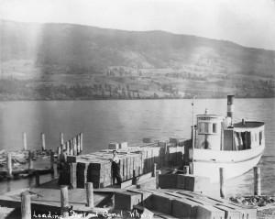  Image source: Lake Country Museum and Archives  After the Canal was built, the lake levels dropped by about 4 feet exposing a natural shelf along the lake.
Activity | - The Tale of Two Lakes:  - Objective: Using the following map activity (pg9-10), have students measure in cm how long both Kalamalka and Wood lake are, using the points provided.  - Based on what they measure, have them use the information following the map to estimate how long the trip would take from the top of Kalamalka, to the bottom of Wood lake.
Further Inquiry | Suggested Field Trips:  Kaloya Regional Park in Lake Country - 16061 Trask Rd.  The Oyama Canal and Kaloya Regional Park are both at the Ithmus. Both have historical significance to the Lake Country area and are excellent locations to take the students for outings and exploration. Nearby is the rail trail and Oyama traditional school.  The Okanagan Rail Trail. The rail trail has sections along the Oyama side which were originally part of the railroad mentioned in this lesson. It is a great area to take the students on a walk and has heritage markers along certain locations of the trail that tell more of Lake Country’s history.  The Oyama Community Hall The community hall in Oyama has been there for the community since 1914. Close to the Isthmus and to Kaloya regional park, it is an excellent spot to visit and to see the heritage marker the Lake Country Museum and Archives has created that tells more history of the  Oyama area.  The Lake Country Museum and Archives  The Museum has a wide range of exhibits and activities for your class to take advantage of. There is also a playground and field behind the building and the lake nearby that students can make use of for various activities.  There may be the opportunity for a guest lecturer to visit your classroom or be present at the museum with the knowledge of more local history stories. If interested, please contact the Museum ahead of time.

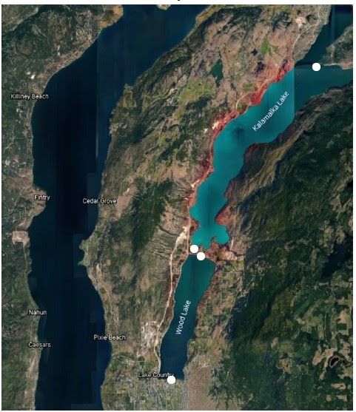

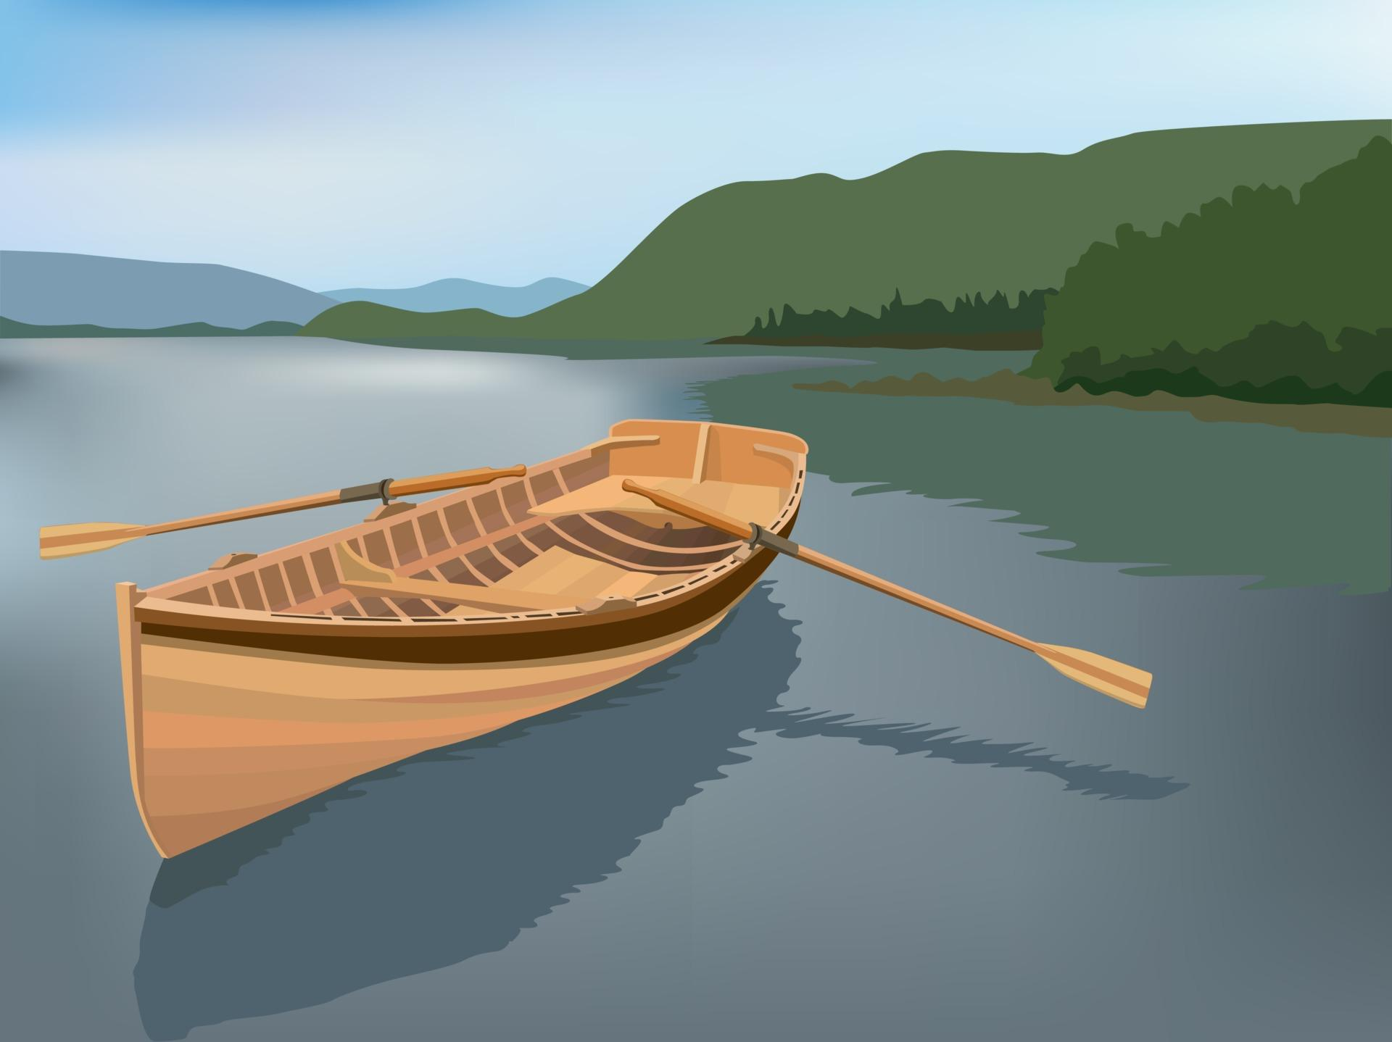
The Tale of Two Lakes
You and your friends are trying to transport fruit from your orchard in Vernon down to a grocery store in Lake country, but you only have a small Canoe to travel in. Before you go you have to let the grocery store know when you plan on arriving so they can be ready for a delivery.
Using the points on the map to measure how long Kalamalka lake and Wood Lake are in centimeters.

Kalamalka Lake is ______cm long
Wood Lake is ______cm long
The total distance you would have to travel on the map is ______cm

You know that 2 centimeters equal around 1 hour of travel by canoe.
How many hours would you estimate it would take to travel the total distance you measured?

<a href="https://www.vecteezy.com/free-vector/canoe">Canoe Vectors by Vecteezy</a>

