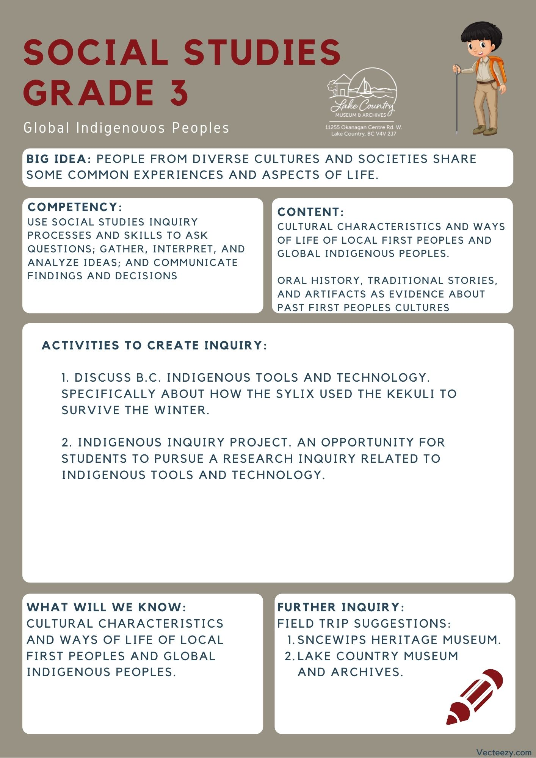
We respectfully acknowledge that the land on which the Lake Country Museum is situated, where this lesson was developed, is on the unceded territory of the Syilx (Okanagan) Peoples.

Copyright © 2021
Lake Country Heritage and Cultural Society
11255 Okanagan Center Road West
Lake Country, BC V4V 2J7

All rights reserved. No part of this publication may be produced, stored in a retrieval system, or transmitted, in any form or by any means, electronic, mechanical, photocopying, recording, or otherwise, without prior written permission of the publisher.
Social Studies Grade 3: Syilx Tools and Technology
Learning Experience
Students will learn from a narrative written about one of the tools the First Nations Peoples in the Lake Country area used to survive, and research another tool of their choosing using school resources

Intention | To provide students with a greater understanding of the Okanagan First Peoples early life here in Lake Country, before settlers arrived.
Objective | Students will learn a narrative on how the Okanagan First Nations People used certain tools to survive through narrative and research.
Historical Context | Early Life in Lake Country  Before the coming of European Settlers, the fertile bottom land of Winfield was dense forest, with occasional oases of small natural meadows, while the present orchard benchlands were covered with pine trees, etc. Large herds of deer roamed the ranges and bunch grass was plentiful everywhere, and grew so tall and lush that anyone passing through left a trail of bent grass.  The lakes and creeks were abundantly stocked with fish, and there was a prolific supply of all kinds of wild fruits, herbs and roots, so that conditions were ideal for the earliest inhabitants — the First Nations People of the Syilx Nation.  They were a nomadic people, following the seasonal berry and harvest, fish and game. As dwellings they used a lean-to made from saplings, chiefly evergreens or a mound-like dwelling covered with pile matting. Contrary to general belief, the tepee was not used by the Okanagan First Nations Peoples. Usually, the Sylix nation situated themselves on or near the banks of a creek or adjacent to a lake.  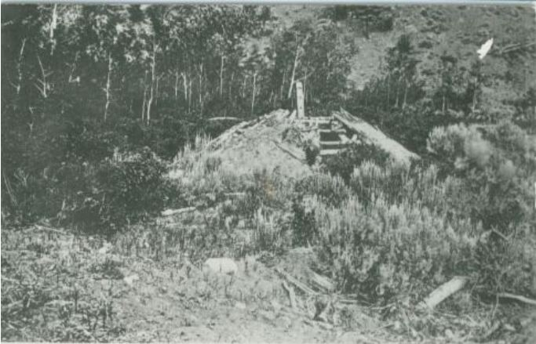  Kekuli or Pit House  In making these winter homes they excavated a circle from three to five feet deep, over which a framework of pole was erected. Their winter habitations were made out of logs to support the structure, grass or pine needles to keep warm, and cedar bark for the siding. The sole entrance was from the centre of the roof, which served also as a smoke exit. A single pole, notched in the manner of steps, served as a ladder.  Kekuli were not only used by the Syilx nation, but many nations across BC including the interior Salish and the Secwépemc nation. Each having some  differences such as being rectangular instead of circular or having multiple entrances.  (Use the slide deck associated to show your class what a Kekuli looks like while explaining its use!)  Further Reading: https://www.thecanadianencyclopedia.ca/en/article/pit-house  Questions for Inquiry and Exploration  - How has this way of life changed for First Nations Peoples in the Okanagan now, compared to the life described in the article?  - Looking at how the First Nations Peoples of the Okanagan lived, as described in this article. What can we infer about their resourcefulness?  - What is the difference between the houses the First Nations Peoples built and the ones we build now? Which use more resources? How do they effect the environment in which they are built upon?
Activity: | Indigenous Inquiry Project:  (for this task you will need access to resources that describe tools developed by your local indigenous people, we suggest asking your schools library if they will have these resources available beforehand)  - Have students divide into groups of 2 or 3  - Hand out the research sheets (available on the last page of this lesson plan)  - Bring students to your school library or have resources brought to your classroom to have them research from, and have find information on a tool or technology that was developed by indegenous people  - They will either then answer the questions on research sheets after or while they find information on their tool or technology  - After answering the questions, have each group present what they learned to the class
Further Inquiry | Field Trip Suggestions:  Visit the Sncewips Heritage Museum in Westbank to learn  more about the living history and heritage of the Syilx  Okanagan People. Set up a tour through the museum’s website: https://www.sncewips.com/  The Lake Country Museum and Archives  The Museum has a wide range of exhibits and activities for your class to take advantage of. There is also a playground and field behind the building and the lake nearby that students can make use of for various activities.  There may be the opportunity for a guest lecturer to visit your classroom or be present at the museum with the knowledge of more local history stories. If interested, please contact the Museum ahead of time.  For further exploration and education, we recommend that you contact the Okanagan Indian Band Education Services Department. (link)  At the moment the Kelowna Heritage Museum has an exhibit that includes a Kekuli: you can visit this website for more information:  https://www.kelownamuseums.ca/museum/okanagan-heritage-museum/
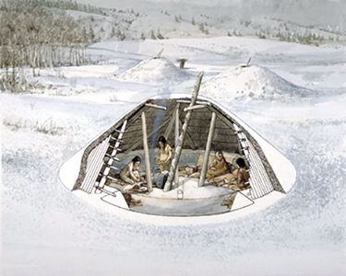
Indigenous Inquiry Project: Research Sheet
Choose a Tool or Technology, like the Kekuli that was developed by a local Indegenous group. You may want to use some of your school's resources to help choose one your group really likes, and answer the questions below about it.

- What did you choose? Describe it and its original purpose.

- How has this tool or technology changed over time? (Is it made of something different now? Is it prepared in a different way? Does it have a new use?)

- How is this tool or technology used today? (Where or when do you think it's used? Who uses it and Why is it used?)

- Which books or resources did you use to find this information? (Title and Author)

