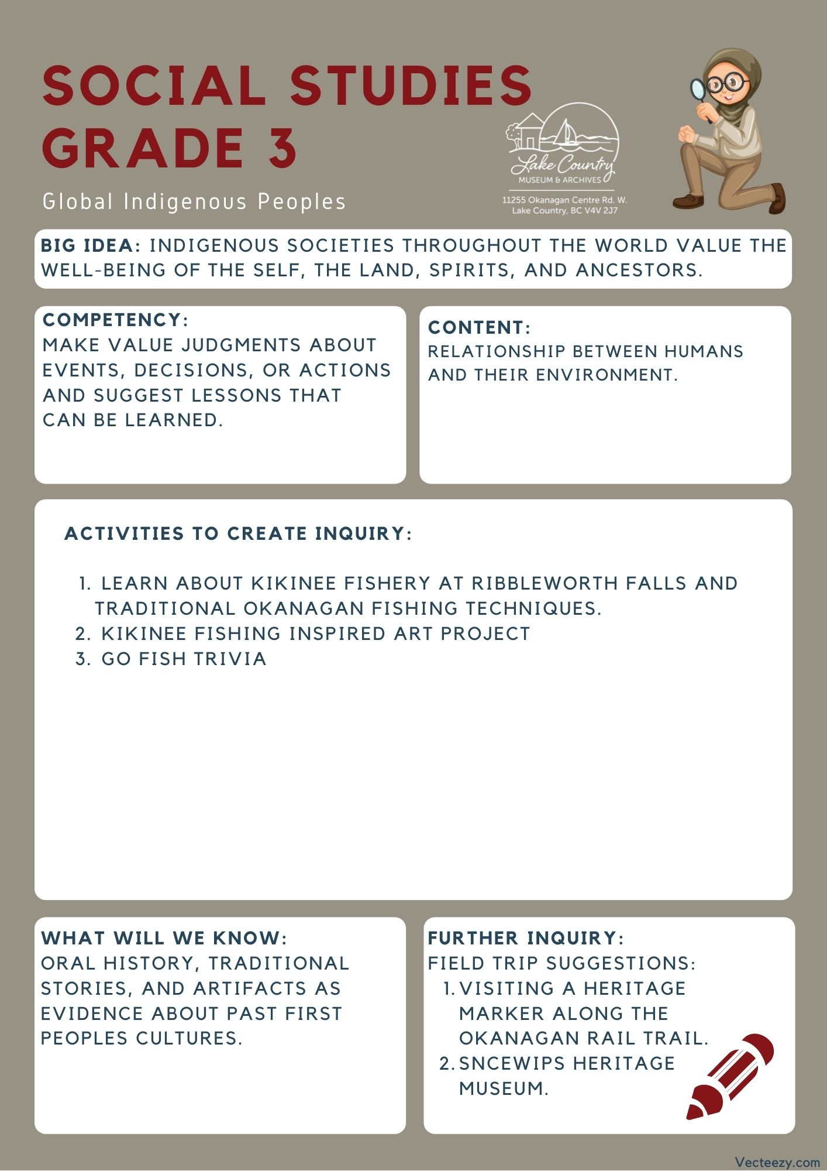
We respectfully acknowledge that the land on which the Lake Country Museum is situated, where this lesson was developed, is on the unceded territory of the Syilx (Okanagan) Peoples.

Copyright © 2021
Lake Country Heritage and Cultural Society
11255 Okanagan Center Road West
Lake Country, BC V4V 2J7

All rights reserved. No part of this publication may be produced, stored in a retrieval system, or transmitted, in any form or by any means, electronic, mechanical, photocopying, recording, or otherwise, without prior written permission of the publisher.
Social Studies Grade 3: Kikinee Fishing
Learning Experience
Through a narrative, students are exposed to accounts of how the Okanagan First Peoples used the environment to fish the lakes. Disclaimer: This lesson plan leaves in wording such as "Indian" due to the Okanagan indian band choosing to use that name for themselves.

Intention | Through a historical narrative, students can learn more about the tools used and developed by the First Nations Peoples of the area for fishing and have a discussion about fishing sustainably.
Objective | Introducing the fishing practices of the Okanagan First Peoples, how they used the environment to create their equipment, and how they worked with nature to gather what they needed. having a discussion about what it means to fish sustainably, and doing an art project inspired by the story and discussion.
The Story | Link to video narration: https://youtu.be/DkfUbp8IGkM  It's late fall in the Okanagan, the leaves are changing and it's starting to get colder. This is around the time you would have seen the Kikinee come to the shoreline of Wood lake around Ribbleworth Falls to spawn, this would bring them all close to one place at once. But the Kikinee wouldn't be there for long because being so close to the shore made it very easy for predators to see them.  The Indigenous fishers of the okanagan knew this and had many different ways of catching the Kikinee. Since the bay near Ribbleworth Falls was so shallow you could easily see the Kikinee. To catch the fish in this shallow area they used nets made of Spitsen. Spitsen was a weed that was twisted to make a twine like yarn! Attached to the ends of the net, they would have rocks that would be used as weights to keep the net close to the bottom of the lake.  Once they were able to make a large net two fishers took to the falls, one fisher would take one end of the net out behind the fish, and the other would pull the net to shore. This led to catching a ton Kikinee at once!  The Indgienous fishers also went out in their boats like we do nowadays, but they didn't have fishing rods to work with. They had to either cast out their nets off the side of the boat, or use another method, spear fishing.  The spears these fishers would use had 3 prongs on them to make it easier to grab a fish. The Indigenous people had one more important technique they used to catch a lot of fish, and that was that they fished at night! During the evening, when it was dark out and the fish were sleeping, there were Indigenous people out fishing. They used a torch to not only see the Kikinee, but the light would also attract Kikinee to their boat! That way, they could easily catch the fish using their three pronged spear.  These traditional ways of fishing that the Okanagan Indigenous people used, show just how creative and resourceful their ideas are! It is very different from how we fish today.  Discussion questions: (about fishing sustainably)  - What do you think would happen if these fishers caught all of the fish in the lake in one season? Would the fish come back?  - How could we make sure the Kikinee would still be in the lake after we would fish each season?
Guidance | Kikinee fishery at Ribbleworth Falls.  Okanagan Indigenous fishers caught Kikinee (Kokanee) all around Wood (formerly Pelmewash) Lake, including along the shoreline on both sides of Ribbleworth Falls. These fish were shore spawners that differed from their stream spawning cousins in a variety of ways, including the time of their spawn. Stream spawners generally returned to their natal gravel beds in September and shore spawners in late October. Okanagan Indigenous fishers took advantage of both fisheries, moving their camps to participate in the progressive harvest.  Two or three types of fishing technologies likely occurred along the eastern shore of Wood Lake, these in response to changing circumstances. To understand this evolution, one must consider the changing spawning habitat available to Wood Lake Kikinee.  Traditional Okanagan Fishing techniques  Immediately south of Ribbleworth Falls it is easy to imagine a shallow bay with a rock and gravel lakebed suitable for shore spawning. Shore spawners did not linger at the spawning site. Rather, large schools of Kikinee would descend upon the shore, females would lay eggs in gravel and in cracks between rocks, males would spread milt to fertilize them and the entire school would quickly leave in order to avoid predators such as Mergansers, Ling Cod and Lake Trout. Males might linger in the area for up to ten days after spawning.  This was a perfect environment for fishing with a mesh or seine net. An archaeological dig of a village site on the southwest corner of Wood Lake revealed a number of stone weights used to hold a net close to the bottom of the lake. The mesh nets and the floats used to keep the nets at the surface have not survived because of the vegetative nature of these instruments, but they are natural complements to the stone weights. The plant material used to make the mesh nets was, and still is, readily available along the shoreline of Wood Lake.  Pierre Logan of the Okanagan Indian Band, in an interview in 1950, recalled net fishing:” …Caught fish by getting a large net with men at each end, go out in water and sweep it into shore. Hemp for nets came from a weed, Spitsen….”  Louie Lewis, of Spahomin, elaborated on net construction: “In fall, they caught Kikinee with nets. Nets made out of weeds, Spitsen. Cords twisted on leg to make twine. Spitsen was the only plant used to make twine.”  Keith Louis, of the Okanagan Indian Band, still uses a seine net to capture shore spawners for research purposes.  There has also been evidence to suggest of using a throw net tossed from a rowboat in this vicinity. This was likely a lesser used fishing methodology suitable for shallow water fishing when fish were densely schooling.  Another method of canoe fishing was to use a three-pronged spear to plunk over a Kikinee and then to lift it into one’s canoe. Sometimes a torch was used to attract the fish to the immediate area. Two Lerman informants report on this method of fishing for Kikinee.  Gideon Eneas of Penticton recalled fishing from a canoe as a boy: “…The Kikinee spawn on Okanagan Lake along the shore –they do not go up the streams. Two men and a boy get in a canoe – one man to paddle and one to spear the fish. The boy carries a torch of pitch–pine sticks that are bound into a bundle with red willows or Saskatoon berry bush branches. He holds the torch behind the man with the spear so the light does not blind him. [Gideon] held the light when he was a boy and they camped near Peachland.”  Pierre Logan offers further detail: “Fishing – use pitch from top of a pine tree by cutting off the top of the tree and cut into sticks [that are then bound] together. One man holds the torch and another spears them. [The t]orch attracts some fish and shows others who are sleeping. Kikinees are [also] speared from the shore [sometimes] with the use of a torch….” Pierre made further comment: “For salmon --- dugout canoe. Get a bundle of pitch sticks, put in front of boat and light it and spear them. Wooden spear.”  Article written by Dr. Duane Thomson, the president of the Lake Country Heritage and Cultural Society and an Associate Professor Emeritus of History at the University of British Columbia. The Thomson family are long-time residents of the Oyama area of Lake Country.
Activity | Kikinee Fishing Inspired Art  Grade 3 Arts Competency: Explore identity, place, culture, and belonging through arts experiences  Lake Country has a mural based on the Kokenee fish, painted by Don Makela in 2001 (See slidedeck for images). The mural can be seen from the trail that runs along Vernon Creek. More information about the mural can be found at the artist’s website: http://www.donmakela.com/MuralMenu.htm  Materials:  - Reference Images of Kokanee fish, printed or on a screen. See slide deck for examples.  - Various Art materials (see project ideas below)  Have students respond to the history of Kikinee fishing through art. You may have students choose from a selection of art materials or have the class all use the same material.  Water Colour (2d option)  Have students lightly sketch out an image of a kikinee fish in any composition of their choosing. Some may want to render the fish close up, some may want to render many fish in various sizes. After, have the students experiment with using water colour paint to add color to their image. They could go for the naturalistic reds of the Kokanee, or perhaps they want to take some creative liberty. Alternatively, you could replace watercolor paint with any other color media such as pencil crayon.  Materials: Water color, Brushes, Paper (preferably of a thicker stock).  If you had epsom salt to wet watercolor paint on the page, students could create some interesting textures resembling scales.  Plastic Water Bottle Fish (3d option)  Using plastic water bottles, have students squish and reform the bottle into the shape of a fish. Some may want to trim the end of the bottle with scissors if they want a shorter fish.  After, they can paint the bottle to resemble a kokanee. Once the paint is dry used construction paper to create the fins of the fish. You can tape or glue them on, or cut slits into the water bottle to slide the paper in. Students may want to glue googly eyes onto the fish or paint eyes on, their choice!  Materials:  Plastic Water Bottles, Paint (preferably acrylic) or paint markers, Brushes, craft/construction paper, scissors, tape/glue.  Go fish trivia: (optional)  - If you would like to relate Kikinee fishing to another subject of your choice this activity is customizable.  - In this game, the teacher creates a mini lake out of paper-mache. Then, teachers place cards with trivia questions for any subject in the lake for students to fish out. When the student reels in the question, they are asked to answer the trivia question. Go around the class until all of your questions are answered.
Further Inquiry | Field Trip Suggestions:  The Okanagan Rail Trail – Woodsdale Rd to Oyama boat launch.  There are historical markers along the Okanagan Rail Trail that talk more about the fish and fishing practices of the area. Visit the markers and trail to imagine what early life was like while opening room for class discussions.  Discussion Prompts:  - What considerations did the developers have when creating the Rail Trail? Possible suggestions would be land ownership or environmental impact.  - Is the trail an example of making something that goes with the environment, or an example of changing the environment to meet your needs? Why?  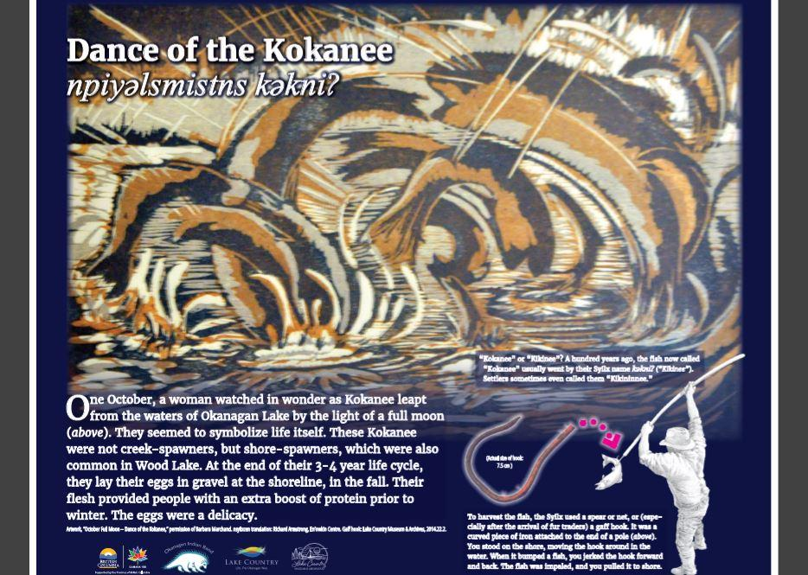  - How does the trail meet the needs of the local community today?  The Lake Country Museum and Archives  The Museum has a wide range of exhibits and activities for your class to take advantage of. There is also a playground and field behind the building and the lake nearby that students can make use of for various activities.  There may be the opportunity for a guest lecturer to visit your classroom or be present at the museum with the knowledge of more local history stories. If interested, please contact the Museum ahead of time.  Visit the Sncewips Heritage Museum in Westbank to learn  more about the living history and heritage of the Syilx  Okanagan People. Set up a tour through the museum’s website: https://www.sncewips.com/  For further exploration and education, we recommend that you contact the Okanagan Indian Band Education Services Department. (link)

